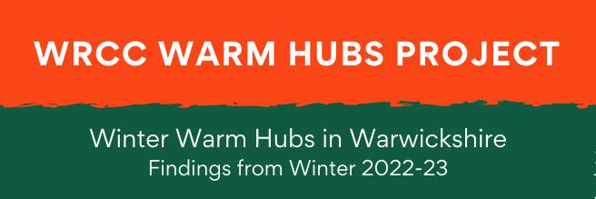

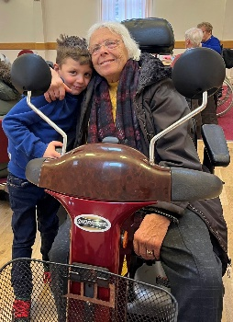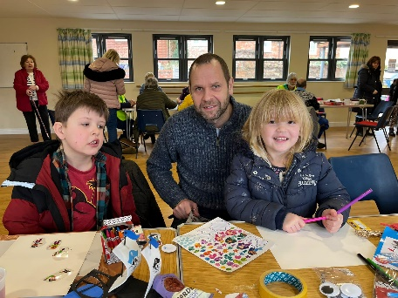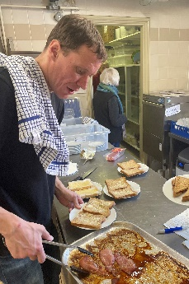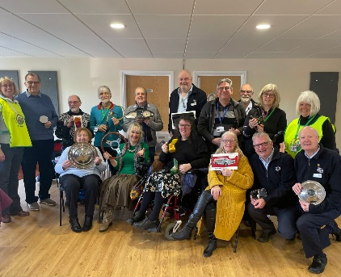
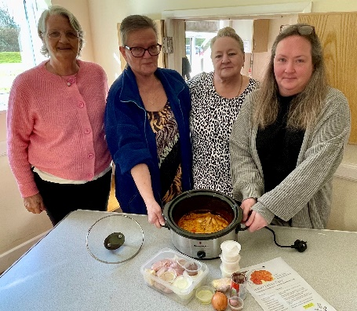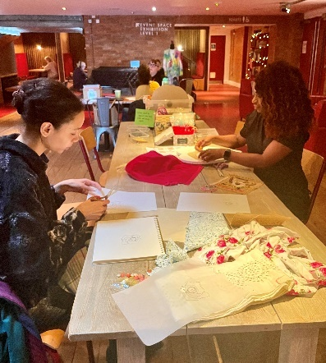
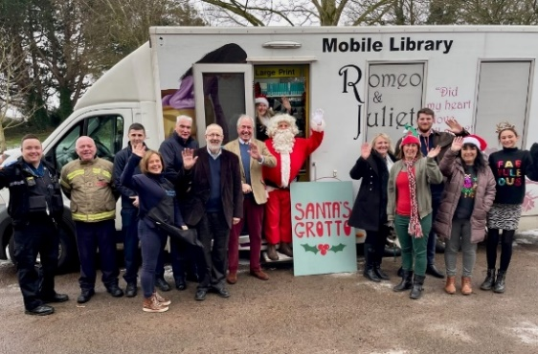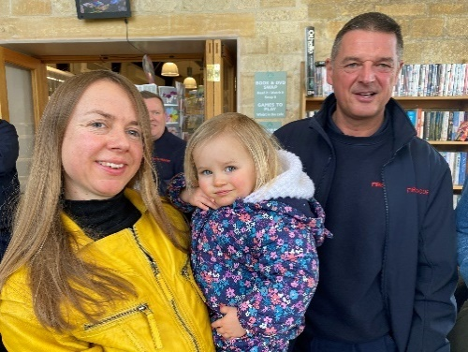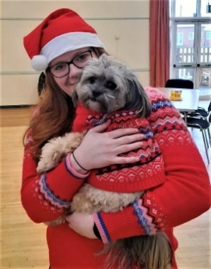

- INTRODUCTION

WRCC’s Warm Hubs community project, sponsored by Cadent, has been running throughout Warwickshire and Solihull since late November 2020. The project’s key objectives are to target social isolation and fuel poverty for vulnerable residents. Those most at risk are also likely to be affected by rising living costs in general, particularly relating to food, housing, and accrued debt.

Since the project started, communities around the UK have been severely affected by the impact of the Covid pandemic and the steep rise in costs of living, driven last winter by the rise in energy costs. Our charity has accordingly adapted and developed its delivery of the Warm Hubs project in response, while continuing to prioritise its original objectives, resulting in the following key initiatives:

- WRCC’s growing network of accredited community led Warm Hubs which provide residents with welcoming, safe, accessible community spaces all year round
- WRCC’s converted Mobile Warm Hub minibus, run by the charity, which provides daily free community cafés in a range of locations during the summer, and runs a more limited service running indoor pop up cafes and supporting other community project during the winter
- WRCC’s expanded seasonal network of community led Winter Warm Hubs, facilitated by providing small grant funding to community groups and venues due to cost of living rises in Winter 2022-23. Last year this funding helped to support a network of 92 Winter Warm Hubs running in Warwickshire and Solihull (between October 2022 - March 2023). During that period, 27,612 visits by residents were made to 1,683 events. WRCC also distributed 928 free energy, home safety and cost of living packs and carbon monoxide alarms

WRCC helps provide support and advice via its Warm Hubs team, including energy information and materials such as free carbon monoxide alarms, plus home safety advice and other support for residents in collaboration with our charity’s informal network of partner organisations and community support services.

This short report looks at the findings from WRCC’s Winter Warm Hubs initiative in Warwickshire, where the majority of the 92 network hubs were located in Winter 2022-23. Each hub received a small grant (of between £300 to £500) and a welcome pack including an Organiser’s Checklist, Winter Warm Hub logo, and a listing on WRCC’s online directory. Hubs were given free information packs (with energy saving advice, home safety tips, signposting to other services and advice, and carbon monoxide alarms), plus online resources, and access to other community support services who wanted to visit hubs. Working with local community groups in Shipston and Kenilworth, WRCC also ran two Winter Warm Hubs as pilot sessions, to trial longer opening times and different types of activities and support.

WRCC requested hub organisers to complete and return post event questionnaires, to evaluate project feedback and inform the findings in this short report. 88% of those responded and an overwhelming 95% of those wanted to carry on some form of community activity, whether by continuing with their current hub or starting again in Winter 2023-24. With the winter ahead anticipated to be another difficult time for our communities, the impact made by Winter Warm Hubs funding last year has led to WRCC’s decision to organise and support a similar initiative for Winter 2023-24.
OVERVIEW OF HUBS

Community groups and organisations showed a real desire to help support local residents during what proved to be a difficult winter. The majority of Winter Warm Hubs were set up by organisers to provide cost of living support for residents (60%) although a third preferred to focus on providing social meeting places (33%). Other organisers were prompted to set up an activity by the availability of funding.

Like WRCC’s accredited Warm Hubs, Winter Warm Hubs were intended to be welcoming, enjoyable social events in their own right – “happy places” as a regular attendee described them - and not only as a last resort for people who were struggling. Many volunteers used the hubs to build trust and relationships with those attending, who then felt more comfortable about asking for advice on any specific problems with cost of living, health and wellbeing. At the same time, key energy and cost saving messages could be promoted to a wider audience. One organiser commented:

“There was a lot of discussion about the cold and keeping warmer – the event was too short to save on home costs but it was a good discussion forum!”

A sizeable 40% of hubs said they would not have been able to run without Winter Warm Hub grant funding. The remainder said they would have run some form of community events without this funding but most would have had to reduce their provision, eg the amount of refreshments/ activities provided, make a charge, or reduce the frequency/duration of an event.

Despite the Winter Warm Hubs initiative being actively advertised and promoted across the county, there were a far greater number of applications from potential hubs in South Warwickshire than elsewhere (it is not entirely clear why, but this also proved to be the case with other funding opportunities run by different organisations throughout the county).

In the second phase of funding launched in December 2022, WRCC actively targeted community groups and venues outside South Warwickshire, which had some impact. In the end, one third of hubs were based in Stratford District, one in five in Warwick District, and the remainder were split fairly evenly between Rugby, Nuneaton and Bedworth, and North Warwickshire Boroughs.

Venues were split approximately equally between church halls, community centres, village halls and other locations. The latter included arts and sports centres, community libraries, community pubs and cafes, a youth space, hospice and a Scouts club. One parish council alternated its event between the village hall, a church and a pub every week.

Over three quarters of hubs (77%) ran weekly events and more than one in ten ran multiple sessions per week. The rest ran monthly or occasionally fortnightly events. A few hubs ran a combination, eg a monthly lunch and a monthly coffee morning. The majority lasted for two hours, which worked well for volunteer availability and also meant venue hire costs, where applicable, could be kept to a reasonable amount. WRCC experimented with running two half day pilot hubs in Shipston on Stour and Kenilworth, but most attendees only tended to stay for about two hours.

Nearly half of Winter Warm Hubs ran for between 11–20 sessions and one in five ran for between 21–30 sessions. The remaining number of hubs were divided equally between running more than 30 sessions or less than 10 sessions in total. The majority who were running at the time stayed open for most of the Christmas period.

All organisers were provided with WRCC’s Winter Warm Hub logo to use on promotional materials, although not everyone did so. Some hubs were already part of other groups and used other logos, and some hubs did not have the time or resources to produce much publicity materials. However, when looking at how they could potentially have made more impact on their local community, hub organisers identified more event advertising and promotion as being an important factor with one third of respondents it ranking it at their top priority.

Due in part to some of the national media coverage about “Warm Hubs”, “Warm Spaces” and “Warm Welcomes”, a handful of organisers shared concerns about using the Winter Warm Hub name, saying that some residents would not want to attend a “free Warm Hub” as they didn’t want to be viewed as needing help. For the majority, however, this was not a significant issue.

“Brand awareness is important - call it a Warm Hub, say it’s a chat and a cuppa and explain more to people when they’re there”

Online directories of hubs were hosted by WRCC as well as by District and Borough Councillors, Warwickshire County Council, local church and community groups etc. As well as raising profile, this was also an opportunity for hub organisers to network and share experiences from other hubs, and to prevent their events from clashing with other local activities.

However, the time constraints could make this difficult, particularly when starting an event from scratch and taking into account volunteers’ other commitments. Some Winter Warm Hub organisers did visit Warm Hubs before setting up their own activities, or entered into their own informal networks with other local hubs, and found this very helpful. Several emphasised the need to put a significant amount of work in to build engagement:

“You need to put effort in to make it a success and listen to voice of the community feedback … It’s not just a case of hiring a building, opening the door and popping the kettle on”

Regardless of this, however, some hubs continued to struggle to attract residents to their events:

“We didn’t quite achieve what we expected – seriously impacting those most affected by the cost of living crisis. [We] just couldn’t reach them here”

It is important to note that, as with WRCC accredited Warm Hubs, there was no such thing as a “standard” Winter Warm Hub! Although all hubs were required to follow the key principles as set out in the Organiser’s Checklist, the model provides for a huge amount of flexibility to enable each hub to meet its community’s particular needs. The amount and type of refreshments and activities offered, and engagement with residents and community supporters, varied considerably from hub to hub.

- ATTENDANCE AT HUBS

As already noted, there was considerable variation between the frequency, duration and engagement offered by hubs so the average number of 19 attendees needs to be regarded in this context. Some hubs attracted up to 80 attendees on occasion, whereas numbers for others were very low, and many organisers found attendance could fluctuate for a number of reasons, including bad weather and illness. Several organisers commented on the need to persevere and take community feedback:

“Don’t give up after the first couple of sessions if it’s not well attended. Change what you did and try something different”

Most of the hubs ran events lasting for a couple of hours during the day so inevitably the age profile tended to be older, especially for those located in rural areas. 58% of those attending were described as of retirement age (aged 65+), about a third were of adult working age, and nearly one in ten were aged under 18. Four out of every five hubs said they had greater numbers of women attending than men or children, although at some of these the number of men increased significantly over time. Visits from the British Motor Museum also saw numbers of men increasing at hubs! Some organisers ran events specifically targeted at families with young children, or after school activities for children and teenagers.

Having a team of volunteers with a range of skills and appropriate training was important for hubs, although some struggled to recruit enough volunteers, and many of those who helped out already had other community commitments. Some groups had identified roles for each volunteer, eg “a good ‘welcomer’ to make people feel comfortable”. Others were more flexible, particularly if there were smaller groups of people attending events.

The ratio of volunteers to attendees ranged considerably, from 1:1 to 1:20, but the most common ratio across all hubs was one volunteer for every three or four attendees, to support community engagement. Some people wanted to volunteer as they wanted a more active role rather than “just” attending. Having a good support team was important for hub organisers, and many volunteers said supporting a Winter Warm Hub was a very positive experience for them as well:

“Enjoy it and surround yourself with lots of volunteers – we get as much out of the Warm Hub as the attendees do!”

Volunteers (and attendees) kept an eye out for each other, and there were times when someone would call round to check on a regular attendee who had not come along that day, or would help another person to get a doctor’s appointment if they seemed to be unwell. Many attendees enjoyed helping others and sharing practical tips with them, such as cheap cooking suggestions, local offers, and other local groups with activities, such as walking groups and craft groups.

One wheelchair user said that their participating village hall was the only local place they could easily access, which made such a difference to them. The inclusive, welcoming aspect of hubs was valued both by attendees and volunteers, as by a town hub organiser pointed out:

“We were pleased with the variety of groups who benefited – those who were bereaved, those living with dementia, wheelchair users and more”

Most organisers were already familiar with volunteer training and safeguarding principles, although a few needed more support and advice. WRCC provided template risk assessments for community groups and venues who requested them, and signposted others to organisations such as Halls Together and Warwickshire CAVA.

Overwhelmingly, the most important reason for people attending hubs was for social interaction – this was the main reason for two thirds of those visiting hubs. Some organisers who had set up hubs primarily for supporting cost of living needs were surprised by the depth of people’s need to connect with others, and that so many people in their communities were still feeling lonely or isolated:

“Having someone to speak to made such a difference to people!”

Refreshments and being able to meet in a warm space, with access to energy advice and other forms of support, as well as activities, were other reasons for people attending. One village hub organiser noted that two regular attendees, who lived close to each other but had never met, had now become firm friends. It was common to hear feedback from residents living alone, particularly those recently bereaved, saying that the hub had given them a purpose in life, to get out and meet new people. Many found that attending their weekly Winter Warm Hub had become a habit.

“If I didn’t go [to the hub] it felt like something was missing from my week”

People often did not want to open up about their personal circumstances at first, but felt more confident about asking for help when needed as sessions went on and they got to know more people there. It was important that people enjoyed coming to a Winter Warm Hub and did not feel they were being individually singled out for help. However, the offer of support and copies of information about other services was made available to anyone attending the hubs.

Several residents attended more than one hub, avoiding having to buy and cook food for a couple of days per week. In some areas, hubs worked together to run events on different days, which compounded the benefits for residents:

“It helped with the cost of living by helping attendees to keep energy and internet costs down at home”

Some vulnerable residents admitted they were cold all the time as they were worried about putting the heating on, and could be given practical energy saving advice. One attendee had no pre-payment vouchers (due to postal strikes) and so had no heating, and they were provided with some replacement ones as a matter of urgency. Other people wanted to know more about accessing Foodbanks or Community Pantries, managing debt, and where to find information on services and benefits as they had no online access at home.

- REFRESHMENTS & ACTIVITIES AT HUBS

All hubs provided refreshments in some form – the minimum requirement was hot drinks and biscuits or cake – but over a third of hubs (39%) exceeded this. This was split between those who offered hot lunches, some with puddings, and “Winter Warmer” meals, and those who provided hot snacks such as toasties, crumpets, bacon sandwiches or sausage rolls. Some offered a wide range of hot and cold food options, often with the support of local suppliers.

Over 90% of hubs provided refreshments completely free of charge, with donations accepted in one of five. Many attendees commented that they would prefer the option to pay if they could afford to do so. Of those who charged, this was at a nominal rate and organisers advised that costs would have been waived for vulnerable people unable to pay.

There was a huge range of activities on offer from different hubs, from young babies all the way through to Young at Heart residents in their 90s. Attendees at a third of hubs most enjoyed playing board games and puzzles, with other popular activities at hubs being reading books, magazines and papers (25% of hubs), children’s activities (17%) and arts and crafts (16%). Nearly one in ten rated indoor exercise or sport most highly. These were some of the many activities highlighted by hubs (not ordered by priority):

One association ran daily homework club and hot meals during the winter, partnering with a range of local organisations for additional support, based at a local school during the week and at a local church at weekends and during school holidays. Another community centre ran an afternoon groups for young families, which was popular. And a town-based youth arts group ran after school activities and events for teenagers to build confidence and support.

Another local group welcomed those affected by Alzheimers (and their carers) to come for hot food and live entertainment. Volunteers at many Winter Warm Hubs knew attendees who had dementia or were vulnerable in other ways, and although many carers stayed to enjoy the event as well, some were able to take a short break themselves while their affected relative could enjoy interacting with others in a safe space. One hospice commented:

“[It provided] significant help to attendees … our hub gave them a short and welcome break from caring for a terminally ill loved one. We are looking at expanding next winter”

Organisations such as Act on Energy, Citizens Advice, Warwickshire Fire and Rescue Services, and Warwickshire Healthwatch came to several Winter Warm Hubs to help vulnerable residents. Volunteers from the British Motor Museum, looking to engage more with communities, ran very popular sessions with memory boxes full of motor memorabilia to entertain and inform people. Warwickshire Library Service ran Tea & Tech drop ins, to support digital inclusion and build online confidence, and Warwickshire Wildlife Trust ran planting sessions and wildlife walks for wellbeing:

“Wellbeing activities have increased hugely, Fire Services have given useful individual advice, and we have had useful contacts for energy and family support”

Warwickshire Fire and Resue Service noted they had received a considerable increase in Safe and Well referrals from Winter Warm Hubs. The wide range of support that hubs around the county received from other organisations included:

Access to local GP services; community awareness ASB sessions; community mobile library support; councillors’ clinics and visits; CPR and defibrillator training; flu vaccination clinics; help with passport applications; local community police and crime awareness visits; MIND one to one sessions; and social prescribers’ visits.

- IMPACT OF HUBS

The positive impact Winter Warm Hubs could have on communities was evident to WRCC’s Warm Hubs team when visiting events and speaking to organisers, volunteers and attendees. Organisers’ feedback provided further evidence - nearly two thirds (62%) felt their hub had a significant impact on attendees, with over a third (37%) feeling it had some impact. The remaining organisers said that attendance at their events was too low to assess this effectively.
One of the clearest indications of hubs’ social value was their reported impact on wellbeing, with 97% of organisers having felt that this had improved for attendees. Over two thirds (69%) also confirmed their hub had helped to provide support with cost of living problems over the winter.
Organisers also reported there was a wider impact on the community beyond those attending events, with nearly two thirds (63%) feeling there was some impact and 17% feeling that there was a significant impact. This was at least partially due to a “ripple” effect in terms of people taking information away with them and sharing with others.
The role of such hubs as community assets was particularly important in rural areas where there were few or no existing social amenities:

“In our very small village, the majority of those not at work or school all attended the hub”
“It greatly helped those living on their own, especially the elderly. Several people said it was a ‘life line’ for them”
Volunteers also appreciated seeing the impact that hubs could make to their communities and the sense of “making a difference” in a tangible sense. And hubs could also raise people’s awareness of what else could be available to help them locally (see above).

Winter Warm Hub organisers felt the most important way to build impact, particularly given the short timescales involved for several, would be to create more awareness and promotion of events. This applied not only to individual events but also to the Winter Warm Hubs initiative as a whole (and by extension the Warm Hubs programme) by WRCC and key organisations such as Parish and Town Councils, District and Borough Councils and Warwickshire County Council.
More funding, especially in the longer term, was another important issue and creating networking opportunities was another common request.
As mentioned in the Introduction, 95% of organisers wanted to continue with some form of community activity, with a quarter of those having always intended to run seasonal activity over the winter months and then restart in Winter 2023-24. The majority of hubs have continued to run events and activities in varying degrees, with some becoming WRCC accredited Warm Hubs - there are now 14 permanent network members.
Other community groups and venues have “taken a break” over the summer holidays and some have decided to re-evaluate what residents are likely to need in the longer term. Lack of funding, a shortage of volunteers, and insufficient demand were described as being the main barriers to continuing with hub activity:
“We would love to carry on as a Warm Hub if we get future funding, as it has proven so beneficial for those vulnerable in our local community”

As a result of the project learning from last year’s Winter Warm Hubs initiative, WRCC is taking the following steps to support Warm Hubs and would be Winter Warm Hubs moving forwards:

- Holding a Warm Hubs Workshop on 13th September 2023 (open to all community hubs and project supporters) which gives WRCC accredited Warm Hubs a platform to share how they engage with communities and the range of activities they provide; brings together community support services and organisations involved with Warm Hubs and Winter Warm Hubs; and connects project funders like Cadent and Warwickshire County Council plus other funding organisations with hub organisers

- Promoting the Warm Hubs project via this workshop and ongoing activity, and encouraging other organisations throughout Warwickshire and Solihull to collaborate, support and promote Warm Hubs and Winter Warm Hubs

- Launching a new programme of Winter Warm Hubs funding on 22nd September 2023

- Providing free online training for hub organisers and volunteers at Winter Warm Hubs in Warwickshire and Solihull to improve their resources and support their work

- Asking Winter Warm Hubs which support service organisations they would like to attend their events, and facilitating such support as may be available

- Launching a new series of funded slow cooking courses in Warwickshire, in collaboration with Cadent and Warwickshire County Council’s Community Food Forum

- Providing updated written and online resources for all Winter Warm Hubs and Warm Hubs

- Providing additional Winter Warmth materials, service referrals and other benefits to accredited WRCC Warm Hubs

For more information about any of the above, please visit www.wrccrural.org.uk/warm-hubs-news or email warmhubs@wrccrural.org.uk. Or contact WRCC’s Warm Hubs team on 01789 842182.

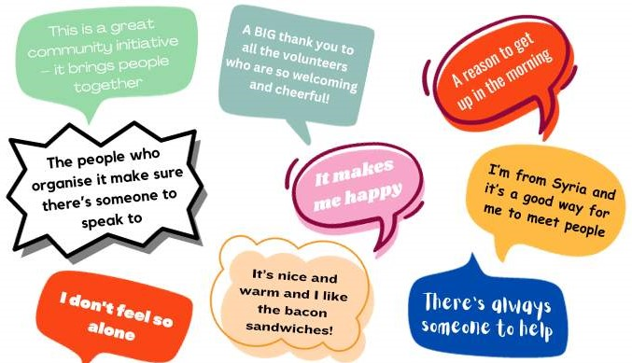

APPENDIX
WINTER WARM HUBS NETWORK
MEMBERS, WINTER 2022-23
(WARWICKSHIRE & SOLIHULL)

Alcester Baptist Church
Alcester Methodist Church
Arley and St Michael’s Community Centre
Arley Methodist Church
All Saints and St Andrew’s Churches, Bedworth
Alderminster Village Hall
Avon Dassett Community Benefit Society
Baddesley Ensor Community Library & Hub
Baginton Village Hall
Benn Partnership Centre, Rugby
Bidford Warm Hub
Bradby Club for Young People, Rugby
British Gurkhas Veterans Association, Nuneaton
Brownsover Community Association
Brunswick Hub at Crown Routes, Leamington
Bubbenhall Parish Council
Castle Hill Baptist Church, Warwick
Chase Meadow Community Centre
Cherington, Stourton & Sutton-under-Brailes Hall
Cohort 4, Atherstone
Combrook Village Hall
Cubbington Village Hall
Foundation House, Stratford Town Trust
Graham Adams Centre, Southam
Hartshill Community Centre
Heathcote Community Centre
Helping Hands, Leamington
Hill Street Youth & Community Centre, Rugby
Ilmington Village Hall
Independent Addiction Recovery, Nuneaton
Independent Advocacy, Bedworth
Jubilee Court Retirement Housing, Alcester
Kenilworth Winter Warm Hub, St Vincent de Paul Kenilworth & Compassionate Kenilworth
Keresley Library
Kineton Village Hall
Lighthorne Heath Village Hall
Lillington Community Pantry
Long Itchington Parish Council
Newbold on Stour Village Hall
Manor Court Baptist Church, Nuneaton
Marie Curie West Midlands Hospice, Solihull
Mary Anne Evans Hospice, Nuneaton
Meriden Warm Hub
Municipal Charities of Stratford upon Avon
Myton Church
Nelson Club and Institute, Stockton
Nether Whitacre Methodist Church
New Bilton Community Association
New Life Church, Warwick
Newton and Biggin Village Hall
Newton Regis Village Hall
North Warwickshire 50+ Lunch Club, Atherstone
Nuneaton Christian Fellowship
Old Meeting United Reform Church, Bedworth
Old Saltleians Rugby Club, Water Orton
Open Door Café, Hampton Magna
Our Lady and St Joseph Catholic Church, Alcester
Phoenix Post Diagnosis Group, Nuneaton
Polesworth Community Support Group
RCCG Harvest Fellowship Church, Rugby
Royal British Legion Galanos House, Southam
Royal Shakespeare Company
Rugby Art Gallery & Museum
Salford Priors Warm Hub
Shipston on Stour Winter Warm Hub, Stour Health & Wellbeing Partnership
Shotteswell Warm Hub
Smithswood Access to Services, Solihull
Snooty Pooch, Solihull
Southam and Bishop’s Itchington Congregational Church
Southam Town Council
St George’s Parish Church, Hillmorton
St John the Baptist Church, Wolvey
St Margaret’s Church, Wolston
St Michael’s and All Angels Church, Stockton
St Nicholas Church, Alcester
St Paul’s Church, Leamington
St Paul’s Church, Stockingford
St Peter’s Church, Wellesbourne
Stratford Youth (Escape Arts)
Studley Methodist Church
Studley Village Hall
Sydni Centre, Leamington
The Kenilworth Centre
Together for Change, Saints Nuneaton
Warwick Methodist Church
Wellesbourne Warm Hub
White Hart Community Groups, Atherstone
Wolverton Church Hall
Wolvey Baptist Church
Wolvey Village Hall
Wolston Baptist Church
Wootton Wawen Parish Council, Wootton Hall

