PRESS RELEASE: Monday 18th September 2023
FIRST WRCC WARM HUBS WORKSHOP -
KEEPING COMMUNITIES CONNECTED!

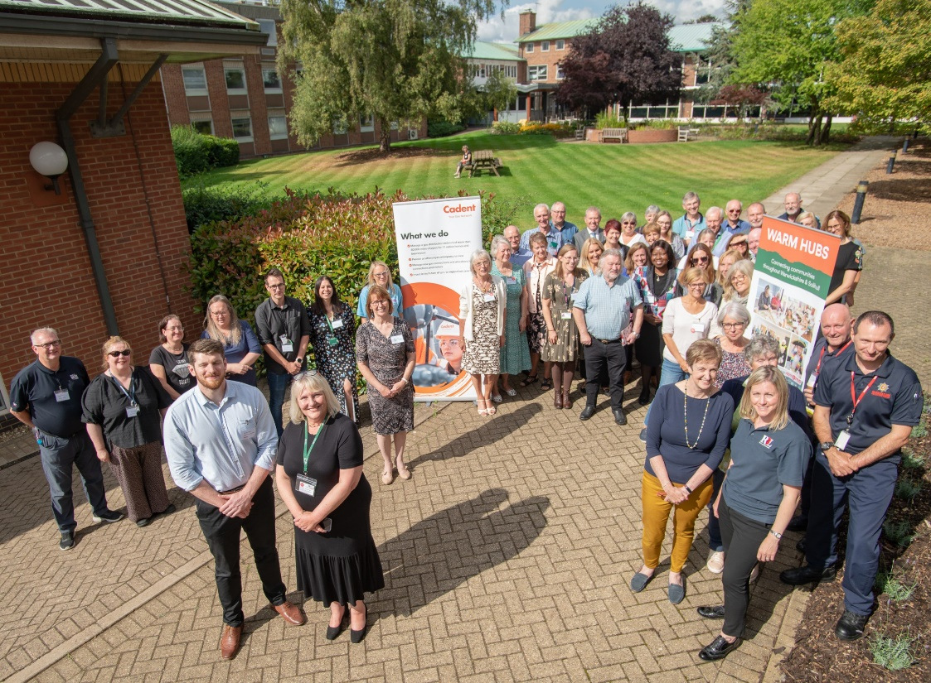

Photo: Edward Allard, Cadent’s Social Programmes Manager, and Jackie Holcroft, WRCC’s Warm Hubs Project Manager (front left) with some of the 120 attendees at the Warm Hubs Workshop, Warwick University (Wellesbourne campus)
The atmosphere was buzzing at WRCC’s first ever Warm Hubs Workshop on Wednesday 13th September, when 120 people came together to make connections, share experiences and learning, and celebrate the amazing work that’s taking place at community hubs throughout Warwickshire and Solihull. Attendees really enjoyed the event, commenting “what a fantastic workshop day”, “there were so many inspirational people and so many heartfelt stories”, and “it was great to meet up with people and to get a feel for what everyone is up to and the challenges they are facing.” “Just brilliant!” added another. After nearly three years of the Warm Hubs project - run by rural charity WRCC and supported by gas distribution network Cadent - there was always going to be a lot to talk about!
Following introductions from WRCC and Cadent, the workshop showcased what’s happening at Warm Hubs in Atherstone, Bidford, Kenilworth, Meriden, Salford Priors, Wellesbourne and Wolvey, all members of WRCC’s network. Organisers shared their personal learning and practical advice about hubs as centres of community engagement, emphasising the importance of providing safe, inclusive places where people know they can come and enjoy a warm welcome, as well as access to help and advice when needed. There was a huge range of activities, entertainment, and community support being offered, as well as a variety of tasty hot and cold food on the menu.

Attendees enjoyed a seated exercise taster session from Think Active and the Warm Hubs team at Salford Priors even announced the launch of their Short Mat Bowls Warwickshire Inter-Hub Competition!

Moving on through the packed programme, the British Motor Museum gave a fun, insightful talk about their community programme and how they worked with WRCC’s Warm Hubs team for their popular outreach programme at hubs last winter (with more community projects to come this winter). Representatives from Citizens Advice, National Energy Action, Warwickshire Healthwatch and Fire and Rescue Services all came together to explain how they can work with Warm Hub organisers to help more vulnerable residents visiting hubs. And there was an introduction to some of the free online training courses available to organisers and teams of volunteers, including Community Energy Champions, which will be coordinated by WRCC.

Funding is a key issue facing all community groups and venues, and Warwickshire and Solihull CAVA and Think Active provided practical tips and advice on grant applications and offering expert guidance and support for those considering future bids. With the colder months approaching, WRCC also announced it will be bringing back its Winter Warm Hubs grants scheme - which helped to support a network of 92 hubs last winter - plus a new online map which will not only show the locations of all WRCC Warm Hubs and Winter Warm Hubs, but will also offer free listing to other community hubs across Warwickshire and Solihull!

The Warm Hubs project targets social isolation and fuel poverty and related issues, one of which is how residents can be helped to access affordable, healthy food while living costs continue to rise, and so the workshop ended with a focus on food initiatives. WRCC launched its new funded slow cooking courses for community groups this winter thanks to a collaboration between Cadent and Warwickshire County Council’s Community Food Forum, which is seeking to find more ways to promote sustainable food partnerships and support residents across the county.

Jackie Holcroft, WRCC Warm Hubs Manager, said: “We’re delighted to welcome so many people from so many organisations to our event today. This shows the strength of support and need for Warm Hubs and how our network supports community development across Warwickshire and Solihull. It’s been incredible to watch people making new connections and expanding their hubs’ community networks throughout the day, and we only wish we could bottle the energy created at this event! We’d particularly like to thank all those volunteers who’ve taken time to come to the workshop, all the community supporters and organisations who’re helping to grow our project’s community impact, and of course our fantastic long-term project sponsor, Cadent.”

Edward Allard, Cadent Social Programmes Manager, said: “Warm Hubs is one of Cadent’s flagship community projects, and we’ve been delighted to support the team at WRCC as this work has gone from strength to strength. We are proud to be able to support communities at a time of real need, and this project highlights how powerful even a cup of coffee and chat can be in bringing people together and creating a sense of community belonging. It’s been a pleasure to meet so many people who share a passion for making a difference to their community, and Cadent
looks forward to continuing to support the important social work carried out by the Warm Hubs project.”

To find out more about WRCC’s Warm Hubs project, please visit www.wrccrural.org.uk/wrcc-warm-hubs or contact warmhubs@wrccrural.org.uk. WRCC’s Winter Warm Hubs grant funding initiative launches on Friday 22nd September and more information will be available via the website. Applications of interest for funded slow cooking courses should also be emailed as soon as possible to the above email address.

ENDS
------------------------------------------------------------------------------------------------------------------------------------------------

ADDITIONAL PHOTOS
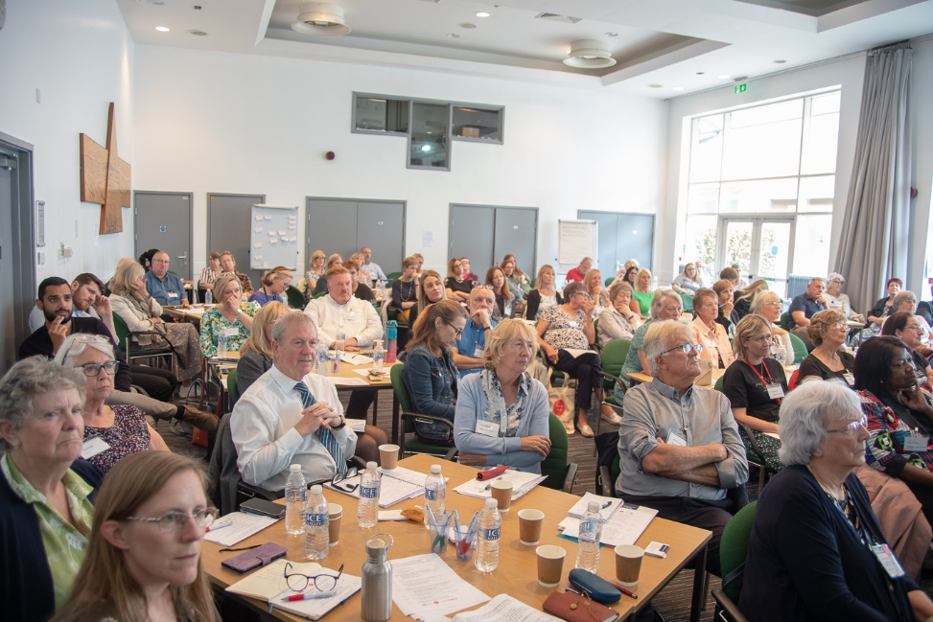
Packed out workshop at Warwick University’s conference centre (Wellesbourne campus)
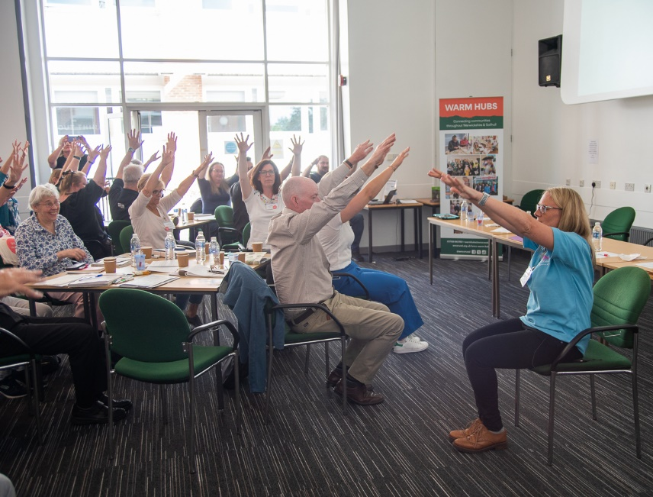
Think Active’s seated exercise taster session!

NOTES TO EDITORS
WARM HUBS PROJECT
WRCC’s Warm Hubs project, supported by Cadent, helps communities tackle social isolation and fuel poverty throughout Warwickshire and Solihull. Our charity works with community groups, venues and community supporters to create a network of inclusive, community led Warm Hubs, running activities that encourage people to come together in safe, warm, welcoming places. With this network at the heart of our project, we are also encouraging community groups and organisations to collaborate more closely to support communities across this region.

In addition to our Warm Hubs network, from 22nd September 2023 WRCC will be launching a new round of Winter Warm Hubs funding, and we are also running a series of funded slow cooking courses (thanks to a collaboration between Cadent and Warwickshire County Council). Our charity is launching a free online map which will list as many community hubs as possible across Warwickshire and Solihull in addition to existing permanent WRCC endorsed Warm Hubs and upcoming Winter Warm Hubs.

WRCC also runs a free Mobile Warm Hub service, which runs free community cafes during the summer season, and will be working more closely with Community Food Forum initiatives during Winter 2023/24.

To find out more about the Warm Hubs, Winter Warm Hubs, and the Mobile Warm Hub service, please visit www.wrccrural.org.uk/wrcc-warm-hubs.
Or contact Jackie Holcroft, Warm Hubs Project Manager: tel: 01789 472614/07523 911394 or email: jackieh@wrccrural.org.uk
WRCC
WRCC (Warwickshire Rural Community Council) is a charity which has been working to support communities in Warwickshire (and Solihull) for 85 years – to help them become thriving, vibrant and sustainable places where people want to live and work.
The charity’s core services include managing the Warm Hubs project in Warwickshire and Solihull, running its Back&4th community transport service, advising village hall committees, managing an oil syndicate, supporting affordable housing projects, and running its newly set up “Meals on Wheels” service - Community Food Fleet. WRCC is also a member of the ACRE Network (Action with Communities in Rural England).

------------------------------------------------------------------------------------------------------------------------------------------------
WRCC, Warwick Enterprise Park, Wellesbourne, Warwick CV35 9EF
Tel: 01789 842182 enquiries@wrccrural.org.uk www.wrccrural.org.uk
WRCC (Warwickshire Rural Community Council) is a registered charity No.1081017
and a Company Limited by Guarantee in England and Wales No. 3930819

