PRESS RELEASE
Monday 5th June 2023
WOLVEY COMMUNITY WELCOMES NEW WARM HUB

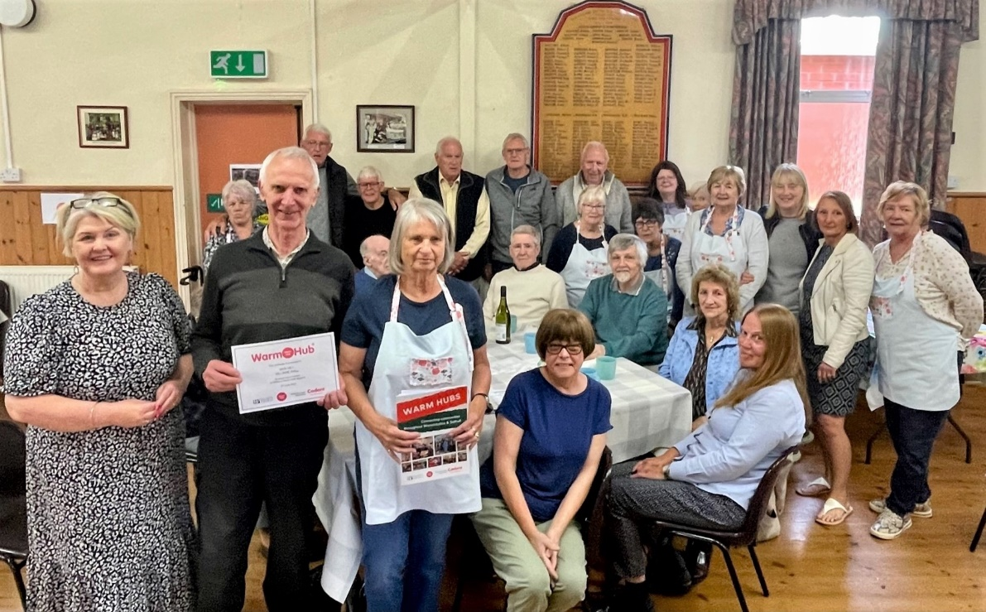

Front (l-r) Anne White, WRCC (Warwickshire Rural Community Council) with John Hardman, Hilary Fisher and Barbara Jones from Wolvey Village Hall, with Wolvey volunteers and residents at their Warm Hub launch event
Over 100 people gathered at Wolvey Village Hall last Friday to celebrate the official launch of their Warm Hub at their monthly coffee morning. It was wonderful to see such an inclusive community event, with a non stop buzz of conversation, tables full of cakes and treats baked by the dedicated volunteers, and even a fairy light decorated play room for younger ones enjoying dinosaur toys, play tents and plenty of messy craft fun!
Becoming a member of the Warm Hubs network (which extends across Warwickshire and Solihull) means that Village Hall volunteers can collaborate more closely with rural charity WRCC, with access to energy support and advice, signposting to other community services, and networking with other Warm Hubs all being available. Slow cooking courses and more community transport support are other options on the menu as well. Warm Hubs are safe, welcoming and happy places and Wolvey is a great example of this community spirit in action.

Regular Phil Bassett commented: “It’s a great social event where you can meet people and support the village. Our volunteers are brilliant and they do everything, as well as organising lots
of other local activities too.” All local people are very welcome to come along to the Warm Hub coffee morning, which runs from 10.30am – 12.30pm on the first Friday of every month.

John Hardman, a member of the volunteering team which also includes Hilary Fisher and Barbara Jones, said: “We’re delighted to run this successful event that brings together so many people, of all ages, to socialise and enjoy activities on a regular basis. We’re also keen to introduce new things to do so if you have any ideas that can benefit our community, please let us know!”
Jackie Holcroft, WRCC Warm Hubs Manager, added, “Congratulations to John and all the volunteers at Wolvey Village Hall for running such an amazing event that’s a real community asset. We’re very pleased to welcome Wolvey to our network of Warm Hubs and look forward to working with you for a long time to come.””
Wolvey Warm Hub runs on the first Friday of every month from 10.30am – 12.30pm at Wolvey Village Hall, The Square, Wolvey, LE10 3LJ. For more information, please email admin@wolveyvillagehall.co.uk

For more information about WRCC’s Warm Hubs project, please visit: www.wrccrural.org.uk/wrcc-warm-hubs

ENDS
------------------------------------------------------------------------------------------------------------------------------------------------
Additional photo 1: child’s play at Wolvey Warm Hub
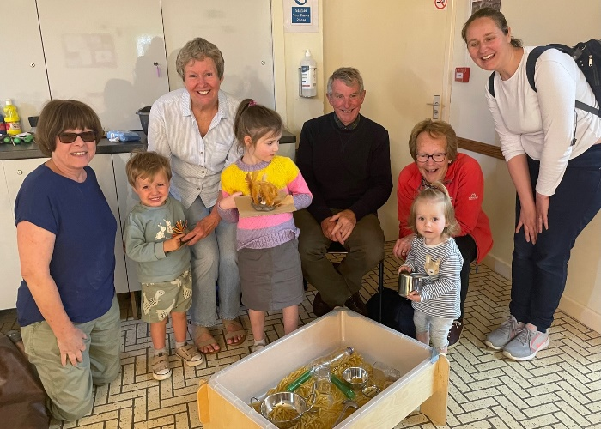

Additional photo 2: cakes and treats from Wolvey Village Hall volunteers

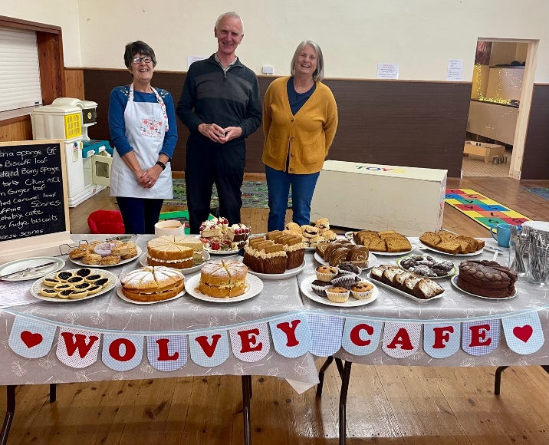

NOTES TO EDITORS - WARM HUBS PROJECT
WRCC’s Warm Hubs project, supported by Cadent, helps communities tackle social isolation and fuel poverty throughout Warwickshire and Solihull. Since November 2020, our charity has worked with parish councils, town councils, village hall committees and other volunteer and community groups to create inclusive, community led Warm Hubs, running activities that encourage people to come together in safe, warm, welcoming places.

We provide support via our expanding network of Warm Hubs run by local community volunteers, our Winter Warm Hubs initiative (which involved 92 hubs and ran from October 2022 - March 2023), and our Mobile Warm Hub service which runs free community cafes around Warwickshire and Solihull.

WRCC also organises energy themed events, promotes energy efficient and cost saving measures to help people stay safe and warm at home – including free energy information packs and carbon monoxide alarms – and are developing additional resources to help residents and venues, including Slow Cooker Courses and Warm Hub Energy Champion training.

To find out more, please visit www.wrccrural.org.uk/wrcc-warm-hubs. We are currently updating our network of Warm Hubs as several of our Winter Warm Hubs now want to become permanent Warm Hubs. We will also be providing further information about Warm Hubs once the evaluation process of our report (see above) has been completed.

For more information, please contact Jackie Holcroft, WRCC Energy, Sustainability and Warm Hubs Manager, on 01789 842182/07523 911394 or via email: jackieh@wrccrural.org.uk

WRCC
WRCC (Warwickshire Rural Community Council) is a charity which has been working to support vital villages in Warwickshire (and Solihull) for 85 years. The charity’s mission is to help rural communities become thriving, vibrant and sustainable places where people want to live and work. The charity’s core services include managing the Warm Hubs project in Warwickshire and Solihull, running its Back&4th community transport service, advising village hall committees, managing an oil syndicate and supporting affordable housing projects. WRCC is also a member of the ACRE Network (Action with Communities in Rural England).

------------------------------------------------------------------------------------------------------------------------------------------------
WRCC, Warwick Enterprise Park, Wellesbourne, Warwick CV35 9EF
Tel: 01789 842182 enquiries@wrccrural.org.uk www.wrccrural.org.uk
WRCC (Warwickshire Rural Community Council) is a registered charity No.1081017
and a Company Limited by Guarantee in England and Wales No. 3930819

