PRESS RELEASE
Tuesday 23rd May 2023
LIGHTHORNE HEATH LAUNCHES COMMUNITY WARM HUB

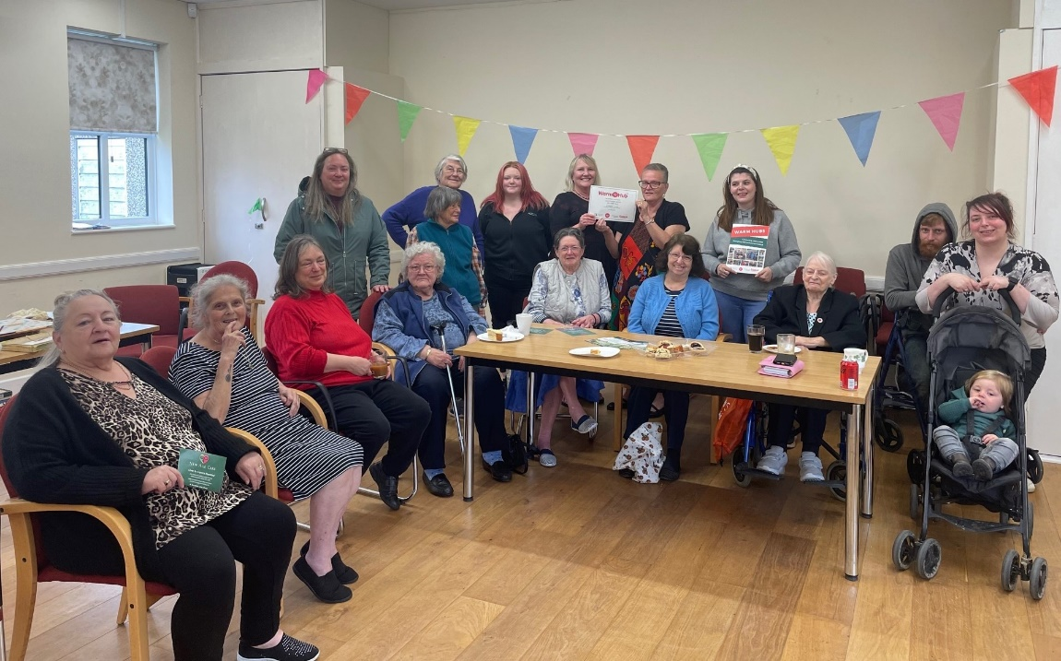

Lighthorne Heath residents and volunteers of all ages celebrating their new Warm Hub at the Village Hall
There were smiles all round last week as Lighthorne Heath residents celebrated the official launch of their permanent Warm Hub with delicious scones, cakes and coffee … and straight away started making plans for the future! Thanks to a cost of living grant from WCC and ongoing support from rural charity WRCC, the hub will now be running all year round and has become the newest member of WRCC’s community Warm Hubs network in Warwickshire and Solihull.
All locals are welcome to come along to the weekly event, which runs from 11.00am – 2.00pm every Tuesday, and a good chat is always guaranteed. WRCC Warm Hubs are safe, friendly and welcoming places where people can meet up with others, enjoy refreshments and get access to energy saving and home safety advice, plus signposting to community support services.
As well as being a friendly place to meet new people, there’s lots more going on at Lighthorne Heath’s Warm Hub. Recent visitors have included the British Motor Museum, Warwickshire Fire and Rescue, and environmental charity Act on Energy. And coming up, the team behind the hub are planning lots more to do this summer, with more slow cooking sessions at different times, day trips out, and the chance to “grow your own” veg as well.
Yvonne Liddell, Warm Hub organiser, said: “We’re delighted that this fantastic event will now be running all year round, and if you haven’t visited us yet, just drop in any Tuesday to find out more! The more the merrier – and if you’d like to get involved as a volunteer and help us to help our community, we’d love to hear from you too”.

Jackie Holcroft, WRCC Warm Hubs Manager, added, “Congratulations to Yvonne and all the team for getting this great event up and running so well. We’re excited to welcome Lighthorne Heath as to our network of Warm Hubs and look forward to working with you for a very long time to come!”
Emma Hills, Trustgreen Community Champion who helps to support local community spaces, said: “It’s been a privilege to work in partnership with the amazing Village Hall volunteers and WRCC, and to see the community come together in this way to establish a warm and welcoming permanent hub.”
Lighthorne Heath Warm Hub runs every Tuesday from 11.00am – 2.00pm at Lighthorne Heath Village Hall, Valiant Close, Lighthorne Heath CV33 9UF.

For more information, and to find out about booking a place on the next slow cooking course, please email info@lighthorneheathvillagehall.org.uk

For more information about WRCC’s Warm Hubs project, please visit: www.wrccrural.org.uk/wrcc-warm-hubs

To find out more about Trustgreen, please visit www.trustgreen.com

ENDS
------------------------------------------------------------------------------------------------------------------------------------------------
Additional photo 1: previous slow cooking course at Lightwood Heath Warm Hub, with Yvonne Liddell (second from left) and Emma Hills (right) and local residents
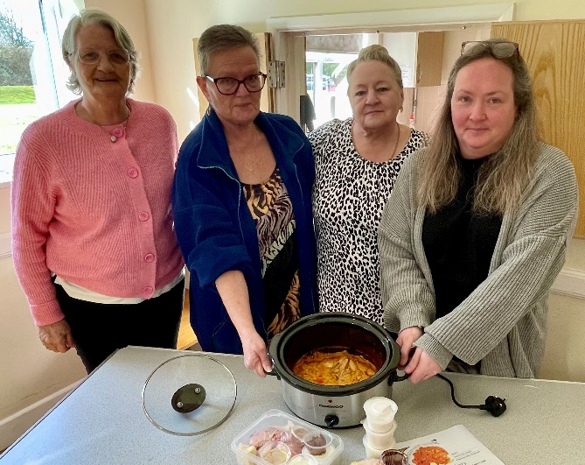

NOTES TO EDITORS - WARM HUBS PROJECT
WRCC’s Warm Hubs project, supported by Cadent, helps communities tackle social isolation and fuel poverty throughout Warwickshire and Solihull. Since November 2020, our charity has worked with parish councils, town councils, village hall committees and other volunteer and community groups to create inclusive, community led Warm Hubs, running activities that encourage people to come together in safe, warm, welcoming places. We provide support via our expanding network of Warm Hubs run by local community volunteers, our Winter Warm Hubs initiative (which ran from

October 2022 - March 2023) and our Mobile Warm Hub service which runs free community cafes around Warwickshire and Solihull.

WRCC also organises energy themed events, promote energy efficient and cost saving measures to help people stay safe and warm at home – including free energy information packs and carbon monoxide alarms – and are developing additional resources to help residents and venues,
including Slow Cooker Courses and Warm Hub Energy Champion training.

To find out more, please visit www.wrccrural.org.uk/wrcc-warm-hubs. We are currently updating our network of Warm Hubs as several of our Winter Warm Hubs now want to become permanent Warm Hubs. We also hope to provide further information about our Winter Warm Hubs initiative once the evaluation process has been completed. For more information, please contact Jackie Holcroft, WRCC Energy, Sustainability and Warm Hubs Manager, on 01789 842182/07523 911394 or via email: jackieh@wrccrural.org.uk

WRCC
WRCC (Warwickshire Rural Community Council) is a charity which has been working to support vital villages in Warwickshire (and Solihull) for 85 years. The charity’s mission is to help rural communities become thriving, vibrant and sustainable places where people want to live and work. The charity’s core services include managing the Warm Hubs project in Warwickshire and Solihull, running its Back&4th community transport service, advising village hall committees, managing an oil syndicate and supporting affordable housing projects. WRCC is also a member of the ACRE Network (Action with Communities in Rural England).

------------------------------------------------------------------------------------------------------------------------------------------------
WRCC, Warwick Enterprise Park, Wellesbourne, Warwick CV35 9EF
Tel: 01789 842182 enquiries@wrccrural.org.uk www.wrccrural.org.uk
WRCC (Warwickshire Rural Community Council) is a registered charity No.1081017
and a Company Limited by Guarantee in England and Wales No. 3930819

