PRESS RELEASE
Tuesday 2nd May 2023
KENILWORTH LAUNCHES NEW COMMUNITY WARM HUB

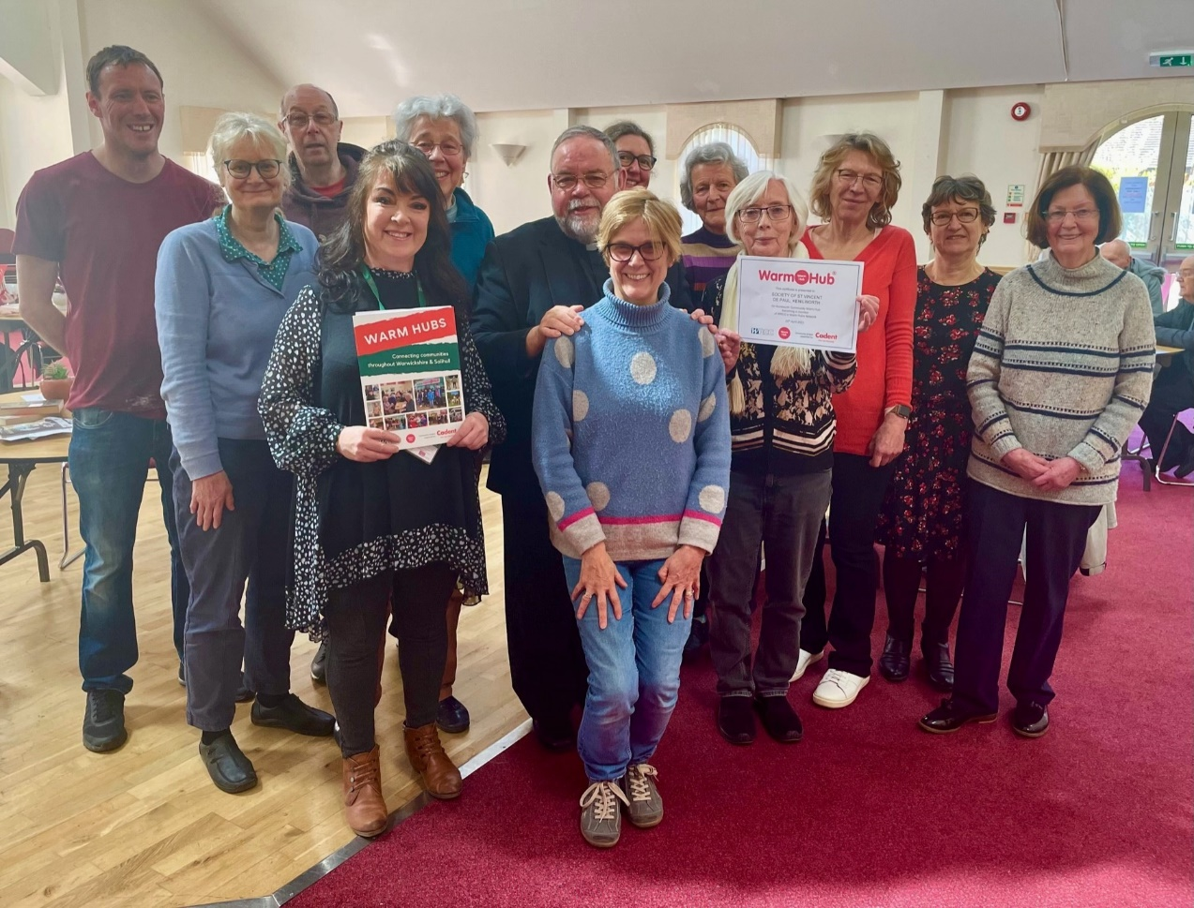

Photo: Residents and volunteers from St Vincent de Paul Society (Kenilworth) celebrating the launch of their new Community Warm Hub with (front L-R) Sue Greenway (WRCC Warm Hubs) and Pauline Hayward (Compassionate Kenilworth)
Over 40 Kenilworth residents and volunteers came together last week for the official launch of the town’s new Community Warm Hub at St Francis of Assisi’s Church. Delicious free scones, cakes and home made sausage rolls were all on the menu, and everyone was delighted that the previous Winter hub had now become a permanent year round social event in the heart of Kenilworth. Regular attendee Pat was one of those celebrating: “I like the friendliness and enjoy the company as I can get lonely at home,” she said. “It’s good for mental health, which is really important.”
Thanks to the dedicated volunteers from Kenilworth’s St Vincent de Paul Society (SVP), the Warm Hub will continue to offer free refreshments, crafts, board games and books for all ages - as well as visits from a wide range of community services and other organisations. Previous visitors have included social prescribers, community police, Fire and Rescue Services, Cadent Gas (who support the Warm Hubs project) and the British Motor Museum. People will also still be able to get information on energy saving tips, home safety and access to other help they may need with the costs of living. And everyone’s welcome to come along!

As Sheila MacMahon from SVP Kenilworth pointed out, it’s very much a group effort: “We’re grateful for all our supporters’ help: for the ongoing support and advice from WRCC’s Warm Hubs team and Compassionate Kenilworth’s volunteers; for Fr Kevin Hooper and the parish for providing this lovely venue free of charge; and for a generous cost of living grant from Warwick District Council. Not forgetting the tasty bacon sandwiches and sausage rolls served up by our chef, Alistair Lewis! It’s fantastic to see the difference we can make when everyone comes together to help like this.”
“Congratulations to all the Kenilworth SVP team on the launch of their Community Warm Hub!” added Jackie Holcroft, WRCC Warm Hubs Manager. “Hubs like these have an important part to play all year round – people need safe, inclusive “happy places” where they know they’ll be warmly welcomed and feel part of a community. We’re delighted to welcome Kenilworth to our growing network of Warm Hubs across Warwickshire and Solihull.”
“We’re thrilled to have helped support Kenilworth’s new Warm Hub,” said Pauline Hayward from Compassionate Kenilworth. “Bringing people together in a lovely, friendly place like this builds community spirit and connections. And after all, having a good chat over a cup of coffee and making time to relax with friends is so important for all of us!”
Kenilworth’s Community Warm Hub runs every Tuesday from 10.00 am – 12.00 noon at St Francis of Assisi Church, 110 Warwick Road, Kenilworth CV8 1HL. For more information, please email svp@kenilworthcatholic.org.uk

For more information about WRCC’s Warm Hubs project, please visit: www.wrccrural.org.uk/wrcc-warm-hubs

To find out about other hubs and community activities in Kenilworth, please visit www.compassionatekenilworth.co.uk/projects-1

ENDS
------------------------------------------------------------------------------------------------------------------------------------------------
Additional photo 1: keen crafters at Kenilworth’s Community Warm Hub
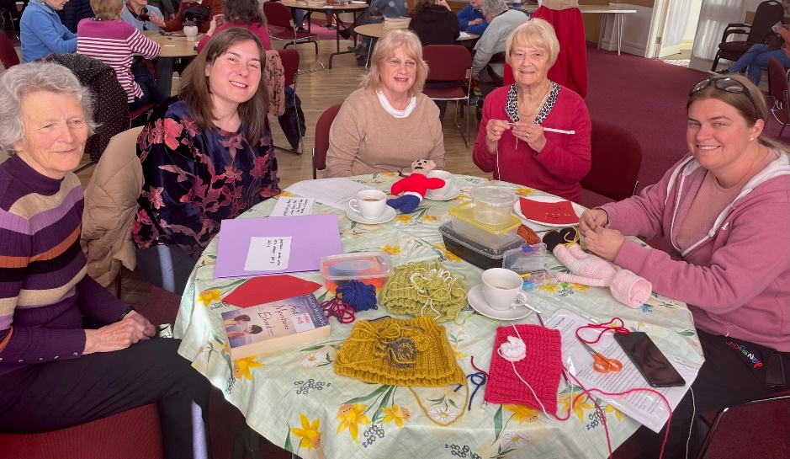

Additional photo 2: Ali Lewis and Pauline Haywood sampling the sausage rolls!

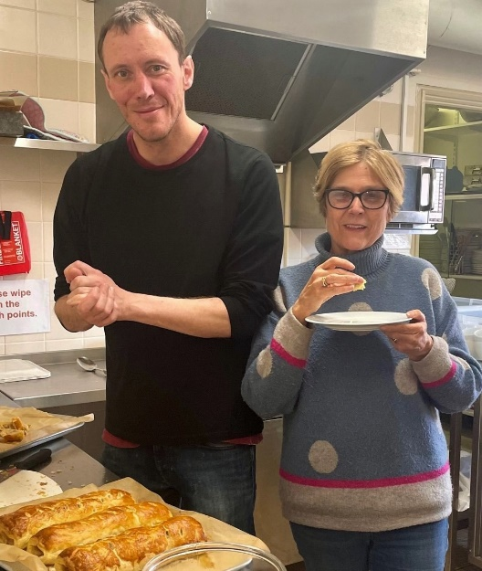

Additional photo 3: residents enjoying a chat over coffee and cake

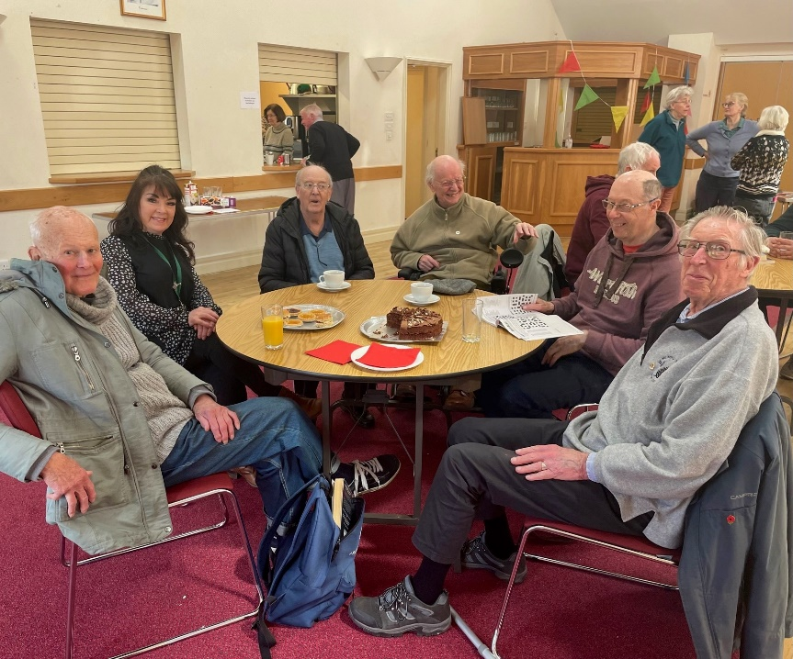

NOTES TO EDITORS
WARM HUBS PROJECT
WRCC’s Warm Hubs project, supported by Cadent, helps communities tackle social isolation and fuel poverty throughout Warwickshire and Solihull. Since November 2020, our charity has worked with parish councils, town councils, village hall committees and other volunteer and community groups to create inclusive, community led Warm Hubs, running activities that encourage people to come together in safe, warm, welcoming places. We provide support via our expanding network of Warm Hubs run by local community volunteers, our Winter Warm Hubs initiative (which ran from

October 2022 - March 2023) and our Mobile Warm Hub service which runs free community cafes around Warwickshire and Solihull.

WRCC also organises energy themed events, promotes energy efficient and cost saving measures to help people stay safe and warm at home – including free energy information packs and carbon monoxide alarms – and is developing additional resources to help residents and venues, including Slow Cooker Courses and Warm Hub Energy Champion training.

To find out more about Warm Hubs and the Mobile Warm Hub, please visit www.wrccrural.org.uk/wrcc-warm-hubs. We are currently updating our network of Warm Hubs as many of our Winter Warm Hubs now want to become permanent Warm Hubs. We also hope to provide further information about our Winter Warm Hubs initiative once the evaluation process has been completed.

For more information, please contact Jackie Holcroft, WRCC Energy, Sustainability and Warm Hubs Manager, on 01789 842182/07523 911394 or via email: jackieh@wrccrural.org.uk
WRCC
WRCC (Warwickshire Rural Community Council) is a charity which has been working to support vital villages in Warwickshire (and Solihull) for 85 years. The charity’s mission is to help rural communities become thriving, vibrant and sustainable places where people want to live and work. The charity’s core services include managing the Warm Hubs project in Warwickshire and Solihull, running its Back&4th community transport service, advising village hall committees via Halls Together (run in conjunction with Leicester RCC), managing an oil syndicate and supporting affordable housing projects. WRCC is also a member of the ACRE Network (Action with Communities in Rural England).

------------------------------------------------------------------------------------------------------------------------------------------------
WRCC, Warwick Enterprise Park, Wellesbourne, Warwick CV35 9EF
Tel: 01789 842182 enquiries@wrccrural.org.uk www.wrccrural.org.uk

WRCC (Warwickshire Rural Community Council) is a registered charity No.1081017
and a Company Limited by Guarantee in England and Wales No. 3930819

