PRESS RELEASE
Tuesday 20th June 2023
BENN PARTNERSHIP CENTRE BECOMES
RUGBY’S FIRST PERMANENT WARM HUB

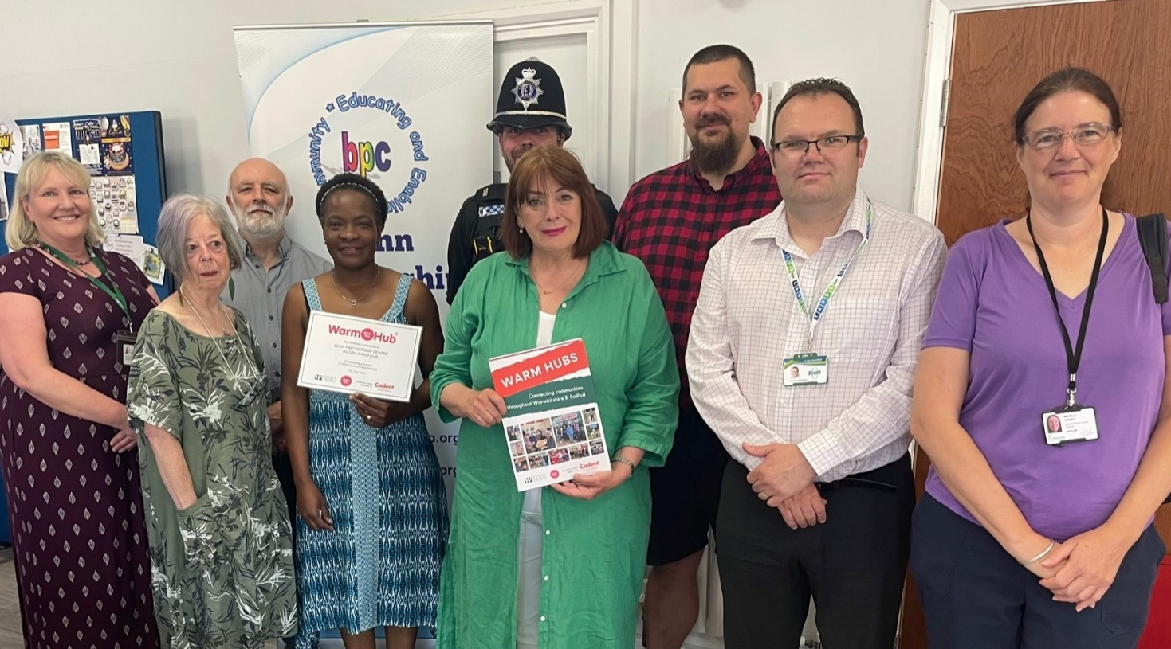

Front row, [L-R] Benn Partnership Centre Trustee Joyce Woodings and Centre Manager Vivien Kajoro, with Councilor Maggie O’Rourke, Mayor of Rugby, Councillor Richard Harrington, Michelle Gravatt, WCC. Back row [L-R] Jackie Holcroft, WRCC, Andy Littlewood, NEA, Rugby PC Guy Mountford, Dean Hamilton, WRCC.
The Benn Partnership Centre team were joined by the Mayor of Rugby and community representatives, including rural charity WRCC (Warwickshire Rural Community Council) and fuel poverty charity National Energy Action, to celebrate the Centre’s official launch as a permanent Rugby Warm Hub last Thursday. The welcome was as warm as the weather, and it was a great opportunity to recognise the amazing work carried out by the team and their future plans for the community.

Councillor Maggie O’Rourke, Mayor of Rugby, said: “It’s so important for Rugby residents to have safe, inclusive community places like the Benn Partnership Centre, where they can connect with others and be signposted to a wide range of services. Congratulations to the Centre for becoming a permanent community Warm Hub!”

Becoming a member of WRCC’s Warm Hubs network (which extends across Warwickshire and Solihull) means that the Benn Partnership Centre can access more support with Community Energy Champion training, more community transport support and extra slow cookers all being on the menu! The Centre is also planning to launch a free community café on Friday mornings.

Vivien Kajoro, Benn Partnership Centre Manager, added:

“We’re thrilled to work with WRCC, to offer services all year round to the most vulnerable people of our community. We’re open every day of the week and everyone is welcome to drop in for a chat. We’ll help you with IT, filling in forms and signpost you to others for more help where needed. Our social group and friendly volunteers meet up on Mondays, Tuesdays and Wednesdays from 10:00am to 1:00pm – why not join us for a free cuppa and cookies, or even stop for lunch? We also host community groups like our Thursday Art Group run by Rugby Art Gallery and Museum - and If you’d like to start a social group and teach us new skills, we have free rooms every Friday. We look forward to seeing you!”
Jackie Holcroft, WRCC Warm Hubs Manager, concluded, “We’re delighted to welcome the Benn Partnership Centre as a new member of WRCC’s Warm Hubs network. The Centre is a real community asset and the fantastic team here do so much to support people in Rugby. We look forward to collaborating with you for a long time to come.””
The Benn Partnership Centre, Railway Terrace, Rugby CV21 3HR is open daily from 9.00am – 5.00pm. For more information, please email info@bennpartnership.org.uk

For more information about WRCC’s Warm Hubs project, please visit: www.wrccrural.org.uk/wrcc-warm-hubs

ENDS

------------------------------------------------------------------------------------------------------------------------------------------------
Additional photo 1: the Benn Partnership Centre team
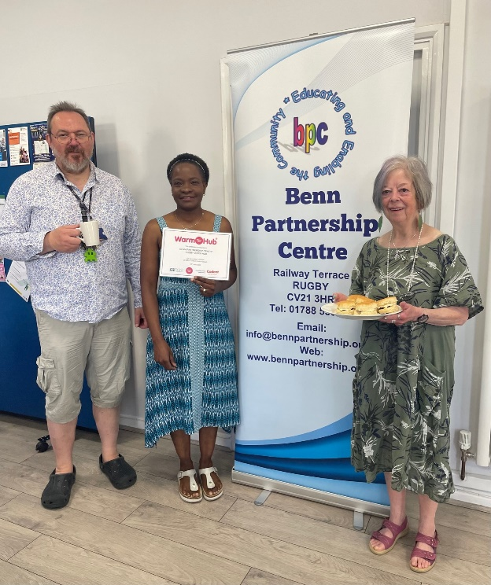

NOTES TO EDITORS - WARM HUBS PROJECT
WRCC’s Warm Hubs project, supported by Cadent, helps communities tackle social isolation and fuel poverty throughout Warwickshire and Solihull. Since November 2020, our charity has worked with parish councils, town councils, village hall committees and other volunteer and community groups to create inclusive, community led Warm Hubs, running activities that encourage people to come together in safe, warm, welcoming places.

We provide support via our expanding network of Warm Hubs run by local community volunteers, our Winter Warm Hubs initiative (which involved 92 hubs and ran from October 2022 - March 2023), and our Mobile Warm Hub service which runs free community cafes around Warwickshire and Solihull.

WRCC also organises energy themed events, promotes energy efficient and cost saving measures to help people stay safe and warm at home – including free energy information packs and carbon monoxide alarms – and are developing additional resources to help residents and venues, including Slow Cooker Courses and Warm Hub Energy Champion training.

To find out more, please visit www.wrccrural.org.uk/wrcc-warm-hubs. We are currently updating our network of Warm Hubs as several of our Winter Warm Hubs now want to become permanent Warm Hubs. We will also be providing further information about Warm Hubs once the evaluation process of our report (see above) has been completed.

For more information, please contact Jackie Holcroft, WRCC Energy, Sustainability and Warm Hubs Manager, on 01789 842182/07523 911394 or via email: jackieh@wrccrural.org.uk

WRCC
WRCC (Warwickshire Rural Community Council) is a charity which has been working to support vital villages in Warwickshire (and Solihull) for 85 years. The charity’s mission is to help rural communities become thriving, vibrant and sustainable places where people want to live and work. The charity’s core services include managing the Warm Hubs project in Warwickshire and Solihull, running its Back&4th community transport service, advising village hall committees, managing an oil syndicate and supporting affordable housing projects. WRCC is also a member of the ACRE Network (Action with Communities in Rural England).

------------------------------------------------------------------------------------------------------------------------------------------------
WRCC, Warwick Enterprise Park, Wellesbourne, Warwick CV35 9EF
Tel: 01789 842182 enquiries@wrccrural.org.uk www.wrccrural.org.uk
WRCC (Warwickshire Rural Community Council) is a registered charity No.1081017
and a Company Limited by Guarantee in England and Wales No. 3930819

