PRESS RELEASE
19th June 2023
CAKES AND CHEER FOR NEW BAGINTON WARM HUB!

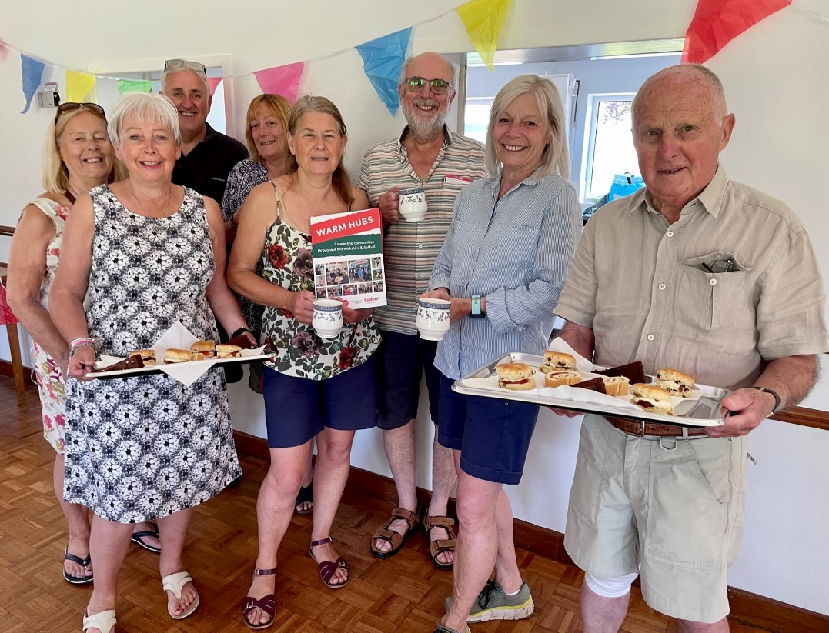

Front (l) Lucy Jones with the team of volunteers from Baginton Village Hall and cakes at the ready at their summer Warm Hub launch event
Nearly forty local residents and cake lovers gathered at Baginton Village Hall last Tuesday to celebrate the official launch of their Warm Hub. There was a lively buzz of conversation all morning and it’s like this every week according to Lucy Jones, the Hall Committee Member who started the community café at the beginning of November. Since then, she and her team of friendly volunteers have seen it go from strength to strength as a popular meeting place.
“It all began when we applied for a small Winter Warm Hub grant from rural charity WRCC to get our free community café up and running,” said Lucy. “And after seven months, it’s become part of village life for our lovely regulars! We’re now pleased to become a permanent WRCC accredited Warm Hub, which will give us access to a range of support and advice from their Warwickshire network.”
Dave Horsley brings his 89 year old mum, Nora, to the Warm Hub café and she wouldn’t miss it for the world. “It’s her favourite day of the week and it makes my life so much easier as well,” explained Dave. Their family in Baginton have close ties with the Village Hall and although Nora has dementia, it’s somewhere she always feels at home.
The community event is also supported by other organisations with a local interest - Buckingham, a construction company working in the area, and Reidy’s Fruit and Veg, who have a stall at The Oak in Baginton every Wednesday.

Jackie Holcroft, WRCC Warm Hubs Manager, added, “Congratulations to Lucy and her team of volunteers for creating this fantastic event that’s filled with community warmth. We’re delighted to welcome Baginton to our network of Warm Hubs and look forward to working with you for a long time to come.””
Baginton Warm Hub runs every Tuesday from 10.00 am – 12.00p noon at Baginton Village Hall, Frances Road, Baginton CV8 3AB. For more information, please visit www.baginton-village.org.uk

For more information about WRCC’s Warm Hubs project, please visit: www.wrccrural.org.uk/wrcc-warm-hubs

ENDS
------------------------------------------------------------------------------------------------------------------------------------------------
Additional photo 1: Nora and Dave Horsley at the launch event
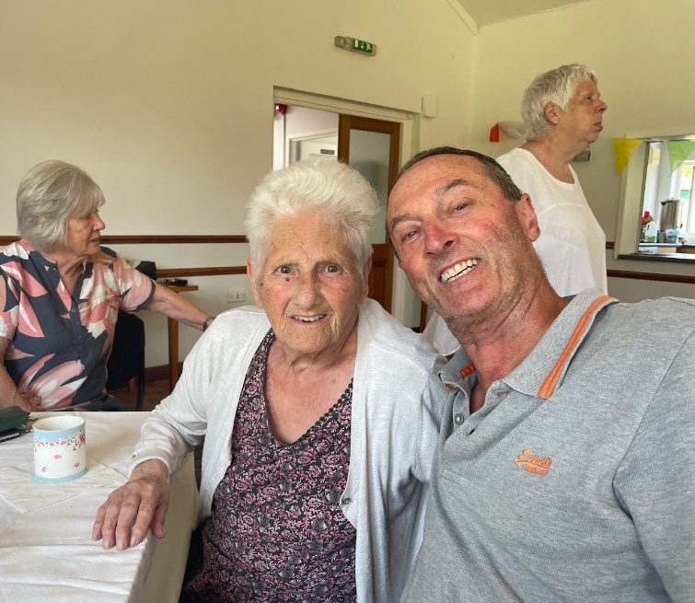

Additional photo 2: Baginton residents celebrating with cups of tea and cake

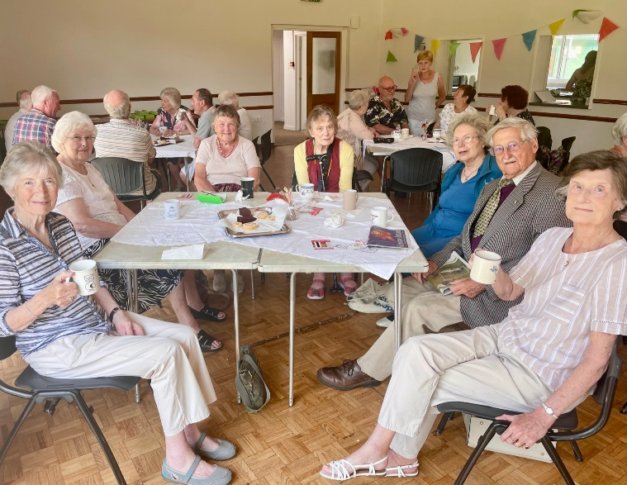

NOTES TO EDITORS - WARM HUBS PROJECT
WRCC’s Warm Hubs project, supported by Cadent, helps communities tackle social isolation and fuel poverty throughout Warwickshire and Solihull. Since November 2020, our charity has worked with parish councils, town councils, village hall committees and other volunteer and community groups to create inclusive, community led Warm Hubs, running activities that encourage people to come together in safe, warm, welcoming places.

We provide support via our expanding network of Warm Hubs run by local community volunteers, our Winter Warm Hubs initiative (which involved 92 hubs and ran from October 2022 - March 2023), and our Mobile Warm Hub service which runs free community cafes around Warwickshire and Solihull.

WRCC also organises energy themed events, promotes energy efficient and cost saving measures to help people stay safe and warm at home – including free energy information packs and carbon monoxide alarms – and are developing additional resources to help residents and venues, including Slow Cooker Courses and Warm Hub Energy Champion training.

To find out more, please visit www.wrccrural.org.uk/wrcc-warm-hubs. We are currently updating our network of Warm Hubs as several of our former Winter Warm Hubs now want to become permanent Warm Hubs. We will also shortly be providing further information about Warm Hubs once the evaluation process of our report (see above) has been completed.

For more information, please contact Jackie Holcroft, WRCC Energy, Sustainability and Warm Hubs Manager, on 01789 842182/07523 911394 or via email: jackieh@wrccrural.org.uk

WRCC
WRCC (Warwickshire Rural Community Council) is a charity which has been working to support vital villages in Warwickshire (and Solihull) for 85 years. The charity’s mission is to help rural communities become thriving, vibrant and sustainable places where people want to live and work. The charity’s core services include managing the Warm Hubs project in Warwickshire and Solihull, running its Back&4th community transport service, advising village hall committees, managing an oil syndicate and supporting affordable housing projects. WRCC is also a member of the ACRE Network (Action with Communities in Rural England).

------------------------------------------------------------------------------------------------------------------------------------------------
WRCC, Warwick Enterprise Park, Wellesbourne, Warwick CV35 9EF
Tel: 01789 842182 enquiries@wrccrural.org.uk www.wrccrural.org.uk
WRCC (Warwickshire Rural Community Council) is a registered charity No.1081017
and a Company Limited by Guarantee in England and Wales No. 3930819

