PRESS RELEASE
Monday 22nd May 2023
ATHERSTONE WELCOMES NEW COMMUNITY WARM HUB!

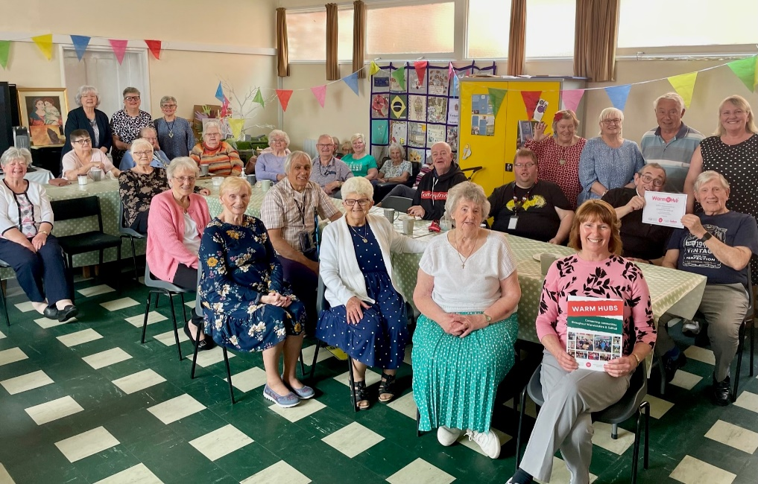

Local residents and volunteers at North Warwickshire 50+ Lunch Club, with representatives from rural charity WRCC, celebrating the launch of Atherstone’s new Warm Hub
There was a fabulous Friday feeling in the air at St Benedict’s Community Hall in Atherstone last week as North Warwickshire 50+ Lunch Club members celebrated becoming the newest member of WRCC’s community Warm Hubs network in Warwickshire and Solihull. After a lively seated exercise class, with tapping toes and maracca shaking to music, the celebrations continued with sandwiches, scones and cake for everyone before it was eyes down for bingo – and a great time was had by all!
WRCC Warm Hubs are safe, friendly and welcoming places where people can meet up with others, enjoy refreshments and get access to energy saving and home safety advice, plus signposting to community support services if needed. The fantastic 50+ Lunch Club has already run twice weekly for 17 years in Atherstone and is an important community resource for local people. Members pay a nominal £1 per session, and in return receive free refreshments and activities, plus subsidised day trips and special functions – all agreed by members in advance.
A new Atherstone Warm Hub initiative is slow cooking courses which are taking place this June and July. Members sign up for four weekly sessions, enjoy a cooking demonstration, and receive a free slow cooker and ingredients to make each recipe. Diane Hall, who’s been a regular at the Lunch Club for several years, is really looking forward to trying the new course. She comes to the hall every Friday to get out of the house and do activities with other people – “I’ve made a lot of friends here,” she said.
Brian Ingram, who organises the event along with his wife, Margaret, said: “We very much look forward to this new relationship with Warwickshire Rural Community Council, and hope that going

forward we can become net contributors to the fantastic work the Warm Hubs network undertakes.”

Jackie Holcroft, WRCC Warm Hubs Manager, added, “Congratulations to Brian, Margaret and all the enthusiastic volunteers who run this established event so successfully - we’ve really enjoyed our morning with your members! We’re delighted to welcome North Warwickshire 50+ Lunch Club to our growing network of Warm Hubs, and look forward to collaborating with you to help support your local community.”
Atherstone Warm Hub North Warwickshire 50+ Lunch Club runs every Tuesday and Friday from 10.30am – 1.30pm at St Benedict’s Community Hall, 7 Owen Street, Atherstone CV9 1DG.

New members are welcome and you can become a member if you’re younger too! For more information and to find out about booking a place on the next slow cooking course, please email
brianingramocds@gmail.com

For more information about WRCC’s Warm Hubs project, please visit: www.wrccrural.org.uk/wrcc-warm-hubs

ENDS
------------------------------------------------------------------------------------------------------------------------------------------------

NOTES TO EDITORS - WARM HUBS PROJECT
WRCC’s Warm Hubs project, supported by Cadent, helps communities tackle social isolation and fuel poverty throughout Warwickshire and Solihull. Since November 2020, our charity has worked with parish councils, town councils, village hall committees and other volunteer and community groups to create inclusive, community led Warm Hubs, running activities that encourage people to come together in safe, warm, welcoming places. We provide support via our expanding network of Warm Hubs run by local community volunteers, our Winter Warm Hubs initiative (which ran from October 2022 - March 2023) and our Mobile Warm Hub service which runs free community cafes around Warwickshire and Solihull.

WRCC also organises energy themed events, promote energy efficient and cost saving measures to help people stay safe and warm at home – including free energy information packs and carbon monoxide alarms – and are developing additional resources to help residents and venues,
including Slow Cooker Courses and Warm Hub Energy Champion training.

To find out more, please visit www.wrccrural.org.uk/wrcc-warm-hubs. We are currently updating our network of Warm Hubs as several of our Winter Warm Hubs now want to become permanent Warm Hubs. We also hope to provide further information about our Winter Warm Hubs initiative once the evaluation process has been completed. For more information, please contact Jackie Holcroft, WRCC Energy, Sustainability and Warm Hubs Manager, on 01789 842182/07523 911394 or via email: jackieh@wrccrural.org.uk

WRCC
WRCC (Warwickshire Rural Community Council) is a charity which has been working to support vital villages in Warwickshire (and Solihull) for 85 years. The charity’s mission is to help rural communities become thriving, vibrant and sustainable places where people want to live and work. The charity’s core services include managing the Warm Hubs project in Warwickshire and Solihull, running its Back&4th community transport service, advising village hall committees, managing an oil syndicate and supporting affordable housing projects. WRCC is also a member of the ACRE Network (Action with Communities in Rural England).

------------------------------------------------------------------------------------------------------------------------------------------------
WRCC, Warwick Enterprise Park, Wellesbourne, Warwick CV35 9EF
Tel: 01789 842182 enquiries@wrccrural.org.uk www.wrccrural.org.uk
WRCC (Warwickshire Rural Community Council) is a registered charity No.1081017
and a Company Limited by Guarantee in England and Wales No. 3930819

