Council
17 October 2022
Title: State of the District
Lead Officer: Melanie Jeffery (01789 267575)
Portfolio Holder/
Lead Member: Councillor T Jefferson

Summary

The State of the District needs to be assessed by the Council. This report summarises the events of the past year, along with an outline of future proposals. It also provides information on the current economic, social and environmental profile of the District.
Recommendation
That the State of the Stratford-on-Avon District is noted, and the issues raised are considered as part of the budget-making process for 2023/24.

Background/Information
  - Stratford-on-Avon District Council’s Constitution stipulates that the Council will debate the State of the District at the Council Meeting in the autumn.
  - The Constitution states that the Leader will decide the form of the debate.
  - The results of the debate will be:
- disseminated as widely as possible within the community and to agencies and organisations in the area;
- considered by the Leader in proposing the Budget and Policy Framework to the Council for 2023/24; and
- considered in the shaping of the Council’s future policies and strategies.

2022 Approach
  - Desk research has been undertaken using a variety of information sources, plus the results of the 2022 Resident’s Survey.
  - The report contains the current State of the District in terms of data and contains information from different sources. It covers many different areas from health to the economy, not all of which Stratford-on-Avon District Council (SDC) can influence. It is important to note that the figures included in the report are from the most relevant data available and reference to events happening at the Council, refer to the year ending 31 March 2022, for the most part.
  - Appendix 1 contains a summary of the State of the District in the form of an infographic.
- Population
Key Facts
Population | 134,700
Change on mid-2020 | +2,300
Median Age | 48.2 years
Density | 138 (people per km²)

3.1
  - Population Size and Profile

    - According to the initial release of the Census 2021 data (at the time of writing much of the Census data had still not been published), the population of Stratford-on-Avon District in March 2021 was estimated to be 134,700. This represents an estimated increase of 2,300, or 1.73%, on mid-2020. As can be seen in Figure 1, increases in population have been much larger since 2015-16.

Figure 1

    - The population of Stratford-on-Avon District is estimated to have increased by 11.8% between 2011-2021. This is the third highest population increase of all authorities within the West Midlands region: only Rugby and Wychavon grew more – by 14.3% and 13.3% respectively. With a growth of 11.8%, Stratford-on-Avon sits in the upper half of all authorities for growth (see Figure 2). Tower Hamlets in London saw the largest growth over the last ten years at 22.1%, with Dartford second with a growth of 20%.

Figure 2
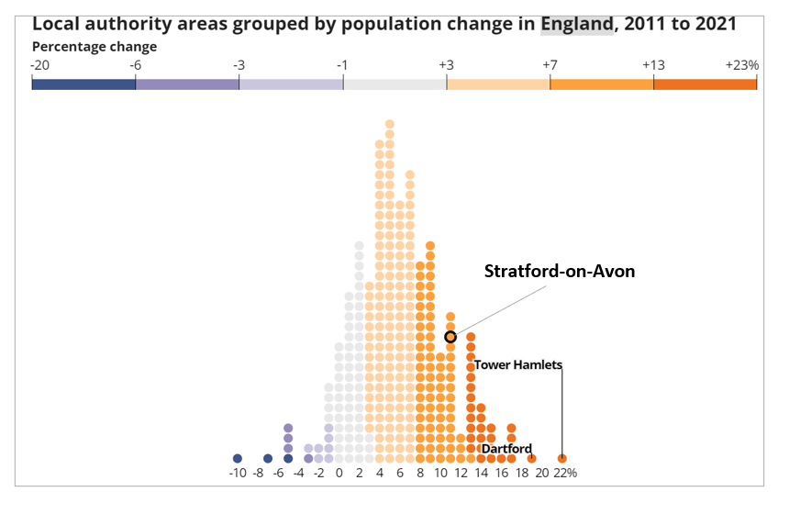
    - The area of Stratford-on-Avon District is 978km², therefore population density mid-2021 was estimated to be 138 people per km². This places SDC in the 20% least densely populated local authorities.
    - Figure 3 shows the estimated demographic breakdown of the District population mid-2021. This shows clearly that the population is heavily weighted towards the older end of the scale. Over 65s make up just over 25% of the population, with 60% aged between 18-64 years, and 15% under 18 years old. There are significantly fewer children and younger adults living in the District compared to the West Midlands region and England as a whole.
    - The median age of the District in 2020 was 48.2 years, while the England median average age was 40 years. This places SDC at 55th oldest authority for median age population, out of 380 authorities across the UK, and fourth highest in the West Midlands after Malvern Hills District Council (50.9 years), Staffordshire Moorlands (49.0 years) and Wychavon (48.4 years). The oldest authority is North Norfolk, with a median age of 54.7 years.
    - The male to female ratio across the population is 48.5% : 51.5%.

Figure 3
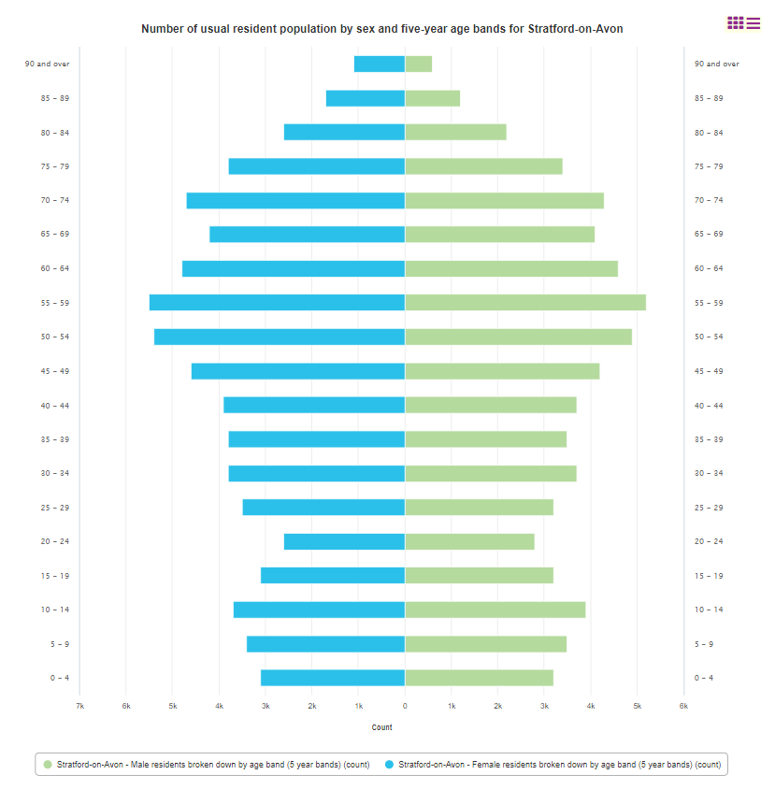
  - Population Projections
    - The population projections produced by ONS have reduced slightly on previous years. Now the ONS figures show that the population of Stratford-on-Avon District is projected to increase by 10,685 by mid-2028 to a total population of 145,385. This represents an increase of 7.93% on 2021.
  - Population by Ward
    - The estimated population across each ward within the District mid-2020 ranges from 2,465 in Clopton Ward to 5,156 in Bridgetown Ward, with the average population per ward at 3,678.

    - Figure 4 shows the estimated changes to ward populations over the past six years, between 2014 and 2020. Welford-on-Avon has seen the greatest estimated population growth over this period of 1,260. Four wards have seen an estimated contraction of population, with Wellesbourne East seeing the greatest contraction of 103 people.
Figure 4

    - Avenue ward had the greatest proportion of working age population as a percentage of total population, with 68% of the population being of working age (16-64 years). Wootton Wawen had the lowest proportion of working age population, at 51% being of working age, and 36% aged 65 years or older.
    - Guildhall had the largest proportion of ‘very old’ population as a percentage of the total ward population, with 15% aged 80 years or older. Tiddington and Shipston South both had 11% of their population aged 80 years or older.
    - Avenue and Quinton wards had the highest proportion of young people, with 21% of the populations aged under 16 years. Welcombe and Guildhall had the lowest proportion of young people in their populations, both at 10%.

- Housing
  - Key facts
Housing Facts
Number of households | 62,200
Median house price | £340,000
Owner occupied | 72.9%
Average household size | 2.3
Number of new dwellings | 1,342

  - Dwelling Numbers
      - According to the Valuation Office list, there were 62,220 properties in the District mid-2021. Of these, the most common dwelling type is a detached house.
      - The housing stock available does not follow the same pattern as Warwickshire or England, as seen in Figure 5. Stratford-on-Avon has more bungalows and detached houses than the Warwickshire or England average, and fewer flats/maisonettes, terraces and semi-detached dwellings.
Figure 5

Table 1: Number of Dwellings by type 2021
 | Stratford-on-Avon |  | Warwickshire |  | England
 | No | % | No | % | No | %
Bungalow | 5,920 | 10 | 21,050 | 8 | 2,295,390 | 9
Flats/Maisonettes | 7,390 | 12 | 39,070 | 15 | 5,888,410 | 24
Terraced | 13,130 | 22 | 64,460 | 25 | 6,502,770 | 27
Semi-Detached | 14,880 | 25 | 72,750 | 28 | 5,900,720 | 24
Detached | 18,410 | 31 | 61,160 | 24 | 3,934,150 | 16

  - House Prices
      - The median house price for the District was £340,000 in the year ending December 2021, well above the England and Warwickshire median of £280,000.
      - The median house price in the District has risen £90,000 or 36% over six years since the year ending December 2014.
      - The lower quartile house price for the District in December 2021 was £254,000 (25% of houses were below this price, 75% above). This is higher than the lower quartile for England of £185,000, and that for Warwickshire of £205,000.
      - The tenth percentile price for the District in March 2022 was £186,500 (10% of houses were below this price, 90% above). This is higher than the tenth percentile price of £125,000 for England and £152,000 for Warwickshire.

      - Figure 6 shows the median house prices for different house types within the District and the average for Warwickshire and England. The median detached price in Stratford-on-Avon is 23.75% higher than the England average and 20.7% higher than the Warwickshire average. The median semi-detached price is 19% higher than the England average, and 15% above the Warwickshire average. Terraced houses are 14% above the England average, and 18% above the Warwickshire average.
Figure 6
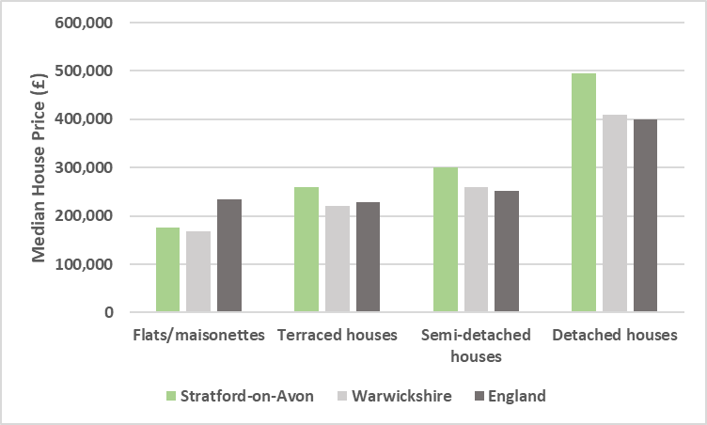

Table 2: Median house price by dwelling type December 2021
 | Stratford-on-Avon | Warwickshire | England
Flats/Maisonettes | £175,000 | £169,000 | £235,000
Terraced | £260,000 | £220,000 | £227,500
Semi-Detached | £300,000 | £260,000 | £252,000
Detached | £495,000 | £410,000 | £400,000

4.3.6 The median monthly rent payable in the District was £795, as seen in Figure 7. This was the third highest rent across the West Midlands, with Solihull and Warwick higher at £850 and £870 respectively.

Figure 7
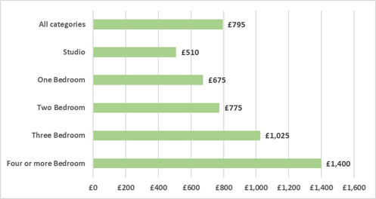
  - Ratio of House Prices to Earnings
      - The median house price to median earnings ratio in the District stood at 10.17 in 2021. This was the third highest ratio in the West Midlands region, with Wychavon and Malvern Hills higher at 10.64 and 10.26 respectively. By comparison, the ratio for Warwickshire was 8.55 and that for England was 9.05.
      - The lower quartile house price to lower quartile earnings ratio in the District was 10.74. This was the highest ratio for the West Midlands region. By comparison, the lower quartile house price to earnings ratio for Warwickshire was 8.67 and for England was 8.04.
      - Figure 8 below shows that the lower quartile price to earnings ratio has grown faster than the median, meaning those in the lower income bracket have been affected worse than those with median income by price rises.
Figure 8

  - Housing Tenure and Occupancy
      - Approximately 1,074 dwellings are thought to be vacant across the District, with 872 classed as long-term vacant. Of these long-term vacant dwellings, approximately 47 are owned by a Private Registered Provider (Housing Association).
      - According to the ONS, in 2019, approximately 72% of dwellings in the District were owner-occupied, 13% were privately rented and 13% were socially rented. An estimated 1.5% lived rent-free.
      - Figure 9 shows the breakdown of dwellings within the District by Council Tax band. The District has fewer Band A and B properties than the Warwickshire or England average, but more higher-banded properties.

Figure 9
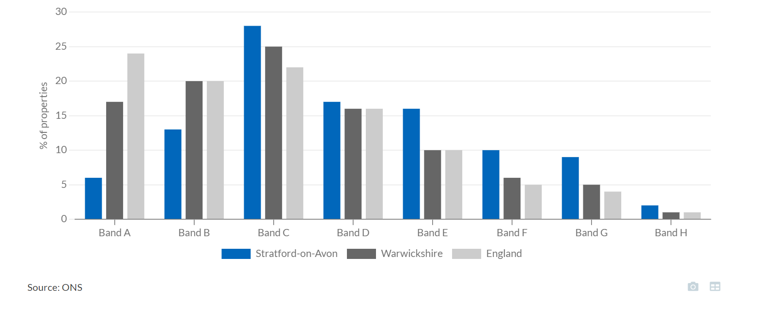

  - House Building
      - A total net of 748 new dwellings were added to the housing stock in 2021. This represented 83.7% of the target for total new dwelling completions in 2020/21, 146 under target.
      - Figure 10 shows the performance against target for net new dwellings in the District. This is the first year in the last seven years where net new dwellings have fallen short of the target. This was largely because of the impact of Covid restrictions.
Figure 10
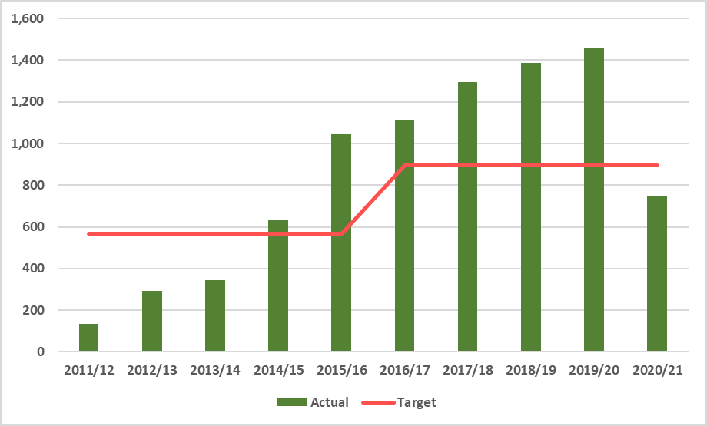
      - Figure 11 shows the net dwelling completions per settlement type over the past eight years. There has been a definite change over this time in where new dwellings are being built. While Stratford-upon-Avon saw the majority of new builds in 2011-14, between 2015-2020 main rural centres and local service villages saw the majority of new house building; in 2021, while nearly half of all new dwellings were located in main rural centres, there was a significant rise in the proportion of new dwellings located in new settlements.
Figure 11
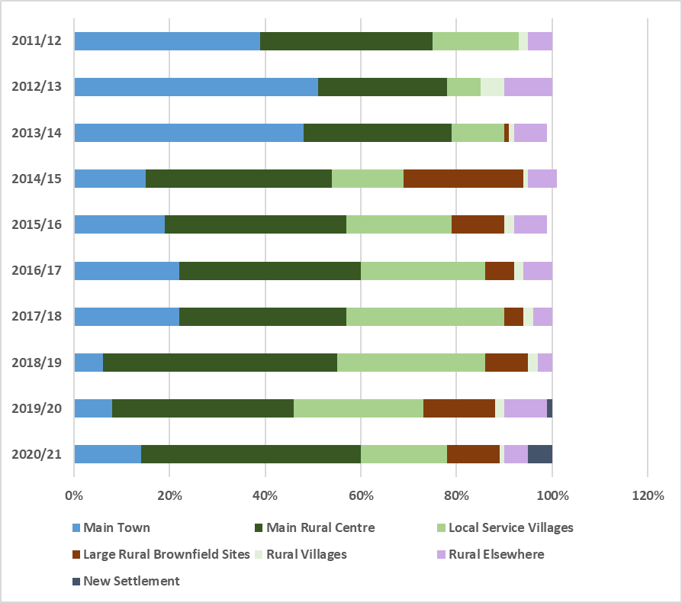

      - Affordable housing has made up an average of 29% of all new dwellings completed since 2012. In 2020/21, affordable housing made up 51.5% of new completions (see Figure 12).
Figure 12
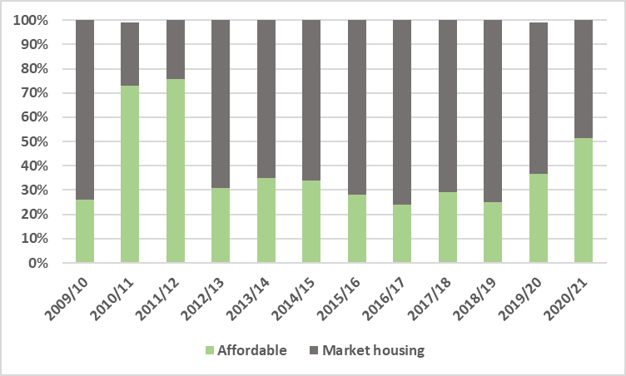

      - Figure 13 shows the size of new dwellings completed over the past nine years (some new builds are unaccounted for as size is unknown). In 2020/21 two and three bed homes made up just over 70% of completions, with four+ beds accounting for approximately 21%. One bed homes made up less than 10% of the total.

Figure 13

- Crime
  - Crime Rates
      - The total number of recorded crimes in the year to June 2022 was 7,343 for Stratford District. This is a rate of 56 crimes per 1,000 people, which is the lowest rate across Warwickshire. This reflects a rise on the previous year.
      - The most prevalent crimes in the District were violent and sexual offences, with a rate of 22 per 1,000 people. This is lower than the same rate across Warwickshire (30.2) and England (34.9).
      - As Figure 14 shows, all other crimes were significantly lower in number. The second most prevalent crime (apart from anti-social behaviour) was ‘other theft’ which had a higher rate of 6.8 per 1,000 than the Warwickshire average of 6.2 per 1,000 people, while the English average was 7.2.
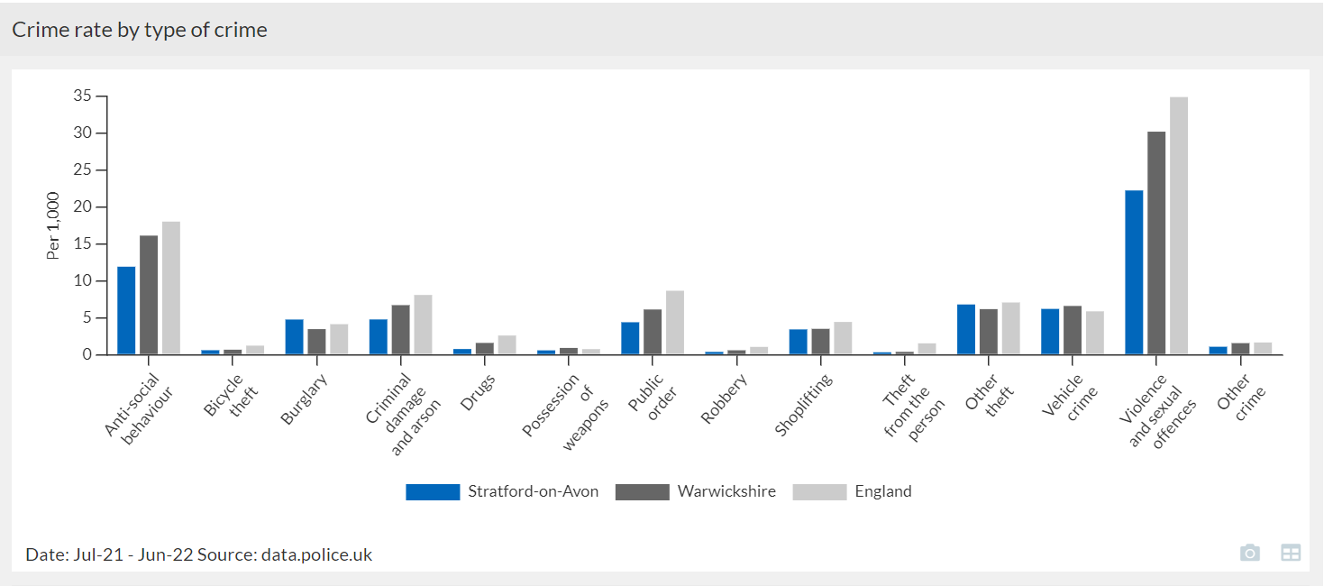
Figure 14

  - Crime at Ward level
      - Figure 15 shows the total crime count for each ward in the year ending June 2022 (please note, there is no data recorded for Clopton ward). Avenue ward saw the highest overall number of crimes recorded in the year to June 2022, at 680. Welcombe was second with 535.

Figure 15
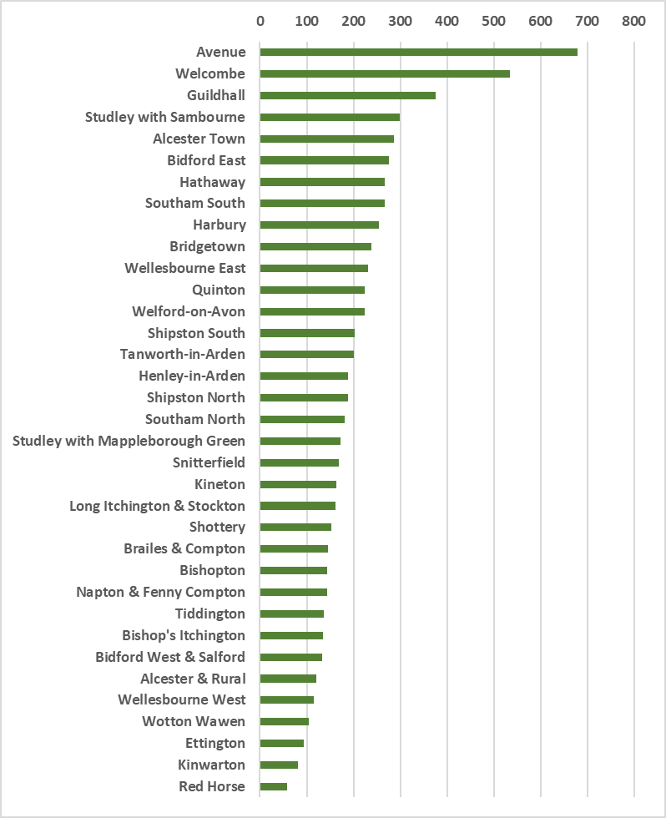

      - The wards towards the centre of Stratford-upon-Avon town saw the highest levels of violent and sexual crime. This category includes a wide range of offences including minor assaults (such as pushing and shoving), harassment and abuse (that result in no physical harm) through to wounding and homicide. Sexual offences include rape, sexual assault and unlawful sexual activity against adults and children, sexual grooming and indecent exposure. Table 3 shows the top 5 wards with the highest counts of recorded violent and sexual crimes in the year to June 2022.

Table 3
 | Count: Violent and sexual crimes
Avenue | 228
Welcombe | 168
Bidford East | 148
Guildhall | 138
Hathaway | 128

      - While Avenue ward had the highest number of violent and sexual crimes recorded, Guildhall had the highest rate of violent and sexual crime per 1,000 people at 74.64, followed by Welcombe at 46.26 per 1,000.
      - Table 4 shows the top 5 wards with the highest number of ‘other theft’ recorded crimes in the year to June 2022.
Table 4
 | Count: ‘Other theft’
Welcombe | 78
Avenue | 72
Studley with Sambourne | 43
Guildhall | 41
Harbury | 38

      - While Welcombe ward had the highest number of ‘other theft’ crimes recorded, Guildhall ward had the highest rate of other theft crimes out of all Warwickshire wards, at 22.17; Welcombe was second highest in Warwickshire with 21.48.
      - Table 5 shows the top 5 wards with the highest number of vehicle crimes recorded in the year to June 2022.
Table 5
 | Count: Vehicle crime
Harbury | 51
Avenue | 50
Tanworth-in-Arden | 48
Welford-on-Avon | 45
Alcester Town | 41

      - While Harbury had the highest number of recorded vehicle crimes, Tanworth-in-Arden ward had the highest rate at 12.34 per 1,000 with Harbury second at 10.
      - Table 6 shows the top 5 wards with the highest number of recorded burglary crimes.

Table 6
 | Count: Burglary
Welcombe | 46
Tanworth-in-Arden | 37
Alcester Town | 36
Studley with Sambourne | 31
Alcester & Rural | 29

      - Welcombe ward also had the highest rate of burglary crime at 2.48 per 1,000. Alcester & Rural and Tiddington were second and third respectively with 1.23/1.22 per 1,000.
      - Table 7 shows the top 5 wards with the highest number of incidents of anti-social behaviour (ASB).
Table 7
 | Count: ASB
Welcombe | 127
Avenue | 124
Guildhall | 105
Tanworth-in-Arden | 84
Hathaway | 71

      - Welcombe also had the highest rate of ASB at 3.3 incidents per 1,000, with Hathaway second with 2.69 per 1,000.
- Employment and Qualifications
  - Employment
      - In March 2022, there were approximately 80,100 people aged between 15 and 64 years. 62,900 were classed as ‘economically active’ in Stratford District i.e. in work (employed or self-employed) or claiming unemployment benefit.
      - As of March 2022, 80.3% of adults were in either full time or part time work in the District. This rate is higher than the West Midlands average of 73.7% and the GB average of 75.2%.
      - 68.8% of adults were classed as employees in the District, and 11.4% classed as self-employed.
      - In March 2022, 1,900 people were classed as unemployed in the District, representing 3.0% of the economically active population.
      - In March 2022, 12,400 people were classed as economically inactive, representing approximately 17.6% of all 16-64 year olds. The economic inactivity rate averages at around 18-20% during the last 20 years.
  - Unemployment Benefit Claims

      - In August 2022 there were 1,665 claiming unemployment benefits of some kind in Stratford District. 53% of these were men, 47% women. This represents 2.2% of the total population aged 16-64 years.
      - Younger adults had a higher rate of claiming benefits than headline rate: 2.9% of all adults aged 18-21 years were claiming benefits and 2.7% of all those aged 18-24 years in the District.
      - By comparison, only 1.6% of all economically active adults aged 50 years or over were claiming benefits.
  - Earnings
      - The median gross weekly earnings in 2021 for full time workers in the District was £676.10. This was higher than the average for the West Midlands at £581.80, and that for Great Britain at £613.10. This represented a 12.74% increase on the median weekly wage for 2020, and is the highest figure seen yet.
      - The weekly median for full-time men was £794.10 while that for full-time women was £533.40. Women’s weekly median pay is therefore only 67% of men.
  - Qualifications
      - In 2021, Stratford-on-Avon was the fifth most qualified authority within the West Midlands area, with 49.1% of adults aged 16-64 years possessing an NVQ4 qualification or higher (NVQ4 is equivalent to an HNC, NVQ6 is equivalent to an undergraduate degree, NVQ3 is equivalent to A Level). The average for Great Britain is 43.6%, while for the West Midlands it is 38.9%. Stafford is the most qualified with 56.3% of adults holding an NVQ4 or higher qualification, followed by Malvern Hills, Rugby then Warwick.
      - 4.2% of working age adults had no qualifications at all. This compared to the Great Britain average of 6.6% and that across the West Midlands of 7.8%. This figure has fluctuated around an average of 6% over the past five years, but the general trend over time is downwards as the population becomes better qualified.
  - Employment and by Industry
      - Table 8 shows the breakdown of the number of jobs by industry sector.
      - Manufacturing accounts for the largest number of jobs at 12,000, representing 17.32% total jobs in the district. This is a higher proportion of jobs than the average for both West Midlands (10.9%) and Great Britain (7.9%).
      - The wholesale and retail trade/repair of motor vehicles and motorcycles was the next largest sector in terms of jobs, with 10,000, meaning that 14.43% total jobs in the district were in this sector. This is the same as the Great Britain average and slightly lower than the West Midlands figure of 16.1%.

Table 8
 | Employment 2020
 | Count | %
ABDE: Agriculture, mining, electricity, gas, water and waste | 2,260 | 3.26%
C: Manufacturing | 12,000 | 17.32%
F: Construction | 3,000 | 4.33%
G: Wholesale and retail trade | 10,000 | 14.43%
H: Transportation and Storage | 1,250 | 1.80%
I: Accommodation and Food service | 6,000 | 8.66%
J: Information and communication | 2,500 | 3.61%
K: Financial and insurance | 3,000 | 4.33%
L: Real estate | 1,250 | 1.80%
M: Professional, scientific and technical | 6,000 | 8.66%
N: Administrative and support services | 4,000 | 5.77%
O: Public administration and defence | 1,000 | 1.44%
P: Education | 4,500 | 6.50%
Q: Health and social work | 7,000 | 10.10%
R: Arts, entertainment and other recreation | 1,750 | 2.53%
S: Other services | 1,750 | 2.53%

      - Tourism-related jobs are an important part of the District services sector. According to the 2021 Tourism Economic Impact Assessment, there were 6.628 tourism-related jobs in the District, equating to 4,826 full-time jobs. This is much lower than previous years’ figures and is a direct result of the Covid-19 pandemic which had a devastating impact on the tourism industry within the district. This equates to 11.5% of all employment in the District.
- Business and Economy
  - Productivity: Gross Value Added (GVA)
      - Table 9 shows the breakdown of £GVA by industry sector and per job. Manufacturing accounts for over a third of all £GVA in the district – amounting to £1,499,000,000. Along with Real Estate, the two sectors account for half of all GVA within the district. This reliance on two sectors means that the district’s economy is less resilient and more open to threats than the more balanced economies of districts such as Warwick.

Table 9
 | GVA 2020 |  | GVA per job
 | GVA £m | %
ABDE: Agriculture, mining, electricity, gas, water & waste | 121 | 2.79% | £53,539.82
C: Manufacturing | 1,499 | 34.59% | £124,916.67
F: Construction | 241 | 5.56% | £80,333.33
G: Wholesale and retail trade | 402 | 9.28% | £40,200.00
H: Transportation and Storage | 40 | 0.92% | £32,000.00
I: Accommodation and Food service | 104 | 2.40% | £17,333.33
J: Information and communication | 154 | 3.55% | £61,600.00
K: Financial and insurance | 263 | 6.07% | £87,666.67
L: Real estate | 669 | 15.44% | £535,200.00
M: Professional, scientific and technical | 177 | 4.08% | £29,500.00
N: Administrative and support services | 162 | 3.74% | £40,500.00
O: Public administration and defence | 63 | 1.45% | £63,000.00
P: Education | 149 | 3.44% | £33,111.11
Q: Health and social work | 129 | 2.98% | £18,428.57
R: Arts, entertainment and other recreation | 37 | 0.85% | £21,142.86
S: Other services | 121 | 2.79% | £69,142.86

  - Business Numbers
      - In December 2021, the number of businesses in the District stood at 8,290 enterprises. 90.2% of these were classed as micro-businesses (0-9 employees). There were 20 large businesses (over 250 employees).
      - The break-down of businesses by size reflected the averages for the district versus Warwickshire and England as a whole, as can be seen in Table 10 below.
Table 10
 | Stratford-on-Avon |  | Warwickshire |  | England
 | Count | % | Count | % | Count | %
Large (250+) | 20 | 0.2 | 125 | 0.45 | 9,305 | 0.39
Medium (50-249) | 110 | 1.3 | 410 | 1.48 | 36,290 | 1.51
Small (10-49) | 690 | 8.3 | 2,260 | 8.16 | 199,325 | 8.28
Micro (0-9) | 7,475 | 90.2 | 24,900 | 89.91 | 2,114,180 | 89.82
Total | 8,290 | 100 | 28,235 | 100 | 2,161,045 | 100

      - The business density ratio for the district of 710 per 10,000 people is the second highest density in the West Midlands, with only Bromsgrove higher at 966 businesses.
      - Figure 16 shows the business survival rates for Stratford-on-Avon compared to Warwick and the Warwickshire average. In 2020, there were 765 business starts, while there were 990 business deaths. The proportion of businesses that survived in their first year in the district was slightly lower than in Warwick, or than the Warwickshire average. However, once businesses get past that first year, survival rates are higher in the district.
Figure 16
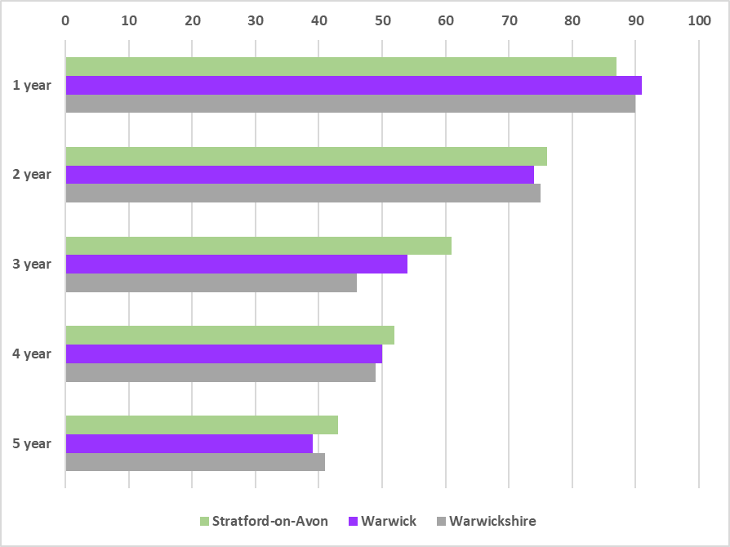

  - Businesses by Industry
      - Table 11 shows the number of businesses within each industry sector in the District in 2021, and the proportion of total businesses which each sector accounts for, along with the Warwickshire and England averages.

Table 11
 | SOA | SOA | Warks | England
 | Count | % | % | %
1: Agriculture, forestry & fishing (A) | 740 | 8.93 | 5.09 | 3.82
2: Mining, quarrying & utilities (B) | 0 | 0.00 | 0.04 | 0.04
3: Manufacturing (C) | 445 | 5.37 | 5.80 | 4.99
4: Electricity, gas, steam and air conditioning (D) | 5 | 0.06 | 0.18 | 0.18
5: Water supply; sewerage, waste management etc (E) | 25 | 0.30 | 0.29 | 0.30
6: Construction (F) | 920 | 11.1 | 10.76 | 13.05
7: Wholesale/retail trade; repair of motor vehicles and motorcycles (G) | 1,030 | 12.4 | 12.93 | 14.78
8: Transport & storage (inc. postal) (H) | 270 | 3.26 | 7.53 | 5.10
9: Accommodation & food services (I) | 475 | 5.73 | 5.29 | 5.78
10: Information & communication (J) | 475 | 5.73 | 6.95 | 8.19
11: Financial & insurance (K) | 150 | 1.81 | 1.66 | 2.29
12: Property (L) | 375 | 4.52 | 3.90 | 3.91
13: Professional, scientific & technical (M) | 1,710 | 20.6 | 19.01 | 16.89
14: Business administration & support services (N) | 720 | 8.69 | 9.59 | 8.56
15: Public administration & defence (O) | 55 | 0.66 | 0.43 | 0.29
16: Education (P) | 150 | 1.81 | 1.75 | 1.72
17: Health (Q) | 230 | 2.77 | 3.05 | 3.78
18: Arts, entertainment and recreation (R) | 250 | 3.02 | 2.15 | 2.51
19: Other service activities (S) | 265 | 3.20 | 3.59 | 3.82

      - In 2021, the largest number of businesses in the District were within the professional, scientific and technical services industry, at 1,710. This industry accounted for just over 20% of all businesses, a similar proportion to Warwickshire and slightly higher than the England average.
      - Wholesale, retail and motor vehicle repair accounted for 12.4%, similar to the county and slightly lower than the national average (14.78%).
      - Construction accounted for 11.1% of all businesses, similar to the county and just under the national average (13.05%).
      - Agriculture, forestry and fishing accounted for 8.93%, a higher proportion than either the Warwickshire average (5.09%) or national average (3.82%).
- Health
  - Overview
People in Stratford-on-Avon District are generally in better health compared to the England average life expectancy in 2019 is 85.0 years for women (England = 83.1) and for men 81.4 years (England = 79.4) . These figures are the highest in the West Midlands region.
  - Disease, death and injury
      - Mortality rates for cardiovascular disease and cancer are much lower in the District than the West Midlands or England average rates.
      - The rate of dementia diagnosis in August 2022 was 52.5%. This is the estimated percentage of people with dementia who are actually diagnosed with it: in other words, 52.5% people with dementia in the district received a diagnosis, meaning that 47.5% people who have dementia are undiagnosed. This is just under the Warwickshire average rate of 54.6, and significantly lower than the English average of 62.1.
      - In 2019, hospital admission rates for alcohol-related conditions in the District were 576.4 per 100,000 for women, which is higher than the English average of 525.4 per 100,000 and the Warwickshire rate of 483.9 per 100,000. The rate for men was 778.1 per 100,000 which is lower than the English average of 837.3 and the Warwickshire rate of 797.6.
      - Suicide rates were lower in the District than the county and England average. The rate for men was 14 per 100,000, compared to 14.8 in Warwickshire and 15.9 in England.
- Poverty
  - From the middle of 2021, UK utilities companies faced an historic rise in the wholesale cost of gas and power prices, and an inability to pass these costs on to the consumer due to the energy price caps imposed by Ofgem. This left many in an unsustainable position, and a number of companies went bankrupt as a result (e.g. Bulb Energy), with 25 bankruptcies by the end of December 2021. As a response to this crisis, the energy price cap was raised from £1,138 to £1,277 (for the average household bill) in October 2021. Since then, Ofgem have announced further rises, with the most recent taking the cap up to £3,549, as from October 2022. This new cap represents a rise of 212% on the price cap leading up to October 2021.
These rises have occurred during a period of quickly rising inflation when UK households are already finding their cost of living squeezed by increasing food prices, petrol and diesel prices and prices for other consumer goods, as well as an announced rise in National Insurance, due to occur in April. Many UK households, therefore, are unsurprisingly very worried about the rising costs of heating and powering their homes.
The UK Government has announced a handful of measures to soften the blow:
- In April 2022, people in Council Tax bands A to D in England received a one-off £150 discount;
- All households will receive a £400 discount on their energy bills, paid in six instalments between October 2022 and March 2023;
- Households on means tested benefits will receive a payment of £650, paid in two instalments;
- Individuals on disability benefits will receive a one-off £150 payment to help with extra costs
- Pensioners will receive an extra one-off £300 cost of living payment; they are able to access between £100 and £300 to help pay heating bills;
- the warm house discount scheme will be expanded to include 3m households, offering a discount to low-income households on electricity bills of around £150;
- and local authorities will have access to £150m fund to help lower income households living in higher council tax properties, as well as households in bands A-D who do not currently pay council tax.
- Recent raising of interest rates by the Bank of England, and announcements by the Chancellor of the Exchequer and resultant fall in the pound have made the outlook for household finances even bleaker.

  - Risk factors for poverty
    - There are a number of factors which can mean that an individual is at risk of living in poverty. They include:
- Living in fuel poverty
- Living in a dwelling without central heating
- Lone parent households
- Living with a disability or long-term health issue
  - Fuel poverty
      - Fuel poverty in England is measured using the Low Income High Costs indicator, which considers a household to be fuel poor if:
- they have required fuel costs that are above average (the national median level);
- were they to spend that amount, they would be left with a residual income below the official poverty line.

      - 13.3% of households in the District were in fuel poverty according to the latest data for 2020, compared to 14.3% in Warwickshire and 13.2% in England.
      - There was huge variation across the District in the proportion of households in fuel poverty, ranging from 20% households in Stratford Mount Pleasant, 19% in Lighthorne and Lighthorne Heath, and 18% in Dunnington and Salford Priors to 5% in Wellesbourne South, with the average being 13%.
  - Dwellings without central heating
      - This measure comes from the 2011 Census, so is not expected to be accurate at this time: however, results from the 2021 Census have not been released as yet.
      - The proportion of dwellings without central heating varied across LSOAs, ranging from 0% in Wellesbourne South up to 6.1% in Town Centre North. Table 12 below shows the LSOAs where over 3% dwellings have no central heating.
Table 13
Lower Super Output Area | Nos of dwellings with no central heating | Proportion of dwellings with no central heating (%)
Town Centre North | 61 | 6.1
Kinwarton | 41 | 4.7
Bidford South, Marlcliff and Barton | 37 | 4.3
Old Town & Town Centre South | 42 | 4.3
Napton on the Hill | 17 | 3.7
Aston Cantlow | 29 | 3.6
Burton Dassett | 33 | 3.4
Fenny Compton, Farnborough & Avon Dassett | 17 | 3.3
Quinton | 36 | 3.3
Studley South | 21 | 3.2
Brailes | 30 | 3.2
Shipston North | 28 | 3.2
Dunnington and Salford Priors | 19 | 3.1
Vale of the Red Horse | 22 | 2.3
Alcester South, Arrow & Weethley | 18 | 2.2
Newbold-on-Stour, Ilmington East & Whitchurch | 10 | 2.2
Ettington | 20 | 2.1
Bidford West and Wixford | 15 | 2.1
Alcester East & Island | 14 | 2.1
Tanworth | 15 | 2
Lighthorne & Lighthorne Heath | 11 | 2
Alveston Hill and Rural | 9 | 2

  - Lone Parent Households
      - 49% of children who live in single-parent families live in poverty. Lone parents have the highest poverty rate of all working-age adults, with 43% living in poverty.
      - There was huge variability in the proportion of lone parent households by LSOA across the district, with percentages ranging from 1.6% households in Earlswood to 11.4% households in Alveston Hill & Rural. Table 13 shows the LSOAs which fell into the top 25% district LSOAs with the highest rates.

Table 14
Lower Super Output Area | Number of lone parent households | Proportion of lone parent households (%)
Alveston Hill and Rural | 52 | 11.4
Alcester North & Conway | 59 | 9.4
Southam West | 64 | 9.2
Southam East | 59 | 9.2
Bidford East, Waterloo & Broom | 56 | 8.4
Bridgetown South East | 45 | 8.2
Maybird | 84 | 8.2
Long Itchington East | 35 | 7.8
The Avenue | 75 | 7.7
Studley North | 43 | 7.4
Bishopton | 46 | 7.1
Studley West & Common | 42 | 7.1
Alcester East & Island | 47 | 7.1
Wellesbourne West | 36 | 7.1
Quinton | 77 | 7.0
Studley South | 44 | 6.7
Lighthorne & Lighthorne Heath | 36 | 6.7
Stratford Mount Pleasant East | 42 | 6.6
Studley East & Priory | 45 | 6.5
Alcester South, Arrow & Weethley | 52 | 6.4

  - People with a long-term health problem or disability
      - There was significant variation across LSOAs in the district in the proportion of population suffering from health issues which impacted on day-to-day activities a lot, ranging from 1.91% in Alveston Hill & Rural to 11.84% in Studley South. Table 14 above shows the LSOAs which fell into the top 25% for highest proportion of population impacted by poor health.

Table 15
Lower Super Output Area | Number of people living with long term health problem or disability | Proportion of people living with long term health problem or disability
Studley South | 179 | 11.84%
Old Town & Town Centre South | 205 | 11.67%
Alcester East & Island | 178 | 11.51%
Dunnington and Salford Priors | 173 | 11.19%
Alcester North & Conway | 153 | 11.17%
Shipston West and Town Centre | 154 | 10.44%
Stratford Mount Pleasant East | 139 | 10.43%
Henley East and Beaudesert | 153 | 10.15%
Studley North | 138 | 10.12%
Tiddington & Alveston | 198 | 9.87%
Wootton Wawen | 130 | 9.86%
Southam South & Town Centre | 192 | 9.60%
Long Itchington East | 102 | 9.50%
Kinwarton | 192 | 9.28%
Maybird | 198 | 9.23%
Bidford East, Waterloo & Broom | 159 | 9.09%
Kineton Castle, Lt. Kineton & Combrook | 130 | 8.81%
Wellesbourne North | 133 | 8.74%
Southam West | 133 | 8.68%

- Ukraine War
  - Refugees in the District
      - In September 2022, the district was expecting 430 Ukrainian guests; 261 of these had already arrived.
      - Figure 17 below shows where in the district these guests are to be located.
The largest number – 33 – are to be homed in Welford-on-Avon, with 28 in Henley-in-Arden and 25 in Snitterfield.

Figure 17
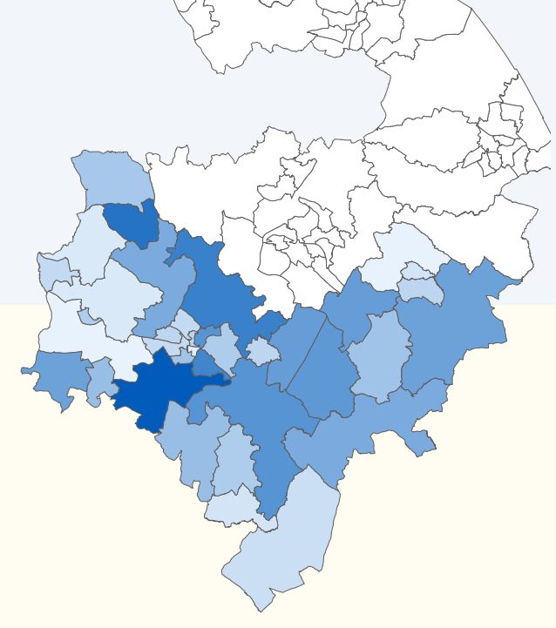

      - 39 school places have been offered with a potential total of 78 needed.
- Stratford District Council Residents Survey 2022
  - The Stratford-on-Avon District Council Residents’ Survey 2022 undertaken from February to April 2022 with 1,875 responses concluded that:
- 86% of those surveyed are satisfied with their local area as a place to live, down five percentage points on 2019.
- Residents were asked to say what were the five most important things making somewhere a good place to live. The top five in the District were: the level of crime (58%); health services (58%); access to the countryside (41%); clean streets (35%) and affordable decent housing (30%). Health services were considered the most important factor in three of the six localities: Alcester/Bidford, Stratford, and Wellesbourne/Kineton. Level of crime was considered the most important factor in the other three: Henley/Studley, Southam and Shipston.
- Residents were asked to think about their local area and indicate up to five things that most need improving. The top five improvements were: road and pavement repairs (48%); the level of traffic congestion (43%); activities for teenagers (33%); affordable decent housing (30%) and public transport (29%). Road and pavement repairs were the factor requiring most improvement in Alcester/Bidford, Henley/Studley, Shipston, Southam and Wellesbourne/Kineton localities, with the level of traffic congestion in Stratford being most important.
- 72% of respondents felt very or fairly strongly that they belong to their immediate neighbourhood, down three percentage points on 2019.
- 54% of respondents tend to agree or definitely agree that their local area is a place where people from different backgrounds get on well together.
- 77% of respondents felt that their local area economy was okay or better, while 23% felt it could be better or was really struggling. This slightly worse picture than 2019, when 79% thought their local economy was okay or better, and 21% felt it could be better or was really struggling.
- 31% agree that they can influence decisions affecting their local area.
- 41% of respondents tend to or strongly agree that Stratford District Council provides value for money.
- 63% of respondents agree a great deal or to some extent that Stratford District Council is making the local area a better place to live.
- 54% of respondents agree a great deal or to some extent that Stratford District Council is working to make the area safer. This is up three percentage points on 2019.
- 58% of residents agree a great deal or to some extent that Stratford District Council is working to make the area cleaner and greener, a fall of two percentage points on 2019.
- 33% agreed a great deal or to some extent that SDC involves residents when making decisions.
- 34% of respondents felt agreed that SDC acts on residents’ concerns a great deal or to some extent, down two percentage points on 2019.
- 57% of respondents felt that SDC keeps residents very or quite well informed about services and benefits. This sentiment has remained fairly static over the last ten years.
- 61% of respondents are fairly or very satisfied with the way Stratford District Council runs things, a fall of 10 percentage points on 2019.
- 62% of respondents said that they were very or fairly satisfied with the way SDC kept public land clear of litter and refuse. 83% of residents were very or fairly satisfied with refuse collection in the district. 72% of residents were very or fairly satisfied with doorstep recycling. 71% of residents felt very or fairly satisfied with the parks and open spaces provided by SDC, a slight fall of three percentage points on 2019.
- 59% of those surveyed were satisfied with the play areas provided by SDC. This is seven percentage points lower than 2019. 46% of respondents were satisfied with car parking provided by SDC, up five percentage points on 2019 and the highest score recorded over the last ten years. 39% of those surveyed were satisfied with the public toilets provided by SDC, up one percentage point on 2019, and the second highest score seen across the last five surveys. 59% of respondents were satisfied with grass cutting, the same score as 2019. Satisfaction with the way SDC process planning applications has been falling over the past ten years, with 23% of respondents expressing satisfaction.
- 69% said they felt either fairly or very safe after dark; this is a lower score than the previous four surveys. 93% of residents felt fairly or very safe during the day.
- The biggest problems in terms of anti-social behaviour were dog fouling and fly tipping, with both seeing 42% of respondents saying that they were a very or a fairly big problem.
- 69% of residents were fairly or very satisfied with the service they received the last time they made contact with the Council. This represents a fall of three percentage points on 2019.
- 76% of residents confirmed that they found it fairly or very easy to access SDC services in the last 12 months, down one percentage point on 2019.
- Achievements/Key Events during 2021/22
  - The Council started to implement the Council Plan during 2019/20, and this was continued during the last year. The Council Plan is an ambitious programme that summarised the overall vision for the Council and highlighted the key ambitions and objectives for our communities as follows:
Stratford-on-Avon District Council Vision
We are ambitious for the future of the District as an excellent place to live, work, learn, visit and invest.
The plan sets out our vision for Stratford-on-Avon District as a place in 2030 and for local government in 2030.
The core of the plan is a set of ambitions and actions for the Council over the next four years under five key objectives:
- Working on regional, national and international stages
- Responding to the climate emergency
- Enhancing the quality of Stratford-on-Avon as place
- Nurturing a thriving, innovative and inclusive economy
- Putting residents and communities centre stage

In agreeing the longer-term vision, specific priorities were also agreed for the four years up to the elections due to be held in May 2023, these priorities are as follows:
Working on regional, national and international stages
We will promote Stratford-on-Avon externally and use our relationships and reputation to help deliver our vision for 2030 and our ambitions for 2023.
Enhancing the quality of Stratford-on-Avon as a place
We will use our roles and powers, an ever-closer relationship with Warwickshire County Council and effective collaboration with other partners to enable us to ensure that Stratford-on-Avon is an excellent place to live, work, learn, visit and invest.
Nurturing a thriving, innovative and inclusive economy
We will work with the Warwickshire Local Enterprise Partnership, West Midlands Combined Authority and Midlands Engine to support our local economy.
Responding to the climate emergency
We will do all we can locally to contribute to national carbon reduction targets, fulfil our aim to becoming a carbon-neutral District by 2030 and support measures to adapt to the impact of climate change.
Putting residents and communities centre stage
We will listen to and engage with residents and communities, use what we hear to shape what we do, and communicate the results.
In order to deliver this, we will become a more agile and resilient Council
  - In implementing the Council Plan for 2021/22 a set of specific actions were agreed by The Cabinet at their meeting on 12 April 2021. The agreed actions took into account the reduced corporate capacity which related to the ongoing COVID pandemic, however they were still stretching and extremely ambitious.
  - The delivery of these actions is reported separately within this report, however, in addition to these actions the Council continued to support our local communities through the pandemic. The main areas of activities included payment of vital grants to businesses and our Environmental Health team ensuring that businesses operated in a COVID secure manner. It is extremely positive that the worst of the pandemic now appears to have past and that the Council can once more concentrate on its priorities.
  - During 2021/22 the Council was working extremely closely with Warwick District Council, with a number of key decisions being made by The Cabinet and Council to implement the vision of seeking to create a single District Council over the Stratford and Warwick areas.

This culminated in a report to Council in December 2021 where it was agreed that a formal submission should be made by the two Council’s to the Department for Levelling Up, Housing and Communities to request this move. Warwick District Council came to the same decision and the formal submission was made before the Christmas break.
  - Council will be aware that this decision has subsequently been reversed and that this ambition will no longer be pursued. However, there were a number of positive outcomes from the working with Warwick District Council which will be continued, these include:
- Jointly Tendering for the Refuse and Recycling Contract
- Developing jointly a South Warwickshire Local Plan
- Developing a South Warwickshire Economic Strategy
- Developing a joint Regulatory Services Enforcement Policy
- Agreed a shared set of ambitions regarding the Climate Emergency
  - Members will also be aware that the Overview and Scrutiny Committee have established a Task and Finish Working Group to help understand the lessons learnt from this exercise. The first meeting of the working group was held on 29 September 2022 and it is hoped that its’ work will be completed before Christmas.
  - It should be noted that there are consequences of not progressing the merger with Warwick District Council, on a financial perspective specifically. The Council had assumed overall savings increasing to £1.275m per annum through the exercise and these had been included within the Medium-Term Financial Plan. Now that the merger is not progressing these savings will now have to be withdrawn. However, because of the continuation of joint working in a number of areas there will be savings of £271k per annum accruing to the Council. This does not include potential recharges not yet quantified.
  - In relation to the wider finances of the Council it is very clear though that we can reasonably expect a period of continued reductions in support, which if not addressed would challenge the financial sustainability of the Council. During 2021/22 the emergence of significant inflationary pressures and the overall impact on cost of living started to become an issue. The Council did achieve an underspend during 2021/22 and this was reported to The Cabinet on 18 July 2022. The majority of this underspend was transferred into an earmarked reserve to help support the Council with inflationary costs in 2022/23.
  - The Council is responsible for ensuring that its business is conducted in accordance with the law and proper standards, that public money is safeguarded and properly accounted for, and used economically, efficiently and effectively.
  - The Council also has a duty under the Local Government Act 1999 to make arrangements to secure continuous improvements in the way in which its functions are exercised, having regard to a combination of economy, efficiency and effectiveness.
  - The Annual Government Statement identifies the framework that comprises the systems, processes, culture and values, by which the Council is directed and controlled and its activities through which it accounts to, engages with and leads the community. It enables the Council to monitor the achievement of its strategic priorities and to consider whether those priorities have led to the delivery of appropriate, cost-effective services.
  - The roles and responsibilities of the executive, non-executive, scrutiny and officer functions, along with the delegations from The Cabinet and the Council are set out in the Constitution. In addition, there are member role profiles and an officer/member protocol that sets out the respective responsibilities and relationships of officers and members. The Constitution is kept under regular review, overseen by the Audit and Standards Committee and the document is fully reviewed every three years. A revised Leader’s Statement has been developed which summarises all of the executive delegations which are currently in place.
  - A risk management framework is reviewed annually which is supported by the County Council. The provision of such advice is now built into the service level agreement for audit services. Operational risks form part of the service plans, and high-level risks are identified in the strategic risk register, which is periodically reviewed by the Management Team.
  - 2021/22 saw the following achievements.
- 1 April 2021 - Garden waste subscription service starts. By June, almost 75% of households across the District had signed up to chargeable garden waste subscription service.
- Contract signed to create a new world-leading Material Recycling Facility (MRF).
- New Restart Grants paid to help businesses reopening after latest lockdown.
- In May 2021, Local elections took place for:
  - Warwickshire County Council
  - Warwickshire Police and Crime Commissioner
  - Planning Referendum – Alcester, Clifford Chambers and Milcote, Ilmington, Napton-on-the-hill
- Stratford and Warwick District Councils began work to produce a new South Warwickshire Local Plan to cover the combined geographic area.
- Local organisations received grant to support young people’s mental wellbeing.
- Stratford and Warwick District Councils chosen by Government to test use of digital tools in planning process.
- Work continued on ‘pioneering Housing Plus’ Fred Winter Centre in Stratford-upon-Avon.
- District Survey carried out, taking a look at the health and vitality of eight key high streets in the Stratford District – Stratford-upon-Avon, Wellesbourne, Southam, Shipston-on-Stour, Bidford-on-Avon, Henley-in-Arden, Alcester and Studley.
- In June 2021, the District Council submitted a bid with the Shakespeare Birthplace Trust to the Government’s Levelling-up Fund.
- District Council reaffirmed commitment to tackling climate change by working together with Warwick District Council to address the declared climate emergency for South Warwickshire.
- District Council approved new Active Communities Strategy Delivery Plan for the next three years.
- New cycle training track opened on Stratford Recreation Ground.
- District Council and SLM Ltd signed a new 10-year Leisure Management Contract.
- In August 2021, recycling collections started again, following the devastating fire at the Pure Recycling facility in Ettington – with alternative disposal arrangements for dry recyclable materials in place.
- District Council received West Midlands Combined Authority’s (WMCA) Thrive at Work Wellbeing Award.
- E-Cargo Bike grant funding success for SDC.
- District Council secured funding from Local Authority Delivery (LAD) Scheme to help improve the energy efficiency of low-income households.
- Stratford and Warwick District Councils welcomed 50 families from Afghanistan.
- In September 2021, a public consultation began on the proposal to create a South Warwickshire Council.
- The Cabinet approved support for the new Domestic Abuse Act 2021.
- £61,000 of CIL developer contributions allocated to three projects across the District:
  - Restoration Phase of the Greig Memorial Hall, Alcester – £50,000
  - Napton-on-the-Hill Community Electric Vehicle Charging Points – £5,910
  - Meon Vale Pavilion Community Project – £5,000
- District Council awarded £10,000 to Refuge to support the domestic abuse outreach service.
- District Council awarded £1.2 million from The Additional Restrictions Grant (ARG) scheme, to support businesses that were not covered by other grant schemes.
- District Council publishes Annual Review: Affordable Housing Development Programme – which sees the second highest total of 386 new affordable homes built. Bringing the total number of affordable homes built across the District over the last 10 years to 2,709.
- Stratford and Warwick District Councils agreed joint waste contract with Biffa Waste Services Ltd.
- In October 2021, Stratford District Council hosted a Recruitment Fair, in conjunction with the return of the Mop Fair.
- District Council adopted new Housing Strategy for the District.
- SDC Councillors took part in a woodland educational and tree planting day with The Heart of England Forest.
- Everyone Active introduced a new role to boost health and wellbeing across the District.
- The Riverside Project gained planning approval.
- In December 2021, Stratford’s award-winning Victorian Market returned.
- At the end of the year, Stratford and Warwick District Councils agreed to formally submit a request to the Secretary of State at the Department for Levelling Up, Housing and Communities (DLUHC) to create a South Warwickshire District Council.
- In January 2022, the District Council received £2.7m from Government for the Omicron Hospitality and Leisure Grant scheme.
- Work started on The Riverside Project.
- A multi-agency community safety event was held at Meon Vale.
- Stratford and Warwick District Councils worked with local charity Act On Energy to promote the grants, advice and support available to residents in South Warwickshire impacted by the energy price rises.
- Stratford and Warwick District Councils stepped in to support Homes for Ukraine scheme.
  - We continue to develop our relationships at a regional level, where we play a full role in CWLEP and the WMCA. In the latter case we are members of:
- The WMCA itself
- The Housing and Land Board
- The Investment Board
- The Growth Company
- The Economic Impact Group

- Key Issues and Targets
The second year of the Council Plan has been completed (following position is as at 31 March 2022):
  - Priority 1 –Working on regional, national and international stages
- Raise the District’s profile nationally and regionally to deliver benefits for residents.
- Work ever more closely with Warwickshire County Council, regional authorities and institutions, neighbouring districts and town and parish councils on shared priorities.
- Ensure the district benefits from Coventry City of Culture (2021) and the Birmingham Commonwealth Games (2022).
Progress 2021/22:
- Shakespeare’s England to provide a recovery plan to support tourism and the local economy.
- Town/Parish Council briefings held twice a year.
- In line with the SUA Transport Strategy develop a Parking Strategy which supports the Climate Change Agenda. This is still being undertaken.
- Deliverables agreed that relate to Stratford district in relation to the Birmingham Commonwealth Games.
Priority 2 – Enhancing the quality of Stratford-on-Avon as a place
- Promote, enhance and protect the cultural, heritage and natural assets of the district.
- Improve the health and wellbeing of all residents.
- Maintain the high level of community safety and address perceptions of crime.
- Strengthen the District’s reputation for high quality education, research and development.
- Increase the level and quality of broadband coverage.
Progress 2021/22:
- Identify a clear strategy for the development of the Gateway Project. This remains ongoing following the unsuccessful Levelling Up bid.
- Delivered the Active Communities Strategy.
- Delivered our Health and Wellbeing Approach in conjunction with partners including the Coventry and Warwickshire Health and Care Partnership.
- Expansion, upgrade and modernisation of CCTV - The project is complete except Malthouse Lane, Earlswood – where mains power was discovered by BT on excavation, necessitating alternative plans to be prepared.
- Delivered the relevant actions within the Crime and Disorder Strategy.
- To support the ambitions for growth at the Wellesbourne Campus and Quinton Rail Technology Centre - Discussions ongoing. Proposals (and timescales) being led by University of Warwick and Porterbook, respectively, but officers ready to assist as appropriate as ambitions are finalised.
- Promotion of Community Fibre programme rollout – monthly meetings with BDUK/BT Openreach to monitor and encourage scheme take up across the District - Meetings with OpenReach continue and assistance provided to local parishes / groups who are trying to access the Gigabit Voucher Scheme.
Priority 3 – Nurturing a thriving, innovative and inclusive economy
- Obtain maximum benefit for the district from the implementation of the West Midlands Local Industrial Strategy
- Enable the growth of businesses in key sectors, including automotive & transport, agricultural technologies and medical sectors
Progress 2021/22:
- New South Warwickshire Economic Strategy being prepared. Stakeholder engagement in July 2021.
- Develop a support package to help businesses post COVID. £1million of Discretionary Business Rate funding set aside to help businesses diversify or grow post pandemic in conjunction with the Growth Hub - All funding spent – £1.2 million - positive press coverage 135 new jobs created and 703 jobs saved. Businesses right across the district helped – Manufacturing / Engineering / Design and Hospitality
- Stratford Riverside Project – Overall design completed and work on site progressing.
- SDC represented on the Town Centre Strategic Partnership.
- Develop a joint South Warwickshire Plan to co-ordinate events (markets, etc.) to support economic recovery – not achieved
Priority 4 – Responding to the Climate Change Emergency
- Take action to adapt to the impact of climate change
Progress 2021/22:
- Climate Change Action Programme approved at Cabinet in November 2021.
Priority 5 – Putting residents and communities centre stage
- Ensure that residents are confident that the council will convene focussed and timely discussions on issue of concern to them
- Communicate actively with residents and respond quickly to customers
- Be on the front foot in our media and communications activities
Progress 2021/22:
- Fred Winter Project not opened as at end on March 2022.
- Public Open Space Policy still being developed.
- Hybrid Meetings were successfully operated by Stratford District Council. Members of the public could watch the live events using Microsoft Teams and whilst the camera views available were limited, it still facilitated visibility of the room. Representatives could also joint remotely via Teams if required.
- Complete the rollout of laptops and provide appropriate training for Members to facilitate on-line surgeries – Members were issued with laptops with access to Teams in order to host online surgeries.
- Consider the inclusion of social media messaging platforms in Contact Centre operations for Customer Engagement. This target is behind schedule.
- Implement a new Media and PR Strategy in partnership with Warwick District Council – not achieved.
Priority 6 – We will become a more agile and resilient council
- Create a working environment and culture which enables responsive and agile working
- Be recognised as a champion of diversity and inclusion
- Provide a sustainable medium-term financial plan by 2023 and enable the council to be less dependent on central government financing
Progress 2021/22:
- Completed an inventory of ‘line-of-business’ applications across both organisations, to prioritise opportunities and address liabilities.
- Created and began the implementation of an integration plan for basic desktop services such as authentication, email and file services
- Completed the design of a Digital Service Change process that considers the design of service offerings from a digital perspective.
- Developed a programme for implementation of merger with Warwick District Council.
- Developed a Workforce Strategy for working arrangements post COVID
- Respect Network to identify action plan achieved.
- Carry out an inclusion audit including exploration of potential external accreditation – not achieved
- Prepared a sustainable Medium Term Financial Strategy.
14 Options available to Council
14.1 None.
15 Evidence Base
15.1 All the evidence is contained within the report.
16 Consultation and Members’ Comments
16.1 Comments from the Leader of the Council are contained within this report.
17 Implications of the Proposal
17.1 Legal/Human Rights Implications
17.1.1There are no direct implications arising from this report.
17.2 Financial
17.2.1 There are no direct implications arising from this report.
17.3 Council Plan
17.3.1There are no direct implications arising from this report.
17.4 Environmental/Climate Change Implications
17.4.1 There are no environmental or climate change implications arising from this report.
17.5 Analysis of the effects on Equality
17.5.1 There are no direct implications arising from this report.
17.6 Data Protection
17.6.1 There are no direct implications arising from this report.
17.7 Health and Wellbeing
17.7.1 There are no direct implications arising from this report.

18 Risk Assessment
18.1 The evidence provided in this report, either through insight or public opinion, must be taken into account in the decision-making processes, when setting the budget and formulating strategy/policies. This report has therefore been produced to support and inform local decision-making and the setting of priorities.

19 Conclusion/Reasons for the Recommendation
19.1 The report outlines the past year’s actions and future proposals for 2022/23.

Councillor Tony Jefferson
LEADER OF THE COUNCIL

Background papers: None

Supporting documents:

Information Sources

Appendix 1 - Infographic

Information Sources Census 2021 Population and household estimates, England and Wales: Census 2021 - Office for National Statistics (ons.gov.uk)
Census 2021 Stratford-on-Avon population change, Census 2021 – ONS
Census 2021 Stratford-on-Avon population change, Census 2021 – ONS
ONS Population Projections via InstantAtlas Warwickshire. Population - LTLA | Stratford-on-Avon | InstantAtlas Reports (warwickshire.gov.uk)
ONS Ward-level population estimates (Experimental Statistics) - Office for National Statistics (ons.gov.uk)
InstantAtlas Warwickshire. Housing - LTLA | Stratford-on-Avon | InstantAtlas Reports (warwickshire.gov.uk)
InstantAtlas Warwickshire Housing - LTLA | Stratford-on-Avon | InstantAtlas Reports (warwickshire.gov.uk)
ONS Lower quartile house prices for administrative geographies: HPSSA dataset 15 - Office for National Statistics (ons.gov.uk)
ONS Tenth percentile house prices for wards: HPSSA dataset 40 - Office for National Statistics (ons.gov.uk)
InstantAtlas Warwickshire Housing - LTLA | Stratford-on-Avon | InstantAtlas Reports (warwickshire.gov.uk)
ONS Private rental market summary statistics in England - Office for National Statistics (ons.gov.uk)
InstantAtlas Warwickshire Housing - LTLA | Stratford-on-Avon | InstantAtlas Reports (warwickshire.gov.uk)
InstantAtlas Warwickshire Housing - LTLA | Stratford-on-Avon | InstantAtlas Reports (warwickshire.gov.uk)
InstantAtlas Warwickshire Housing - LTLA | Stratford-on-Avon | InstantAtlas Reports (warwickshire.gov.uk)
InstantAtlas Warwickshire Housing - LTLA | Stratford-on-Avon | InstantAtlas Reports (warwickshire.gov.uk)
Stratford-on-Avon District Council AMR 2020-21. (stratford.gov.uk)
Stratford-on-Avon District Council AMR 2020-21. (stratford.gov.uk)
Stratford-on-Avon District Council AMR 2020-21. (stratford.gov.uk)
Stratford-on-Avon District Council AMR 2020-21. (stratford.gov.uk)
InstantAtlas Warwickshire Warwickshire - Crime - District | Stratford-on-Avon | InstantAtlas Reports
InstantAtlas Warwickshire Warwickshire - Crime - District | Stratford-on-Avon | InstantAtlas Reports
Nomis Labour Market Profile - Nomis - Official Census and Labour Market Statistics (nomisweb.co.uk)
Nomis Labour Market Profile - Nomis - Official Census and Labour Market Statistics (nomisweb.co.uk)
Nomis Labour Market Profile - Nomis - Official Census and Labour Market Statistics (nomisweb.co.uk)
Nomis Labour Market Profile - Nomis - Official Census and Labour Market Statistics (nomisweb.co.uk)
Nomis Labour Market Profile - Nomis - Official Census and Labour Market Statistics (nomisweb.co.uk)
Nomis Labour Market Profile - Nomis - Official Census and Labour Market Statistics (nomisweb.co.uk)
ONS Regional gross value added (balanced) by industry: all ITL regions - Office for National Statistics
Nomis Labour Market Profile - Nomis - Official Census and Labour Market Statistics (nomisweb.co.uk)
LGInform Business density (businesses per 10,000 people in Stratford-on-Avon | LG Inform (local.gov.uk)
InstantAtlas Economy - LTLA | Stratford-on-Avon | InstantAtlas Reports (warwickshire.gov.uk)
Nomis Labour Market Profile - Nomis - Official Census and Labour Market Statistics (nomisweb.co.uk)
LGInform An Overview of Health and Wellbeing in Your Area | LG Inform (local.gov.uk)
LGInform An Overview of Health and Wellbeing in Your Area | LG Inform (local.gov.uk)
LGInform An Overview of Health and Wellbeing in Your Area | LG Inform (local.gov.uk)
InstantAtlas Warwickshire Health - LTLA | Stratford-on-Avon | InstantAtlas Reports (warwickshire.gov.uk)
The Department for Business, Energy and Industrial Strategy Fuel poverty factsheet, England, 2020 (publishing.service.gov.uk)
The Department for Business, Energy and Industrial Strategy Fuel poverty factsheet, England, 2020 (publishing.service.gov.uk)

