PRESS RELEASE
Tuesday 19th July 2022
HOME SAFETY CAMPAIGN SWEEPING
AROUND SHOTTESWELL

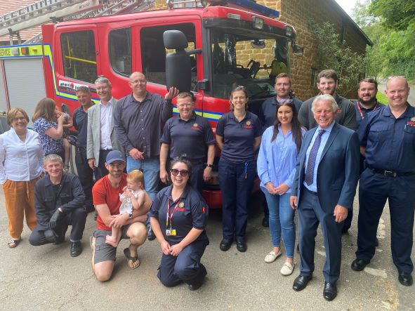

Shotteswell resident Gareth Jenkins holding his daughter Pippa with chimney sweep Paul Braggins (front left) and representatives from Cadent, Warwickshire Fire and Rescue and Shotteswell Village Hall. Also WCC Portfolio Holder Andy Crump (fourth from left) and County Councillor Chris Mills (front right) next to Group Commander Scott Moultrie (far right) [All photos: WRCC]
We may be in the grip of a summer heatwave, but as Gareth Jenkins and 18 month old Pippa (pictured above) from Shotteswell found out on Friday, it’s never too early to get your chimney swept!
While professional chimney sweep Paul Braggins did a great job, local gas distribution network Cadent and Warwickshire Fire and Rescue joined together with Shotteswell Warm Hub and rural charity WRCC to campaign for increased awareness of home safety measures. And thanks to Cadent’s Warm Hub sponsorship, several households’ chimneys around the village are being swept for free.
“Don’t put off sweeping your chimney until it’s too late,” warned Gareth, who was delighted to take part in this community initiative. “Nothing’s more important than your family’s safety!”
Warwickshire Fire and Rescue also carried out a full Safe and Well Check at his property. This is a free service which includes providing fire advice, looking for fire hazards, inspecting electrical sockets and identifying risks of slips and trips. The team installed a new smoke alarm as well - if the worst happens, having an alarm can give you extra time to escape a fire and save your life.

Councillor Andy Crump, WCC Portfolio Holder for Fire and Rescue and Community Safety, said: “We want everyone to stay safe during the colder months this year, so think about the last time your chimney was swept and plan ahead. Our safe and well checks are great for ensuring residents remain independent and safe in their homes.”
Although Shotteswell isn’t connected to mains gas, Cadent made sure a new carbon monoxide alarm was also fitted in the property for safety. Poisonous, odourlesss carbon monoxide can be found in homes where chimneys haven’t been swept regularly and don’t have sufficient ventilation – or when people recklessly use barbecues indoors (warning: never do this at home!).

Cadent Social Programme Manager Edward Allard added: “It’s important that organisations work together to educate everyone on the signs, symptoms, and dangers of carbon monoxide. Regularly sweeping your chimney and installing a carbon monoxide alarm are simple, effective methods to stay safe at home. Cadent also provides free alarms via the Warm Hub network.”

“We know many people in rural communities will light fires to help stay warm this winter, and faced with the increasing costs of living, it’s important you don’t try to save money by cutting corners on safety,” commented Ben Zammett, Shotteswell Village Hall Committee Chair. “Get your chimney swept now and it’s one less thing to worry about!”
Kim Slater, WRCC Chief Executive, concluded: “Thanks to everyone involved for coming together to support this campaign in Shotteswell. The Warm Hub project targets fuel affordability, promotes energy efficiency and helps to keep people safe and warm at home - it’s great to be able to share such an important and positive safety message.”

PHOTOS ATTACHED
ENDS
------------------------------------------------------------------------------------------------------------------------------------------------
NOTES TO EDITORS
WRCC
WRCC has been working to support vital villages in Warwickshire for over 80 years. The charity’s mission is to help rural communities become thriving, vibrant and sustainable places where people want to live and work. The charity’s core services include running its Back&4th community transport service, advising village hall committees, managing a Warwickshire energy consortium and supporting affordable housing projects. WRCC is a member of the ACRE Network (Action with Communities in Rural England).
WARM HUBS AND THE MOBILE WARM HUB

The Warm Hub project in Warwickshire and Solihull, sponsored by Cadent, has the following key objectives:
- to target social isolation by creating inclusive activities that bring people and communities together
- to target fuel poverty by promoting energy efficient and cost saving measures, and helping people to stay safe and warm at home
WRCC accredited its first Warm Hub at Shotteswell Village Hall (December 2020), followed by a second at The Crawford Memorial Hall in Bidford (September 2021) and another at The Pavilion, Meriden Sports Park (February 2022). Several more are planned over the next 16 months. WRCC started its complementary Mobile Warm Hub service in May 2021, which has so far run community cafes at 19 locations and also supported deliveries and collections for Warwick District Foodbank.
To find out more, please contact Jackie Holcroft, WRCC Warm Hubs Project Manager - call 01789 842182/07523 911394 or email jackieh@wrccrural.org.uk
SHOTTESWELL
Shotteswell is a small village situated in a conservation area within South Warwickshire with approximately 260 (2017) residents. It does not have shops or a pub, so the village hall is much valued by residents and the key place where villagers come together.
The hall is an old schoolhouse gifted in trust to the local community 48 years ago. It has served the community well and is currently in use most days of the week. The use of the hall has increased significantly over the last few years although this was of course affected by Covid and the related restrictions that came into effect. To find out more about Shotteswell Village Hall and its community activities, please call Ben Zammett on 01295 738564 or email info@shotteswellvillagehall.co.uk.
CADENT

Cadent is the UK’s largest gas distribution network with a 200-year legacy. We are in a unique position to build on strong foundations whilst encouraging the curiosity to think differently and the courage to embrace change. Day to day we continue to operate, maintain and innovate the UK’s largest gas network, transporting gas safely and protecting people in an emergency. Our skilled engineers and specialists remain committed to the communities we serve, working day and night to ensure gas reaches 11 million homes from Cumbria to North London and the Welsh borders to East Anglia, to keep your energy flowing.

Cadent manages the national gas emergency service free phone line on behalf of the gas industry - 0800 111 999 (all calls are recorded and may be monitored). Cadent Gas Ltd is owned by a consortium of global investors.
------------------------------------------------------------------------------------------------------------------------------------------------
WRCC, Warwick Enterprise Park, Wellesbourne, Warwick CV35 9EF
Tel: 01789 842182 enquiries@wrccrural.org.uk www.wrccrural.org.uk

WRCC (Warwickshire Rural Community Council) is a registered charity No.1081017
and a Company Limited by Guarantee in England and Wales No. 3930819

