PRESS RELEASE
FRIDAY 11th NOVEMBER 2022
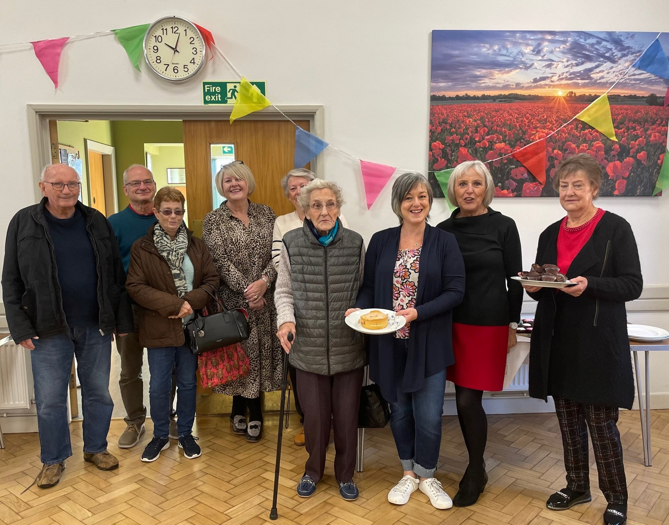
[PHOTOS: Some of the Salford Priors residents attending their weekly Warm Hub (left); Kim James, Salford Priors Parish Council and Anne White, WRCC, discussing energy saving tips (right)]
SALFORD PRIORS WARM HUB ENERGISES COMMUNITY!

Salford Priors’ Community Café Warm Hub is doing everything it can to help people facing spiralling living costs this winter. This week’s Thursday morning event at the Memorial Hall, attended by 30 people, was supported by rural charity WRCC’s Warm Hubs team who focused on how to keep on top of your energy bills, what to do if you’re struggling, and practical tips on keeping warm and safe at home.
“It’s a worrying time as so many households are finding it harder to manage with the rise in energy, food and mortgage costs, especially with Christmas coming around the corner,” said Anne White, WRCC Warm Hubs Project Co-ordinator. “But there are still things you can do, such as carefully checking your energy bills each month (even if you have a smart meter) and raising any concerns with your supplier, using appliances such as slow cookers or air fryers rather than ovens, and making sure you’re claiming any grants you may be entitled to. And don’t forget home safety - you may be able to get a free Safe and Well visit from Fire and Rescue Services!”
One of the most important things is to talk to other people, whether you need advice on energy use or cost-effective cooking, home safety or money matters, or just want a chat to keep your spirits up. Being in touch with others is so important for practical support and personal wellbeing, and that’s where Salford Priors Warm Hub really comes into its own. As Parish Council Vice Chair Kim James, who organises the weekly free community cafe, explains:
“As soon as you come through the door, you’ll be welcomed by our volunteers and offered a hot drink with toast or teacakes – and today everyone can enjoy free soup and a roll as part of our new Winter Warmer meals on offer. There’s plenty of people to chat to and you’ll find a really friendly community spirit. Just what you need to cheer you up on a cold winter’s day!”
There’s lots to do at the community café, including playing board games, dominoes, chess or cards, or browsing through a good book (and the Mobile Library makes regular stops). Residents can pop in for a few minutes or the full two hours to relax, use the hall’s wifi and not have to turn

their own heating on for a while. Energy information flyers and materials are also available and you can be put in touch with other organisations to get help and advice. And everyone’s welcome!
This free community event runs from 10.00 am – 12.00 noon every Thursday at Salford Priors Memorial Hall, School Road, Salford Priors WR11 8XD.
Salford Priors Warm Hub is a member of WRCC’s Warm Hubs network. This network has now rapidly expanded to support many more community groups and venues in Warwickshire and Solihull who are starting up Winter Warm Hubs to help residents facing the cost of living crisis. Visit www.wrccrural.org.uk/wrcc-warm-hubs for your nearest Warm Hub or Winter Warm Hub and links to energy information, available grants, support organisations and other useful resources.

ENDS

NOTES TO EDITORS

WARM HUBS PROJECT

WRCC’s Warm Hubs project, supported by Cadent, helps communities tackle social isolation and fuel poverty throughout Warwickshire and Solihull. Our charity works with parish councils, village hall committees and other community groups to create inclusive, community led Warm Hubs, running activities that encourage people to come together in safe, warm, welcoming places.

We organise energy themed events, promote energy efficient and cost saving measures to help people stay safe and warm at home – including free energy information packs and carbon monoxide alarms – and are developing additional resources to help residents and venues, including Slow Cooker Courses, Warm Hub Energy Champion training, Winter Warmth items and Winter Warm Hub start-up grants.

Our charity provides support via our expanding network of Warm Hubs run by local community volunteers, including our new Winter Warm Hubs (running initially up to 31st March 2023 with the possibility of converting to permanent Warm Hubs thereafter), and our Mobile Warm Hub service which runs free community cafes and supports Community Pantries and Foodbanks.

To find out more about the Warm Hubs, Winter Warm Hubs, and the Mobile Warm Hub service, please visit www.wrccrural.org.uk/wrcc-warm-hubs.
To see our network of Warm Hubs and Winter Warm Hubs (updated on a regular basis), please visit www.wrccrural.org.uk/warm-hubs-network.

Or contact Jackie Holcroft, WRCC Energy, Sustainability and Warm Hubs Project Manager, on 01789 842182/07523 911394 or via email: jackieh@wrccrural.org.uk
WRCC
WRCC (Warwickshire Rural Community Council) is a charity which has been working to support vital villages in Warwickshire (and Solihull) for 85 years. The charity’s mission is to help rural communities become thriving, vibrant and sustainable places where people want to live and work. The charity’s core services include managing the Warm Hubs project in Warwickshire and Solihull, running its Back&4th community transport service, advising village hall committees, managing an oil syndicate and supporting affordable housing projects. WRCC is also a member of the ACRE Network (Action with Communities in Rural England).

------------------------------------------------------------------------------------------------------------------------------------------------
WRCC, Warwick Enterprise Park, Wellesbourne, Warwick CV35 9EF
Tel: 01789 842182 warmhubs@wrccrural.org.uk www.wrccrural.org.uk

WRCC (Warwickshire Rural Community Council) is a registered charity No.1081017
and a Company Limited by Guarantee in England and Wales No. 3930819

