PRESS RELEASE
Friday 9th DECEMBER 2022
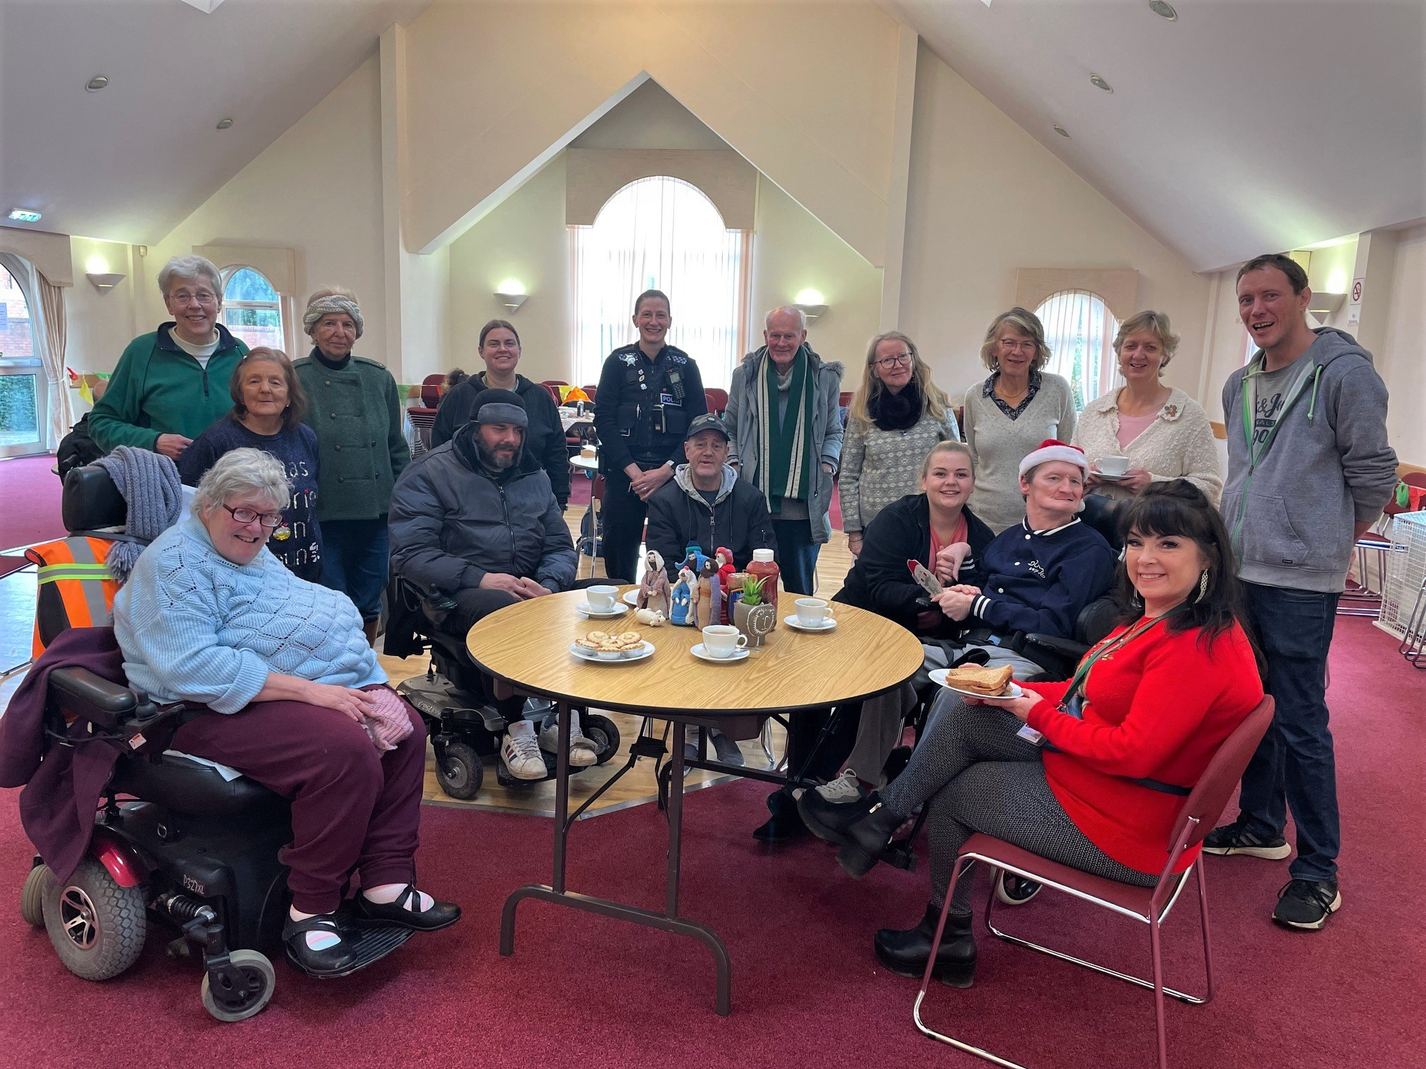
PHOTO: Kenilworth residents with WRCC, Compassionate Kenilworth, SVP Kenilworth and local police enjoying mince pies and bacon sandwiches at the Winter Warm Hub
KENILWORTH WINTER WARM HUB - GETTING READY FOR CHRISTMAS!

There was lots of festive cheer at last Tuesday’s Kenilworth Winter Warm Hub. Over 35 people came together to start the seasonal celebrations with mince pies and Christmas decoration making, and everyone enjoyed the bright, cheerful community atmosphere at St Francis of Assisi’s Church. “It’s just what’s needed,” said Graham, who’s been coming since the free weekly event started last month. “It’s good to meet new people - and the bacon sandwiches are great!”
This event is part of WRCC (Warwickshire Rural Community Council)’s Warm Hubs initiative, sponsored by Cadent Gas, which runs throughout Warwickhire and Solihull. Warm Hubs are warm, safe places where people can enjoy refreshments and activities such as board games, puzzles, crafts and books. Plus there’s energy saving tips, home safety information, free carbon monoxide alarms, and links to other community support services, eg Safer Neighbourhood police.
Most importantly, everyone who comes to a Warm Hub is made to feel welcome and part of a community. Magda, another regular attendee, added: “I have found friendship, support and an open door from people who I never knew before.” Some people drop in for a coffee and a quick chat, whereas others stay all morning (9.00am – 1.00pm) to enjoy all the activities on offer.
Kenilworth’s Winter Warm Hub is one of more than fifty new events that have been started by WRCC and local groups such as Compassionate Kenilworth and Kenilworth SVP to support communities across the county this winter. There will be a special Kenilworth Christmas event at St Francis’s Church on Tuesday 20th December, when Santa will be dropping by so bring the

children along too - everyone’s invited to wear Christmas jumpers, take part in Christmas crafts and activities, and enjoy special seasonal treats!
Pauline Hayward, Compassionate Kenilworth, said: “Compassionate Kenilworth is delighted to be partnering with WRCC and SVP to run this weekly Winter Warm Hub. You can find our full list of local community hubs at www.compassionatekenilworth.co.uk and on our Facebook page.”
Jackie Holcroft, WRCC Warm Hubs Manager, said: “It’s great to be able to support Kenilworth residents and many thanks to our partners Compassionate Kenilworth, the SVP team who have welcomed us to this fantastic community space and our sponsor Cadent. We’re really enjoying meeting and chatting to so many local people – and everyone’s welcome to join in the fun at our free weekly community event!”
Kenilworth’s Winter Warm Hub runs from 9.00am – 1.00pm every Tuesday (except for 27th December) at St Francis of Assisi RC Church, Warwick Road, Kenilworth CV8 1HL, until 28th March 2023. On 13th December and 14th February, due to pre-existing bookings the event will be held at the Methodist Church, New Priory Road, Kenilworth CV8 1LQ.
You can find your nearest Warm Hub in Warwickshire at www.wrccrural.org.uk/warm-hubs-network.

ENDS

NOTES TO EDITORS

WARM HUBS PROJECT

WRCC’s Warm Hubs project, supported by Cadent, helps communities tackle social isolation and fuel poverty throughout Warwickshire and Solihull. Our charity works with parish councils, village hall committees and other community groups to create inclusive, community led Warm Hubs, running activities that encourage people to come together in safe, warm, welcoming places.

We organise energy themed events, promote energy efficient and cost saving measures to help people stay safe and warm at home – including free energy information packs and carbon monoxide alarms – and are developing additional resources to help residents and venues, including Slow Cooker Courses, Warm Hub Energy Champion training, Winter Warmth items and Winter Warm Hub start-up grants.

Our charity provides support via our expanding network of Warm Hubs run by local community volunteers, including our new Winter Warm Hubs (running initially up to 31st March 2023 with the possibility of converting to permanent Warm Hubs thereafter), and our Mobile Warm Hub service which runs free community cafes and supports Community Pantries and Foodbanks.

To find out more about the Warm Hubs, Winter Warm Hubs, and the Mobile Warm Hub service, please visit www.wrccrural.org.uk/wrcc-warm-hubs.
To see our network of Warm Hubs and Winter Warm Hubs (updated on a regular basis), please visit www.wrccrural.org.uk/warm-hubs-network.
Or contact Jackie Holcroft, WRCC Energy, Sustainability and Warm Hubs Project Manager, on 01789 842182/07523 911394 or via email: jackieh@wrccrural.org.uk

WRCC
WRCC (Warwickshire Rural Community Council) is a charity which has been working to support vital villages in Warwickshire (and Solihull) for 85 years. The charity’s mission is to help rural communities become thriving, vibrant and sustainable places where people want to live and work. The charity’s core services include managing the Warm Hubs project in Warwickshire and Solihull, running its Back&4th community transport service, advising village hall committees, managing an oil syndicate and supporting affordable housing projects. WRCC is also a member of the ACRE Network (Action with Communities in Rural England).

------------------------------------------------------------------------------------------------------------------------------------------------
WRCC, Warwick Enterprise Park, Wellesbourne, Warwick CV35 9EF
Tel: 01789 842182 warmhubs@wrccrural.org.uk www.wrccrural.org.uk

WRCC (Warwickshire Rural Community Council) is a registered charity No.1081017
and a Company Limited by Guarantee in England and Wales No. 3930819

