PRESS RELEASE
Monday 23rd January 2023
SHIPSTON WINTER WARM HUB WELCOMES
BRITISH MOTOR MUSEUM!

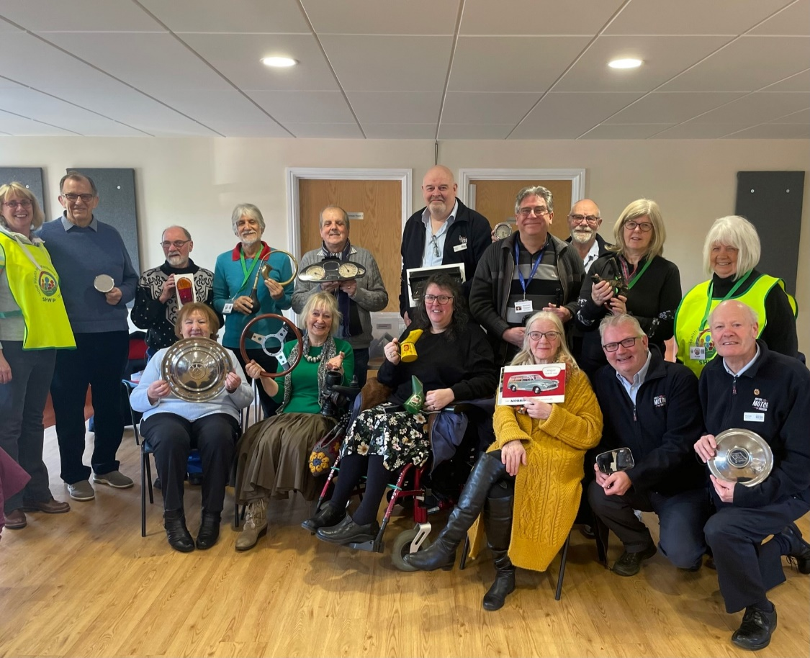

Photo: Shipston and Stour area residents displaying a few of the artefacts from the British Motor Museum, brought by Jim Ellison (second right) and his team, with Mayor Councillor Marianne Westwood (centre) and Stour Health and Wellbeing Partnership volunteers.

Residents from Shipston and the Stour area were treated to a very interactive Winter Warm Hub last week, thanks to a team from the British Motor Museum who brought their amazing Memory Boxes to the Scout Hut. There were all sorts of fascinating objects to identify, plus horns to honk, steering wheels to wave, stories to share and classic car magazines to reminisce over! “It was really lovely to see all the motoring artefacts and to meet the museum volunteers who were so keen to share their knowledge”, said Mayor Councillor Marianne Westwood.
And it wasn’t just the locals who had a great time – the motor experts were equally enthusiastic about their visit, which was free thanks to Warm Hubs funding from the Arts Council. “What a great venue and engaging audience!” commented team leader Jim Ellison, who’s hoping to visit several more Warm Hubs after their successful road trip to Shipston.

Shipston’s Winter Warm Hub has been running on Thursday mornings at the Scout Hut since October, and has become a popular social event. This week visitors from Alderminster Village Hall, who’ve just started their own hub, also came along to share tips and experiences. Michael, who’s a Shipston regular, explains how important the social aspect of Warm Hubs is: “I live on my own and it’s important for me to get out of the house and meet new people. Yesterday I went to another Warm Hub at Wellesbourne and here today I met someone who’s invited me to a walking group. Now I’m joining up with them tomorrow!”
The event is run jointly by the Stour Health and Wellbeing Partnership and WRCC, the charity running the Warm Hubs project in Warwickshire which now has a network of nearly 100 community hubs! Each hub is different but they all provide welcoming, warm and safe places for residents to meet up. People can also get free energy saving information and materials, carbon monoxide alarms, home safety advice and access to other community support organisations.
Jackie Holcroft, WRCC Warm Hubs Manager, said: “It’s fantastic to see the British Motor Museum supporting Warm Hubs, and it’s a great example of what we can achieve when community groups and other organisations come together to help residents’ wellbeing and support our communities.”

Vanessa Compton from SHWP concluded: “Thank you again to the British Motor Museum for such an enjoyable morning! This is the latest in many of the free activities we’ve run on Thursdays, from craft sessions to Tai Chi testers, CPR and defib training to flu clinics, and watch out for our Tea and Tech session coming soon too. Everyone’s welcome to come along, whether you just want to pop in for a quick chat or stay and enjoy friendly company and fun activities all morning!”

Shipston’s Winter Warm Hub runs every Thursday from 9.00am – 1.00pm at the Scout Hut, New Street, Shipston on Stour CV36 4EW.

Find more WRCC Warm Hubs and Winter Warm Hubs in Stratford District at: www.wrccrural.org.uk/warm-hubs-network

Find more hubs in Shipston at: https://www.shwp.org.uk/news/shipston-on-stour-warm-hubs/

To find out more about this community initiative by the British Motor Museum, please email Emma or Jim at community@britishmotormuseum.co.uk or call 01926 895238.

ENDS
------------------------------------------------------------------------------------------------------------------------------------------------

Additional photos:

Jim Ellison explaining where the saying “couldn’t give two hoots” comes from
British Motor Museum volunteers sharing stories and steering wheels
Looking at old motor magazines with local residents

NOTES TO EDITORS

WARM HUBS PROJECT
WRCC’s Warm Hubs project, supported by Cadent, helps communities tackle social isolation and fuel poverty throughout Warwickshire and Solihull. Our charity works with parish councils, village hall committees and other community groups to create inclusive, community led Warm Hubs, running activities that encourage people to come together in safe, warm, welcoming places.

We organise energy themed events, promote energy efficient and cost saving measures to help people stay safe and warm at home – including free energy information packs and carbon monoxide alarms – and are developing additional resources to help residents and venues,
including Slow Cooker Courses, Warm Hub Energy Champion training, Winter Warmth items and most recently Winter Warm Hub start-up grants.

Our charity provides support via our expanding network of Warm Hubs run by local community volunteers, including our new Winter Warm Hubs (running initially up to 31st March 2023 with the possibility of converting to permanent Warm Hubs thereafter), and our Mobile Warm Hub service which runs free community cafes and supports Community Pantries and Foodbanks.

To find out more about the Warm Hubs, Winter Warm Hubs, and the Mobile Warm Hub service, please visit www.wrccrural.org.uk/wrcc-warm-hubs.
To see our network of Warm Hubs and Winter Warm Hubs (updated on a regular basis), please visit www.wrccrural.org.uk/warm-hubs-network.
Or contact Jackie Holcroft, WRCC Energy, Sustainability and Warm Hubs Manager, on 01789 842182/07523 911394 or via email: jackieh@wrccrural.org.uk
WRCC
WRCC (Warwickshire Rural Community Council) is a charity which has been working to support vital villages in Warwickshire (and Solihull) for 85 years. The charity’s mission is to help rural communities become thriving, vibrant and sustainable places where people want to live and work. The charity’s core services include managing the Warm Hubs project in Warwickshire and Solihull, running its Back&4th community transport service, advising village hall committees, managing an oil syndicate and supporting affordable housing projects. WRCC is also a member of the ACRE Network (Action with Communities in Rural England).

------------------------------------------------------------------------------------------------------------------------------------------------
WRCC, Warwick Enterprise Park, Wellesbourne, Warwick CV35 9EF
Tel: 01789 842182 enquiries@wrccrural.org.uk www.wrccrural.org.uk

WRCC (Warwickshire Rural Community Council) is a registered charity No.1081017
and a Company Limited by Guarantee in England and Wales No. 3930819

