PRESS RELEASE
Tuesday 25th April 2023
SHIPSTON LAUNCHES NEW COMMUNITY WARM HUB

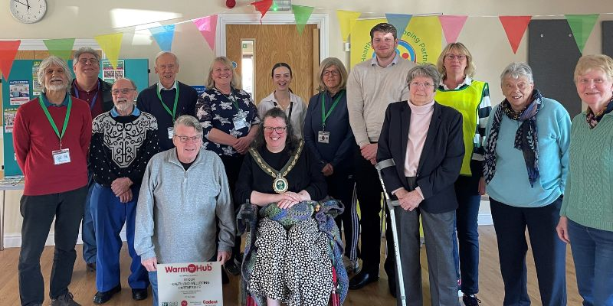

Shipston and Stour area residents celebrating their new Community Warm Hub at Shipston’s Scout Hut, with representatives from Stour Health and Wellbeing Partnership, WRCC, Cadent, WCC, Mayor Councillor Marianne Westwood (centre), and Geoff Boyling (kneeling) who helped to build the original Scout Hut!
Residents from Shipston and the Stour area came together last Thursday to celebrate the launch of their new Community Warm Hub with scones, cake and of course lots of cups of tea! We also welcomed a special surprise guest, Geoff Boyling, who helped to build the original Scout Hut in the early 1960s – it was really interesting to hear how much has changed since then but fortunately the sense of community spirit in Shipston is still very present.
Which is why the Stour Health and Wellbeing Partnership (SHWP) wanted to continue with their Thursday morning event at the Scout Hut, initially run as part of rural charity WRCC’s Winter Warm Hubs initiative. Over the winter, residents had been able to enjoy a friendly weekly welcome and free refreshments, board games and books, visits from the British Motor Museum and Warwickshire Wildlife Trust, Tai Chi testers and children’s crafts, flu clinics and defib training, energy saving advice and much more!
Thanks to WRCC’s ongoing Warm Hubs project, supported by Cadent, and a cost of living grant from Warwickshire County Council, the event will now be continuing as a permanent Community Warm Hub and all residents are very welcome to come along. “It’s really good to know it’s still carrying on,” said Michael, a regular attendee who’s also visited other Warm Hubs in the area.
“We’re thrilled to be running Shipston’s first Community Warm Hub and would like to thank all our supporters,” said Vanessa Compton, Chair of SHWP’s Executive Committee. “And watch out for lots more fun and free activities for all ages every week, such as nature walks, cost of living workshops, children’s summer activities and an unmissable performance from vintage singer

Betsy Harmony! Why not make Thursday mornings your regular time to meet up with friends, make new ones – and find out what else is going on locally?”
“Congratulations to Vanessa and all the SHWP team on the launch of their Community Warm Hub and all the fantastic community work they do locally,” added Jackie Holcroft, WRCC Warm Hubs Manager. “Warm Hubs are not just for winter – people need safe, inclusive “happy places” where they know they’ll be warmly welcomed and feel part of a community all year round. And of course we can still help provide advice where needed on saving energy, home safety and signposting to other organisations as the cost of living crisis sadly continues.”
“It was a pleasure to come to the launch of Shipston’s new Community Warm Hub,” said Mayor Councillor Marianne Westwood, who has attended previous events. “I’m sure it will continue to be a much needed community event for residents in Shipston and the local area.”
Edward Allard, Cadent’s Social Programmes Manager, concluded: “We’re delighted to celebrate Shipston’s Warm Hub joining our Warwickshire wide partnership with WRCC, and we know that several more members will also be coming on board over the next few weeks following the project’s additional winter support. This partnership is providing an increasingly important network of places for residents to enjoy social interaction as well as energy advice all year round.”

Shipston’s Community Warm Hub runs every Thursday from 10.00 am – 12.00 noon at the Scout Hut, New Street, Shipston on Stour CV36 4EW. For more information, please email admin@shwp.org.uk or visit www.shwp.org.uk/news

For more information about WRCC’s Warm Hubs project, please visit www.wrccrural.org.uk/wrcc-warm-hubs

ENDS
------------------------------------------------------------------------------------------------------------------------------------------------
Additional photo 1: Front (L-R): Shipston’s Mayor Councillor Marianne Westwood, Anne White (WRCC), Vanessa Compton (SHWP);
Back row (L-R): Stan Gordon (Mind), Bob Armstrong (SHWP), Dominika Stockham (WCC), Sarah Tolliday (SHWP) and Edward Allard (Cadent)
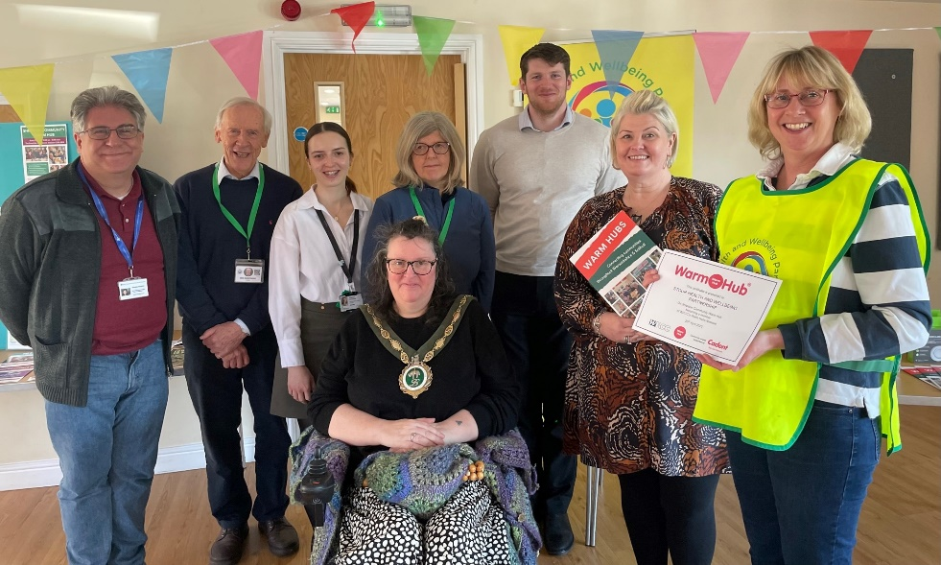

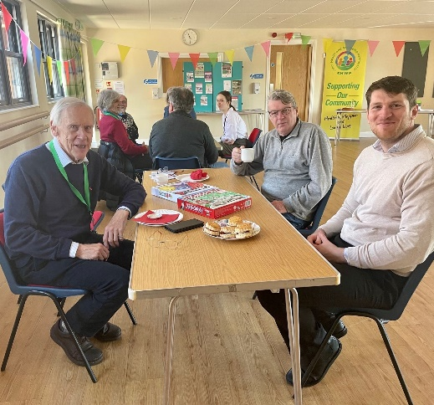
Additional photo (2) : Geoff Boyling sharing stories of the Scout Hut with Bob Armstrong, SHWP (front left) and Edward Allard, Cadent (front right)

NOTES TO EDITORS - WARM HUBS PROJECT
WRCC’s Warm Hubs project, supported by Cadent, helps communities tackle social isolation and fuel poverty throughout Warwickshire and Solihull. Since November 2020, our charity has worked with parish councils, town councils, village hall committees and other volunteer and community groups to create inclusive, community led Warm Hubs, running activities that encourage people to come together in safe, warm, welcoming places. We provide support via our expanding network of Warm Hubs run by local community volunteers, our Winter Warm Hubs initiative (which ran from October 2022 - March 2023) and our Mobile Warm Hub service which runs free community cafes around Warwickshire and Solihull.

WRCC also organises energy themed events, promote energy efficient and cost saving measures to help people stay safe and warm at home – including free energy information packs and carbon monoxide alarms – and are developing additional resources to help residents and venues,
including Slow Cooker Courses and Warm Hub Energy Champion training.

To find out more, please visit www.wrccrural.org.uk/wrcc-warm-hubs. We are currently updating our network of Warm Hubs as several of our Winter Warm Hubs now want to become permanent Warm Hubs. We also hope to provide further information about our Winter Warm Hubs initiative once the evaluation process has been completed. For more information, please contact Jackie Holcroft, WRCC Energy, Sustainability and Warm Hubs Manager, on 01789 842182/07523 911394 or via email: jackieh@wrccrural.org.uk

WRCC
WRCC (Warwickshire Rural Community Council) is a charity which has been working to support vital villages in Warwickshire (and Solihull) for 85 years. The charity’s mission is to help rural communities become thriving, vibrant and sustainable places where people want to live and work. The charity’s core services include managing the Warm Hubs project in Warwickshire and Solihull, running its Back&4th community transport service, advising village hall committees, managing an oil syndicate and supporting affordable housing projects. WRCC is also a member of the ACRE Network (Action with Communities in Rural England).
------------------------------------------------------------------------------------------------------------------------------------------------
WRCC, Warwick Enterprise Park, Wellesbourne, Warwick CV35 9EF
Tel: 01789 842182 enquiries@wrccrural.org.uk www.wrccrural.org.uk
WRCC (Warwickshire Rural Community Council) is a registered charity No.1081017
and a Company Limited by Guarantee in England and Wales No. 3930819

