PRESS RELEASE
Monday 11th July 2022

NEW COMMUNITY WARM HUB FOR WELLESBOURNE!

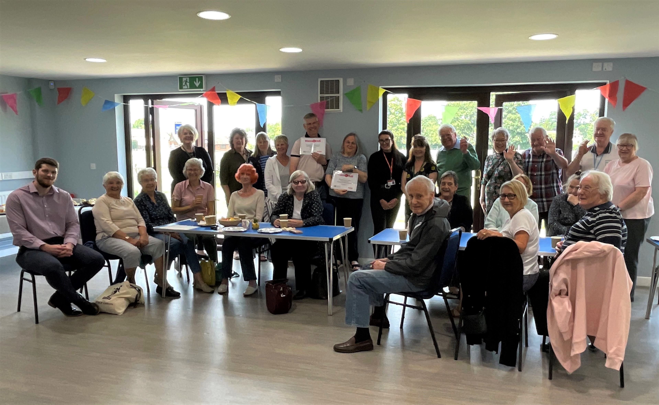

Wellesbourne residents celebrating the launch of their new Warm Hub at Wellesbourne Sports and Community Centre (all photos: WRCC)
Who doesn’t love a good afternoon tea? Wellesbourne residents certainly did as they celebrated the launch of their new community Warm Hub at Wellesbourne Sports and Community Centre on Monday 4th July. This followed on from the temporary weekly community cafes previously held at the centre by WRCC’s Mobile Warm Hub team.
The Warm Hubs project, run by Wellesbourne based rural charity WRCC and supported by local gas distribution network Cadent, helps communities in Warwickshire and Solihull fight social isolation. It helps to create inclusive, accessible events where local people can meet up, make new connections, and get more information about community support groups. Residents can also get free advice on reducing their energy bills and practical tips on keeping warm and safe at home, as well as carbon monoxide alarms and room thermometers.
Those attending Wellesbourne’s launch event were delighted to be having a permanent Warm Hub in the village. “I really look forward to Mondays!” said one resident. Others agreed: “There’s always a great atmosphere and it’s a really friendly group. We’re so glad it’s going to continue.”

Wellesbourne and Walton Parish Council Chair Anne Prior commented:
“We’re very pleased to support this sociable activity started by the Mobile Warm Hub team at our fantastic Sports and Community Centre. We hope to reach even more village residents now that the weekly coffee afternoon is becoming a permanent event.”
Graeme Russell, Wellesbourne Methodist Church and Community Missioner, added:
“We feel it’s important to have a regular place for local people to come, regardless of their circumstances or situation, where they can find a friendly face, a hot drink, and a conversation – we’re looking forward to seeing new people and making new friendships!”
WRCC Warm Hubs Project Co-ordinator Anne White said:
“We’re excited to welcome Wellesbourne as the fourth Warm Hub in our expanding network. Thank you to Anne, Graeme and all our regulars who have made Sue and me feel so welcome over the past few months – we’ll definitely be keeping in touch and calling in for coffee and chats!”
Edward Allard, Social Programmes Manager at Cadent, concluded:
“It was great to meet residents at Wellesbourne’s launch and it makes it clear how much communities value these events. Cadent is committed to Warm Hubs’ objectives of bringing people together in warm, safe spaces and providing free energy saving advice and support.”
Wellesbourne’s Warm Hub event runs every Monday afternoon from 2.00pm – 3.30pm at the Sports and Community Centre, Loxley Close, Wellesbourne. Free refreshments are served and everyone is welcome.
If you’re interested in setting up a Warm Hub, or would like the Mobile Warm Hub to visit your village, please email warmhubs@wrccrural.org.uk or visit www.wrccrural.org.uk/warm-hubs to find out more.

ENDS
------------------------------------------------------------------------------------------------------------------------------------------------

ADDITIONAL PHOTOS (attached separately)
Graeme Russell, Wellesbourne Methodist Church and Community Missioner (second left) and Councillor Anne Prior, Wellesbourne and Walton Parish Council Chair, receiving their Warm Hub certificates from Edward Allard, Cadent Social Programmes Manager (far left) and Kim Slater, WRCC CEO (far right)
Cutting the cake, below: Councillor Anne Prior, Wellesbourne and Walton Parish Council Chair (centre left) and Graeme Russell, Wellesbourne Methodist Church and Community Missioner (centre right), with Susan Greenway, WRCC Mobile Warm Hub Project Co-ordinator (far left), Jazzmine Bryce, Cadent Gas Project Co-ordinator, Anne White, WRCC Warm Hubs Project Co-ordinator (second right) and Edward Allard, Cadent Social Programmes Manager (far right)

NOTES TO EDITORS

WRCC
WRCC has been working to support vital villages in Warwickshire for over 80 years. The charity’s mission is to help rural communities become thriving, vibrant and sustainable places where people want to live and work. The charity’s core services include running its Back&4th community transport service, advising village hall committees, managing a Warwickshire energy consortium and supporting affordable housing projects. WRCC is a member of the ACRE Network (Action with Communities in Rural England).

WARM HUBS AND THE MOBILE WARM HUB
WRCC works with village halls, community groups and volunteers to target social isolation and loneliness in Warwickshire and Solihull via the Warm Hub Project, sponsored by Cadent, the UK’s largest gas distribution network.
WRCC accredited its first Warm Hub at Shotteswell Village Hall (December 2020), followed by a second at The Crawford Memorial Hall in Bidford (September 2021) and another at The Pavilion, Meriden Sports Park (February 2022). Several more are planned over the next 16 months. WRCC started its complementary Mobile Warm Hub service in May 2021, which has so far run community cafes at 20 locations and also supported deliveries and collections for Warwick District Food
To find out more about WRCC, Warm Hubs and the Mobile Warm Hub service, please contact Jackie Holcroft, WRCC Project Manager. Please call 01789 842182/07523 911394 or email jackieh@wrccrural.org.uk

------------------------------------------------------------------------------------------------------------------------------------------------
WRCC, Warwick Enterprise Park, Wellesbourne, Warwick CV35 9EF
Tel: 01789 842182 enquiries@wrccrural.org.uk www.wrccrural.org.uk

WRCC (Warwickshire Rural Community Council) is a registered charity No.1081017
and a Company Limited by Guarantee in England and Wales No. 3930819

