PRESS RELEASE
MONDAY 10th OCTOBER 2022
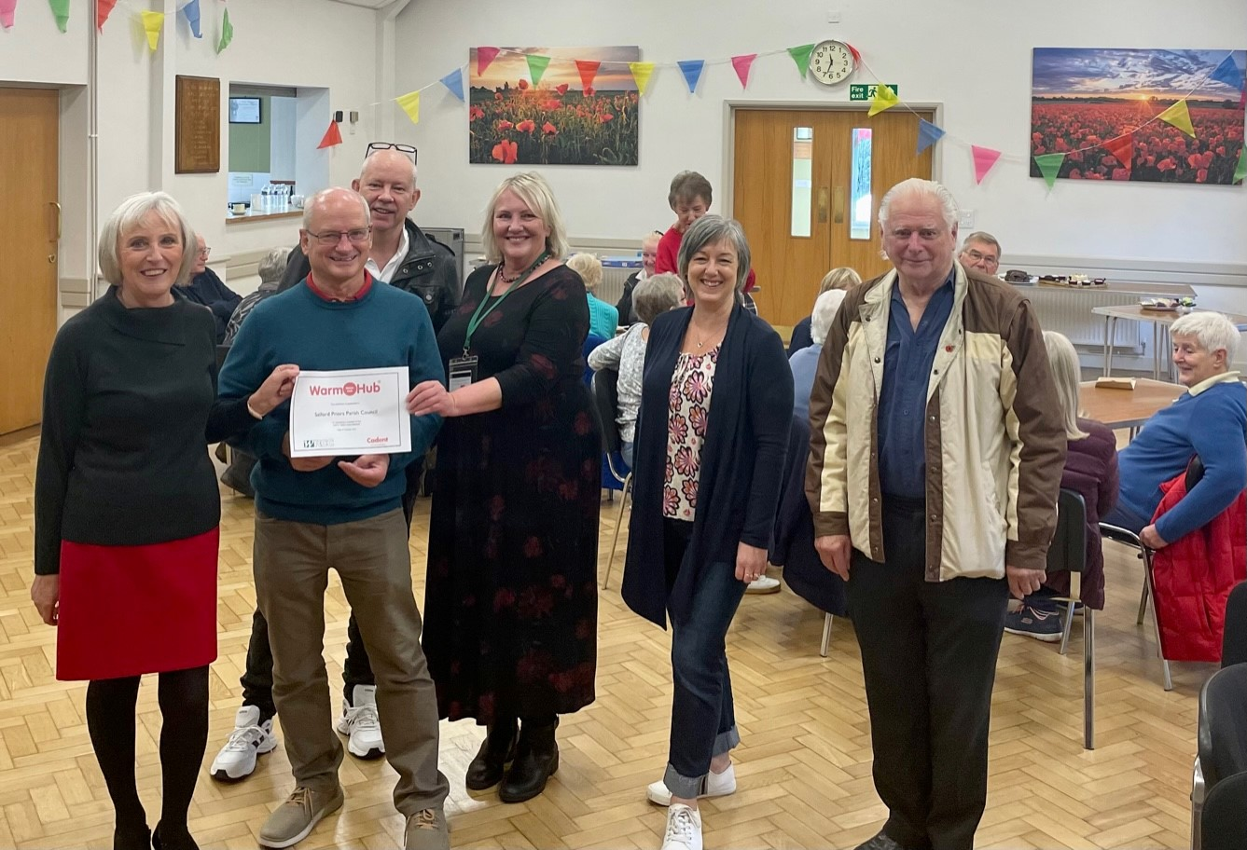
Salford Priors Parish Councillors receiving their Warm Hub certificate: L-R Rosemary Green and Kim James with Jackie Holcroft (WRCC), Clerk Donna Bowles (centre) and Councillors David Penn (right) and James Meakins (back)

SALFORD PRIORS WELCOMES ITS NEW WARM HUB!

There was plenty of cake, chat and community spirit at Salford Priors Memorial Hall last Thursday, when the Parish Council and rural charity WRCC came together to officially launch the village’s Warm Hub. The free community cafe will run at the hall every Thursday from 10.00am – 12.00 noon, supported by the Parish Council and local volunteers.
This new community event provides residents with a warm, welcoming place to come together and meet new people or catch up with old friends. As well as enjoying a good chat over free refreshments at the community café, people can play cards, dominoes or board games, or maybe dip into a good book courtesy of the Mobile Library, whose team attended Thursday’s event. And toast, teacakes and crumpets are now on the menu for next week!
Local resident Yvette had already been to a couple of earlier events and was a firm fan of the Warm Hub. She said: “Everyone’s so friendly! I have MS and can be a bit housebound, so this is a great way for me to get out and meet new people. I also think socialising with others is really important for everyone’s mental health.”

John, a member of the Memorial Hall committee, was pleased to see such a “brillant community event”. “It’s a wonderful initiative,” agreed his wife, Penny,” and I hope it goes from strength to strength!”
Kim James, Parish Council Vice Chair, explained why they had wanted to set up a Warm Hub:
“We thought it was important to create a warm, friendly space where people could feel at home, especially with winter approaching and the rising costs of living affecting everyone. Having visited Bidford’s popular Warm Hub, we decided that having our own Warm Hub in Salford Priors would be a great way to bring people together, including those who may be more vulnerable. And if anyone would like to get more involved, they’re welcome to join our team of community café volunteers!”
Jackie Holcroft, WRCC Warm Hubs Project Manager, commented:
“Congratulations to Salford Priors Parish Council, the newest member of WRCC’s growing Warm Hubs network! We’re delighted that residents can now come together in this lovely hall every Thursday to enjoy free refreshments in a fantastic community atmosphere. We look forward to continuing to collaborate with the Parish Council, helping people to access energy saving advice and stay safe and warm at home, and signposting to other community support services.”
Salford Priors’ Warm Hub community café runs every Thursday from 10.00am – 12.00 noon at The Salford Priors Memorial Hall, School Road, Salford Priors WR11 8XD.
Warm Hubs are community events set up in safe, warm places to bring people together for company, which can also offer information and advice on energy costs, the rising costs of living, home safety, and access to additional community support. WRCC’s Warm Hubs project, supported by Cadent Gas, connects communities throughout Warwickshire and Solihull. To find your local Warm Hub or discover how you can set up a Warm Hub (a limited number of WRCC set up winter grants are currently available), visit www.wrccrural.org.uk/wrcc-warm-hubs.

ENDS
------------------------------------------------------------------------------------------------------------------------------------------------

ADDITIONAL PHOTOS
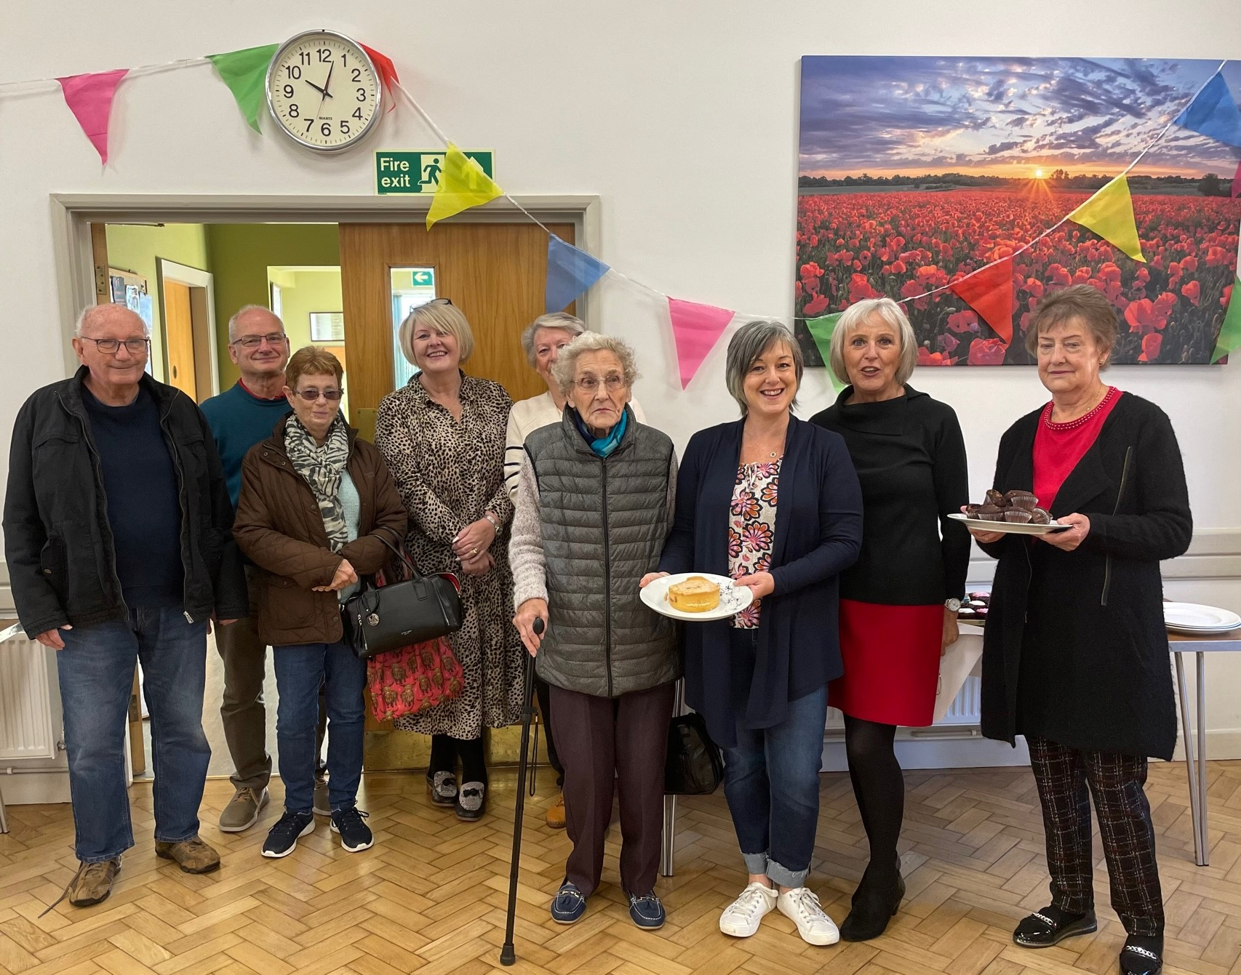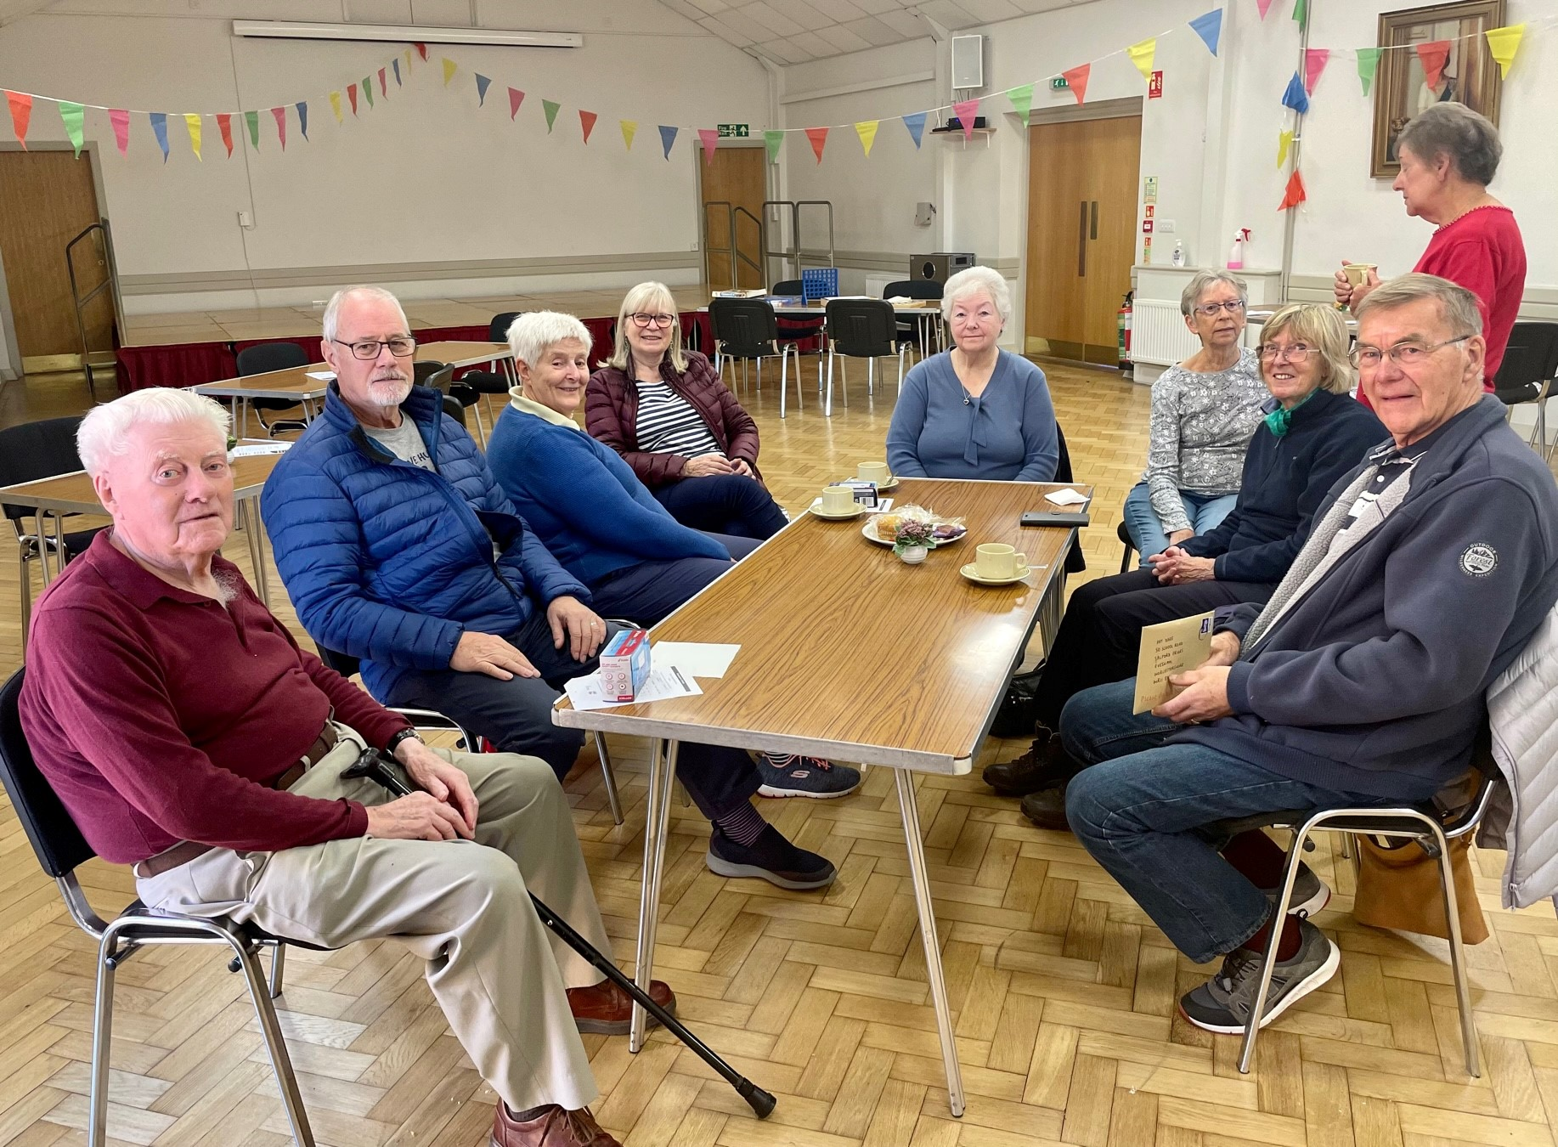

NOTES TO EDITORS

WARM HUBS PROJECT

WRCC’s Warm Hubs project, supported by Cadent, brings residents together and helps communities to tackle social isolation and fuel poverty throughout Warwickshire and Solihull. Our charity works with parish councils, village hall committees and other community groups to create inclusive, community led Warm Hubs, running activities that encourage people to come together in safe, warm, welcoming places.

We organise energy themed events, promote energy efficient and cost saving measures to help people stay safe and warm at home – including free energy information packs and carbon monoxide alarms – and are developing additional resources to help residents and venues (see below). Our charity provides support via our expanding network of Warm Hubs run by local community volunteers, including our new Winter Warm Hub opportunities, and our own Mobile Warm Hub service which runs free community cafes and supports local Foodbanks and Community Pantries.

To find out more about the Warm Hubs and the Mobile Warm Hub service, please visit our website. Or contact Jackie Holcroft, WRCC Energy, Sustainability and Warm Hubs Project Manager, on 01789 842182/07523 911394 or via email: jackieh@wrccrural.org.uk

WRCC
WRCC (Warwickshire Rural Community Council) is a charity which has been working to support vital villages in Warwickshire for 85 years. The charity’s mission is to help rural communities become thriving, vibrant and sustainable places where people want to live and work. The charity’s core services include running its Back&4th community transport service, advising village hall committees, managing a Warwickshire energy consortium and supporting affordable housing projects. WRCC is also member of the ACRE Network (Action with Communities in Rural England).

------------------------------------------------------------------------------------------------------------------------------------------------
WRCC, Warwick Enterprise Park, Wellesbourne, Warwick CV35 9EF
Tel: 01789 842182 warmhubs@wrccrural.org.uk www.wrccrural.org.uk

WRCC (Warwickshire Rural Community Council) is a registered charity No.1081017
and a Company Limited by Guarantee in England and Wales No. 3930819

