DRAFT PRESS RELEASE
Monday 19th December 2022
COMMUNITY COMES TOGETHER TO CELEBRATE
SHOTTESWELL WARM HUB’S SECOND ANNIVERSARY

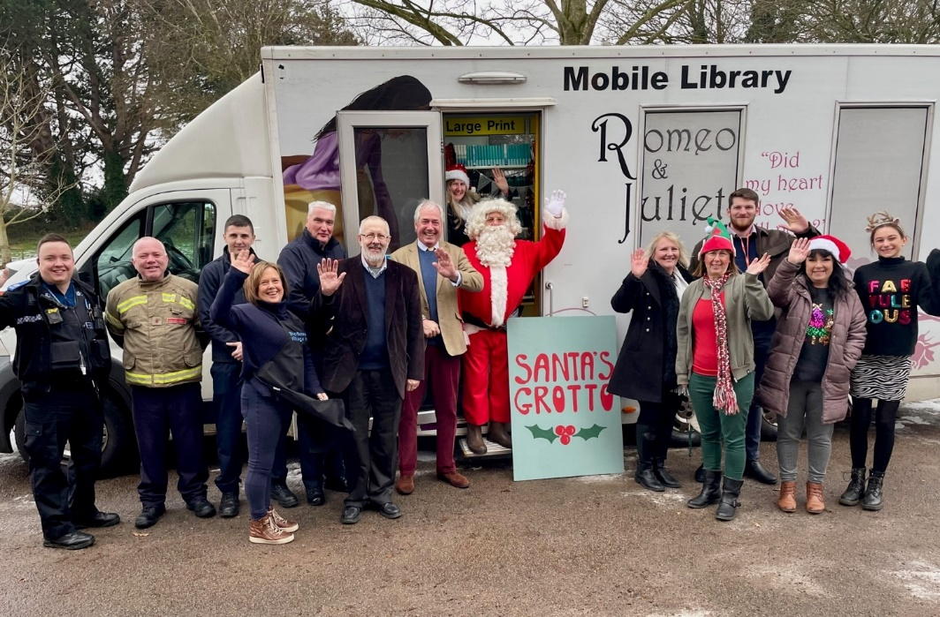

Photo: Shotteswell residents and volunteers celebrating with Father Christmas and the Lord Lieutenant of Warwickshire, centre, and representatives from Wellesbourne Police, Gaydon Fire Crew (Warwickshire Fire and Rescue Services), Warwickshire Mobile Library, WRCC and Cadent

It may have been a cold December Sunday in Shotteswell, but the community atmosphere at the Village Hall this weekend could not have been more warm and welcoming. Shotteswell Warm Hub attendees including regular volunteer Martha Pearson (above, far right) got into the spirit with festive jumpers and headgear, and Christmas carol music played in the background. The Mobile Library is a familiar sight in the village and driver Alison Staveley was happy to help transform it into a Grotto fit for Santa and his Elf on Sunday!
While inside the Village Hall, committee volunteers worked tirelessly to cook and serve 135 free tasty cooked breakfasts, to celebrate the second anniversary of Shotteswell’s Warm Hub. Tim Cox, Lord Lieutenant of Warwickshire, joined in the festive fun and spent the morning chatting to local residents and community support services. “I’m delighted to be in Shotteswell today,” he said. “The amazing atmosphere and wide age range of people here shows just how important this event is for local residents.”
Shotteswell’s monthly village breakfast event became the first Warm Hub in Warwickshire back in 2020, launched by local charity WRCC (Warwickshire Rural Community Council) whose Warm Hubs project in Warwickshire and Solihull is supported by Cadent Gas. There are now nearly 90
;:
Warm Hubs and Winter Warm Hubs in WRCC’s network! www.wrccrural.org.uk/warm-hubs-network
Warm Hubs vary from community to community – the focus may be on cooking breakfasts like Shotteswell, running coffee mornings, playing board games or enjoying crafts or other activities – but they all provide accessible warm, safe places for residents to meet up. People can also get free energy saving information and materials, carbon monoxide alarms, home safety advice and access to other community support organisations.
Jackie Holcroft, WRCC Warm Hubs Manager, said: “Congratulations to Shotteswell on a fantastic second anniversary event! It’s great that so many residents and volunteers have turned out today, and we’re really pleased that the community spirit has been further strengthened by support from the Emergency Services, the Mobile Library, the Lord Lieutenant and our sponsor Cadent.”

Edward Allard, Cadent’s Social Programmes Manager, added: “We’re delighted to celebrate the continued success of Shotteswell’s Warm Hub, the first in our Warwickshire wide partnership with WRCC. The Warm Hubs initiative is providing an increasingly important network of places for residents to enjoy social interaction as well as warmth and energy advice, this winter and beyond.”

Ben Zammett, Chair of Shotteswell Village Hall Committee, concluded: “Thank you to everyone for joining us today, and we were really pleased to see more new faces as well as our regulars joining us for this important occasion. We look forward to welcoming residents and community supporters to many more of our Warm Hub breakfasts in 2023!”

Shotteswell Warm Hub runs monthly on the third Sunday of each month from 9.00am -11.30am at Shotteswell Village Hall, Coronation Lane, Shotteswell OX17 1JF

For more information about WRCC’s Warm Hubs project, visit www.wrccrural.org.uk/wrcc-warm-hubs

ENDS
------------------------------------------------------------------------------------------------------------------------------------------------

Additional photos:

Local residents enjoying breakfast in the Village Hall
Children in Santa’s Grotto

NOTES TO EDITORS

WARM HUBS PROJECT
WRCC’s Warm Hubs project, supported by Cadent, helps communities tackle social isolation and fuel poverty throughout Warwickshire and Solihull. Our charity works with parish councils, village hall committees and other community groups to create inclusive, community led Warm Hubs, running activities that encourage people to come together in safe, warm, welcoming places.

We organise energy themed events, promote energy efficient and cost saving measures to help people stay safe and warm at home – including free energy information packs and carbon monoxide alarms – and are developing additional resources to help residents and venues,
including Slow Cooker Courses, Warm Hub Energy Champion training, Winter Warmth items and most recently Winter Warm Hub start-up grants.

Our charity provides support via our expanding network of Warm Hubs run by local community volunteers, including our new Winter Warm Hubs (running initially up to 31st March 2023 with the possibility of converting to permanent Warm Hubs thereafter), and our Mobile Warm Hub service which runs free community cafes and supports Community Pantries and Foodbanks.

To find out more about the Warm Hubs, Winter Warm Hubs, and the Mobile Warm Hub service, please visit www.wrccrural.org.uk/wrcc-warm-hubs.
To see our network of Warm Hubs and Winter Warm Hubs (updated on a regular basis), please visit www.wrccrural.org.uk/warm-hubs-network.
Or contact Jackie Holcroft, WRCC Energy, Sustainability and Warm Hubs Manager, on 01789 842182/07523 911394 or via email: jackieh@wrccrural.org.uk
WRCC
WRCC (Warwickshire Rural Community Council) is a charity which has been working to support vital villages in Warwickshire (and Solihull) for 85 years. The charity’s mission is to help rural communities become thriving, vibrant and sustainable places where people want to live and work. The charity’s core services include managing the Warm Hubs project in Warwickshire and Solihull, running its Back&4th community transport service, advising village hall committees, managing an oil syndicate and supporting affordable housing projects. WRCC is also a member of the ACRE Network (Action with Communities in Rural England).

------------------------------------------------------------------------------------------------------------------------------------------------
WRCC, Warwick Enterprise Park, Wellesbourne, Warwick CV35 9EF
Tel: 01789 842182 enquiries@wrccrural.org.uk www.wrccrural.org.uk

WRCC (Warwickshire Rural Community Council) is a registered charity No.1081017
and a Company Limited by Guarantee in England and Wales No. 3930819

