PRESS RELEASE
Tuesday 14th December 2021
SHOTTESWELL WARM HUB CELEBRATES FIRST CHRISTMAS ANNIVERSARY

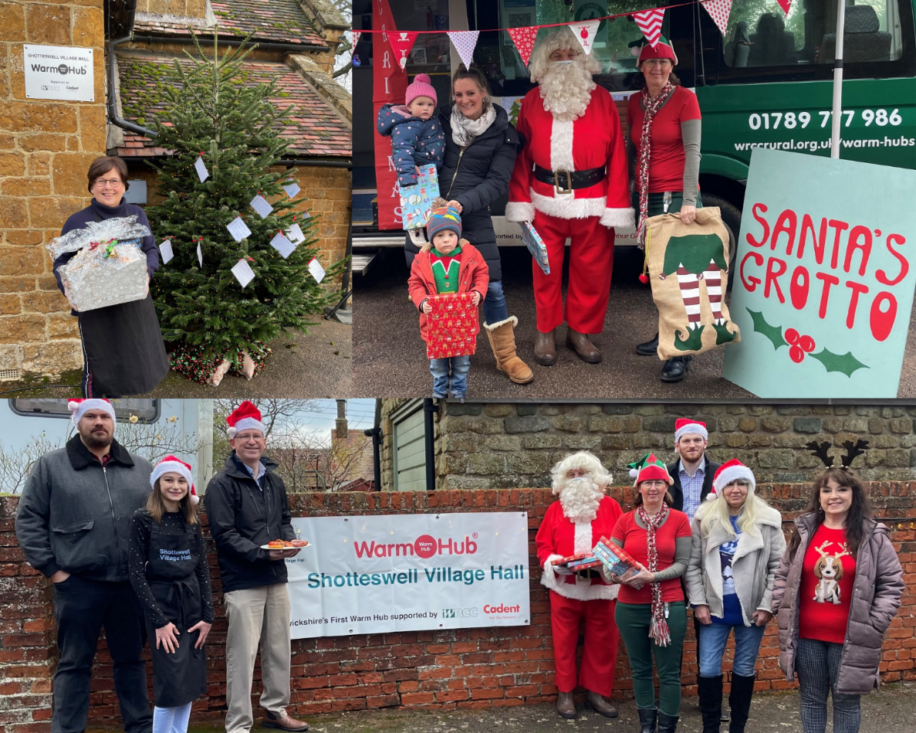

Photos: Top left, Hilary Wareing (Shotteswell Village Hall Committee) with prize hamper; top right, Father Christmas and his Elf with local children outside his Mobile Grotto; bottom, Jeremy Wright MP (with breakfast) with Santa, residents and Committee members, and WRCC and Cadent representatives
Shotteswell Village Hall welcomed some special visitors to last Sunday’s Breakfast Club, to help celebrate its first anniversary as a Warm Hub. There were “oohs” and “aahs” in abundance from younger children when they saw Santa and his Mobile Grotto, while other residents enjoyed a chat with local MP Jeremy Wright over their delicious cooked breakfasts.

Shotteswell Committee members were determined to give the community a Christmas treat, while also taking Covid related precautions, including booking timed half hour meal slots, additional outdoor seating and offering takeaway and home delivery options. “It’s so nice to be able to do anything Christmassy after last year!” said many of those attending, who’d really been looking forward to the event.

As well as enjoying breakfast, with fresh produce supplied by local farm shop Carpenters, residents could win a free hamper of Christmas goodies by completing a short survey, including suggesting new activities they’d like to see in the Hall. The children – all of whom had been very good this year, according to Father Christmas! – received presents and could decorate their own cards while listening to Christmas carols and songs. And they loved seeing the Gaydon crew’s fire engine too.

Jeremy Wright MP commented: “It was a pleasure to help celebrate Shotteswell Warm Hub’s birthday. All those involved deserve huge credit for spreading warmth in every sense to the local community.” WRCC (who run Warm Hubs in Warwickshire, as well as the Mobile Warm Hub minibus service with VASA) and Cadent (who sponsor the project) were also delighted with the festive community atmosphere.

Jackie Holcroft, WRCC Project Manager, said: “Congratulations to Shotteswell on their first anniversary as a Warm Hub and it’s fantastic to see how much everyone is enjoying today’s event! We’re excited about working with the community to create new inclusive social activities in 2022.”

Edward Allard, Cadent Customer Safeguarding Manager, added: “It’s hard to believe a year has already passed since we launched our first Warm Hub at Shotteswell. The Committee has worked to keep the community connected in the face of Covid restrictions, and Cadent looks forward to supporting more initiatives to target social isolation and improve residents’ wellbeing.”

Ben Zammett, Chair of Shotteswell Village Hall Committee, concluded: “It’s been a challenging year for everyone but our monthly Sunday Breakfast Club is going strong. We’re proud of what we’ve achieved so far and plan to support our village in other ways by working closely with our Warm Hub partners next year.”

ENDS
------------------------------------------------------------------------------------------------------------------------------------------------

NOTES TO EDITORS
WRCC
WRCC has been working to support vital villages in Warwickshire for over 80 years. The charity’s mission is to help rural communities become thriving, vibrant and sustainable places where people want to live and work. The charity’s core services include running its Back&4th community transport service, advising village hall committees, managing a Warwickshire energy consortium and supporting affordable housing projects. WRCC is a member of the ACRE Network (Action with Communities in Rural England).
WRCC is working with village halls and community groups to target social isolation and loneliness in Warwickshire and Solihull by setting up Warm Hubs and the Mobile Warm Hub, both supported by Cadent Gas, the UK’s largest gas distribution network. WRCC currently has accredited Warm Hubs in Shotteswell and Bidford, with more planned for 2022 including venues in Meriden, Kenilworth, Arley and Ansley. WRCC launched its Mobile Warm Hub initiative with VASA in May 2021, and its mobile minibus café travels around the county visiting village halls and also supporting Warwick District Food Bank with deliveries and collections on a weekly basis.
To find out more about WRCC, Warm Hubs and the Mobile Warm Hub service run in partnership with VASA, please contact Jackie Holcroft, WRCC Warm Hubs Project Manager, on 07523 911394 or email jackieh@wrccrural.org.uk

SHOTTESWELL
Shotteswell is a small village situated in a conservation area within South Warwickshire with approximately 260 (2017) residents. It does not have shops or a pub, so the village hall is much valued by residents and the key place where villagers come together.
The hall is an old schoolhouse gifted in trust to the local community 48 years ago. It has served the community well and is currently in use most days of the week. The use of the hall has increased significantly over the last few years although this was of course affected by Covid and the related restrictions that came into effect.
To find out more about Shotteswell Village Hall and its community activities, please call Ben Zammett on 01295 738564 or email info@shotteswellvillagehall.co.uk.

CADENT

Cadent is the UK’s largest gas distribution network with a 200-year legacy. We are in a unique position to build on strong foundations whilst encouraging the curiosity to think differently and the courage to embrace change. Day to day we continue to operate, maintain and innovate the UK’s largest gas network, transporting gas safely and protecting people in an emergency. Our skilled engineers and specialists remain committed to the communities we serve, working day and night to ensure gas reaches 11 million homes from Cumbria to North London and the welsh borders to East Anglia, to keep your energy flowing.

Cadent manages the national gas emergency service free phone line on behalf of the gas industry - 0800 111 999 (all calls are recorded and may be monitored). Cadent Gas Ltd is owned by a consortium of global investors.

------------------------------------------------------------------------------------------------------------------------------------------------
WRCC, Warwick Enterprise Park, Wellesbourne, Warwick CV35 9EF
Tel: 01789 842182 enquiries@wrccrural.org.uk www.wrccrural.org.uk

WRCC (Warwickshire Rural Community Council) is a registered charity No.1081017
and a Company Limited by Guarantee in England and Wales No. 3930819

