PRESS RELEASE
Monday 28th February 2022

MERIDEN WELCOMES NEW COMMUNITY WARM HUB

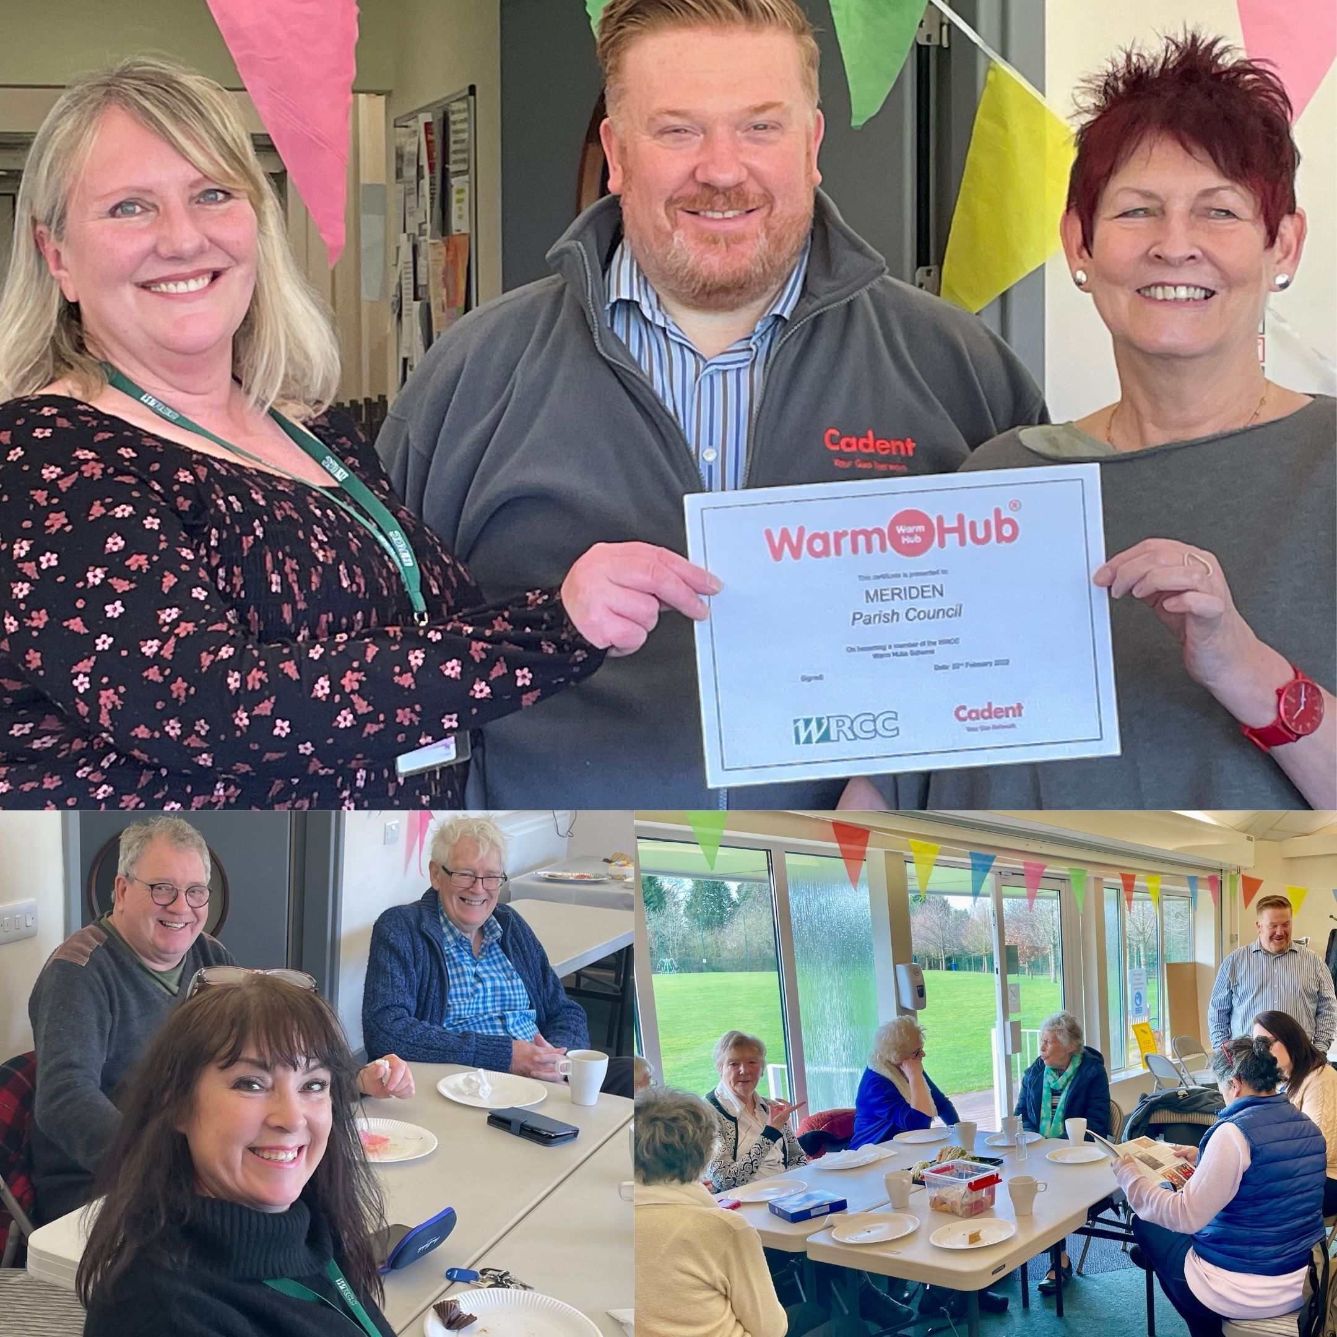

[Top, L-R] Jackie Holcroft (WRCC Project Manager) and Phil Burrows (Head of Cadent Customer Vulnerability Social Programme Delivery) presenting the Warm Hub certificate to Councillor Rosie Weaver BEM (Meriden Parish Council Chair), with some of the residents at the Warm Hub launch event [below]
Photos: WRCC – additional group photos attached
On Tuesday 22nd February, residents gathered at the Sports Park Pavilion to celebrate the official launch of Meriden’s very own community Warm Hub. This follows on from the weekly visits the Mobile Warm Hub minibus (run by Warwickshire charities WRCC and VASA) made to the Pavilion from October to December last year, encouraging people to socialise in a warm, safe and welcoming space.

The Warm Hubs project in Warwickshire and Solihull helps local communities fight social isolation by creating inclusive, accessible events - like Meriden’s free coffee mornings - where everyone can come together to have a good chat, make new connections, and get helpful information about community support groups.
Residents can also get advice on taking steps to reduce their energy bills and practical tips to keep warm and safe at home, plus free carbon monoxide alarms and room thermometers. The project is supported by sponsor Cadent, as well as by other community organisations such as environmental charity Act on Energy on an informal basis.
Local residents are delighted that the Warm Hub is becoming a permanent fixture in village life. “I like meeting new people and when the minibus came last year, it helped me to start mixing with people after lockdowns,” said one. “It’s a great event and we’re looking forward to coming back again – thank you!” commented others.
Meriden Parish Council were keen to launch the weekly event and build on the community engagement created by the Mobile Warm Hub last year. Parish Council Chair Rosie Weaver BEM said:
“This is such an important initiative for the residents of Meriden parish, especially with all our fuel bills rising and the end of Covid restrictions. We all need to support each other!”
Jackie Holcroft, WRCC Warm Hubs Project Manager, added:
“Congratulations to Meriden Parish Council! We’re really excited to launch our third Warm Hub here, following the ongoing success of our Warm Hubs in Shotteswell and Bidford. We look forward to continuing to collaborate with the Parish Council and helping to make a positive difference to the wellbeing of residents in Meriden.”
Phil Burrows, Head of Cadent Customer Vulnerability Social Programme Delivery, concluded:
It’s fantastic to support a project like Warm Hubs, especially in the current challenging times with communities’ increasing needs for social interaction as well as warmth and energy advice. Many thanks to both teams at WRCC and Meriden for making the event such a success!”
Meriden’s Warm Hub event runs every Tuesday (from 8th March) from 10.30am – 12.30pm in The Pavilion, Meriden Sports Park. Free coffee/tea and biscuits are served and everyone is welcome.
If you’re interested in setting up a Warm Hub, or would like the Mobile Warm Hub to visit your village, please email jackieh@wrccrural.org.uk or visit www.wrccrural.org.uk/warm-hubs to find out more.

ENDS
------------------------------------------------------------------------------------------------------------------------------------------------

NOTES TO EDITORS

WRCC
WRCC has been working to support vital villages in Warwickshire for over 80 years. The charity’s mission is to help rural communities become thriving, vibrant and sustainable places where people want to live and work. The charity’s core services include running its Back&4th community transport service, advising village hall committees, managing a Warwickshire energy consortium and supporting affordable housing projects. WRCC is a member of the ACRE Network (Action with Communities in Rural England).

WARM HUBS AND THE MOBILE WARM HUB
WRCC is working with village halls and community groups to target social isolation and loneliness in Warwickshire by setting up Warm Hubs and the Mobile Warm Hub, both supported by Cadent Gas, the UK’s largest gas distribution network.
WRCC accredited the first Warwickshire Warm Hub at Shotteswell Village Hall in December 2020, followed by a second at The Crawford Memorial Hall in Bidford, and launched the Mobile Warm Hub initiative with VASA in May 2021.
To find out more about WRCC, Warm Hubs and the Mobile Warm Hub service, please contact Jackie Holcroft, WRCC Project Manager. Please call 01789 842182/07523 911394 or email jackieh@wrccrural.org.uk

------------------------------------------------------------------------------------------------------------------------------------------------
WRCC, Warwick Enterprise Park, Wellesbourne, Warwick CV35 9EF
Tel: 01789 842182 enquiries@wrccrural.org.uk www.wrccrural.org.uk

WRCC (Warwickshire Rural Community Council) is a registered charity No.1081017
and a Company Limited by Guarantee in England and Wales No. 3930819

