PRESS RELEASE
Monday 20th September 2021

NEW COMMUNITY WARM HUB LAUNCHES IN BIDFORD

Presenting the Warm Hub certificate to Bidford Parish Council: (L-R) Edward Allard, Cadent Gas (Customer Safeguarding Manager), Tom Robinson and Nigel Winnan (Customer and Social Obligations Strategy Manager) both from Wales & West Utilities, Kim Slater, WRCC (Chief Executive) and Parish Councillors Bill Fleming (Chair), Fred Hiscocks and Tereza Cullum.
Photos: Charlie Budd, The Tall Photographer.
Last Wednesday, local residents gathered at The Crawford Memorial Hall in Bidford to celebrate the official launch of their very own community Warm Hub. This follows on from the weekly visits the Mobile Warm Hub minibus (run by Warwickshire charities WRCC and VASA) had made to Bidford since May, which supported people to socialise in a friendly, safe outdoors space.
The Warm Hub project in Warwickshire helps local communities fight social isolation by creating inclusive, accessible events - like Bidford’s free coffee morning - where everyone can come together to have a good chat, make new connections, and get helpful information about community support groups. Long term resident Pamela is one of many people who’re happy that the Warm Hub has become a permanent fixture in village life: “It’s so important to get out of the house and keep in touch with others”, she emphasised.
Bill Fleming, Parish Council Chair, was determined to launch the weekly event in the village hall, as the outdoors mobile coffee morning had made such a difference to people over the past few months. “It came at just the right time for the community, and the Parish Council is delighted to be carrying on the great work that the Mobile Warm Hub started”, he said. “I’m sure the minibus

team will still be popping in for coffee and a chat now and then!”
There’s lots of ways in which the new Warm Hub can benefit Bidford residents. Shevaun Greef, local Midcounties Co-op community champion, confirmed that as well as continuing to provide volunteering support and refreshments, the store will encourage their local suppliers to offer tasting sessions at future events.
And Cadent Gas and Wales & West Utilities, collaborating to support the project in Bidford, are also going to attend some sessions to answer questions about energy efficiency and home safety, and provide people with practical tips on keeping warm and saving money. The launch took place during Gas Safety Week.
Kim Slater, WRCC Chief Executive, said:
“We’re thrilled to be launching our second Warwickshire Warm Hub in Bidford, following the ongoing success of our first Warm Hub in Shotteswell, and WRCC looks forward to accrediting more in the months to come.
Congratulations to the Parish Council for running the Warm Hub and thanks to Cadent Gas and Wales & West Utilities for their support. It’s great to see so many people and organisations coming together to create this community-led event, helping Bidford tackle the big issues of social isolation and loneliness which have been greatly worsened by Covid-19.”
Bidford Warm Hub’s community event runs every Wednesday from 10.00am – 12.00 noon in The Crawford Memorial Hall.
If you’re interested in setting up a Warm Hub, or would like the Mobile Warm Hub to visit your village, please email warmhubs@wrccrural.org.uk or visit www.wrccrural.org.uk/warm-hubs to find out more. WRCC has commissioned a short video about the project, which was filmed at last week’s event and will be shared in due course.
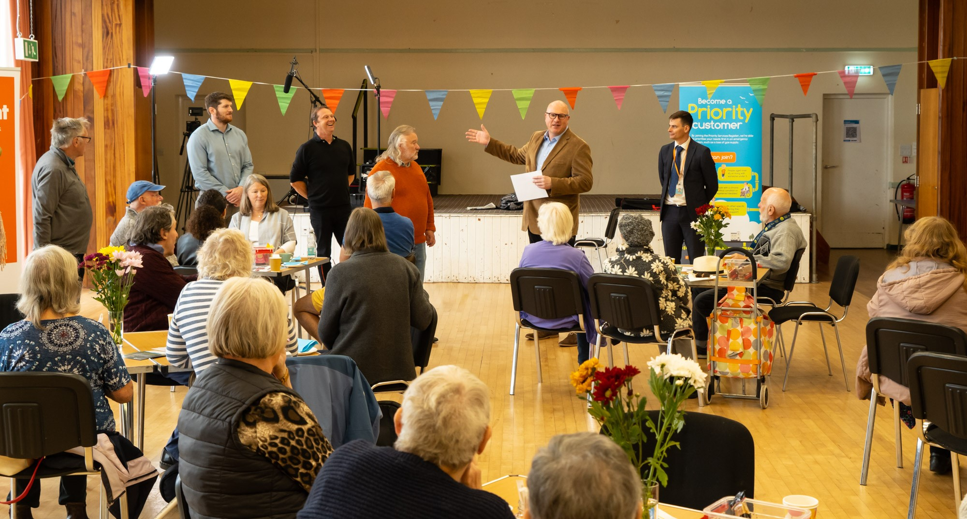

ENDS
------------------------------------------------------------------------------------------------------------------------------------------------

NOTES TO EDITORS

WRCC
WRCC has been working to support vital villages in Warwickshire for over 80 years. The charity’s mission is to help rural communities become thriving, vibrant and sustainable places where people want to live and work. The charity’s core services include running its Back&4th community transport service, advising village hall committees, managing a Warwickshire energy consortium and supporting affordable housing projects. WRCC is a member of the ACRE Network (Action with Communities in Rural England).

WARM HUBS AND THE MOBILE WARM HUB
WRCC is working with village halls and community groups to target social isolation and loneliness in Warwickshire by setting up Warm Hubs and the Mobile Warm Hub, both supported by Cadent Gas, the UK’s largest gas distribution network. Cadent are collaborating with Wales & West Utilities to support the Warm Hub in Bidford.
WRCC accredited the first Warwickshire Warm Hub at Shotteswell Village Hall in December 2020 and launched the Mobile Warm Hub initiative with VASA in May 2021.
To find out more about WRCC, Warm Hubs and the Mobile Warm Hub service, please contact Jackie Holcroft, WRCC Projects Coordinator. Call 01789 842182/07523 911394 or email jackieh@wrccrural.org.uk

------------------------------------------------------------------------------------------------------------------------------------------------
WRCC, Warwick Enterprise Park, Wellesbourne, Warwick CV35 9EF
Tel: 01789 842182 enquiries@wrccrural.org.uk www.wrccrural.org.uk

WRCC (Warwickshire Rural Community Council) is a registered charity No.1081017
and a Company Limited by Guarantee in England and Wales No. 3930819

