PRESS RELEASE
MONDAY 10th OCTOBER 2022

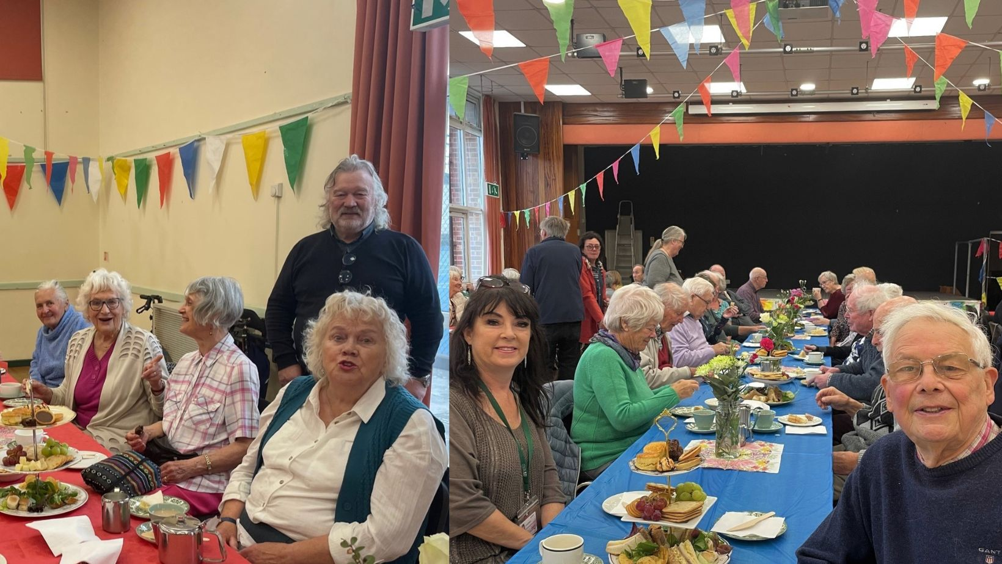
Enjoying the afternoon tea and birthday celebrations: left, Parish Council Chair Bill Fleming, with Ann and friends from Bidford; right, Sue Greenway, WRCC, with Bob and other Bidford residents

HAPPY BIRTHDAY TO BIDFORD WARM HUB!

Over 80 people came together in the Crawford Memorial Hall on Wednesday to celebrate the Bidford Warm Hub’s first birthday. Residents enjoyed a fantastic free four hour afternoon tea, with china cups and cakestands to match, and the hall was beautifully decorated with colourful bunting. Singer Kitten von Mew gave a fabulous performance, ending by leading a rousing chorus of “Happy Birthday”. And all agreed that the hardworking team of Bidford Warm Hub volunteers, led by the Fleming family, had put on a party to remember!
The Bidford Warm Hub is a free weekly community coffee morning which has run since September 2021 (its original birthday event was postponed following the Queen’s death). It regularly attracts more than 50 locals every Wednesday. Bidford residents Tony and Sue are long term regulars and wouldn’t miss their weekly social morning - “It’s become a focal point of my week,” said Tony. And Phyllis, who’s been coming since the event first started, agreed, adding: “It’s a reason to put my lipstick on and get out of the house! Most importantly, it’s our happy place.”
Bill Fleming, Parish Council Chair and Bidford Warm Hub organiser, explained why this community event is so popular:

“Our Warm Hub is more than just a free coffee morning. Everyone’s welcome and people genuinely feel they’re part of a friendly community. We’ve seen some of our residents’ confidence grow hugely over the past year and that’s helped them to reach out to other groups and do other activities that they wouldn’t have done without coming here first. And if anyone needs additional support, especially with winter coming up, we can try to help as well as putting them in touch with WRCC and other community support organisations.”
Jackie Holcroft, WRCC Warm Hubs Project Manager, commented:
“It’s fantastic to see the difference the Bidford Warm Hub has made to the local community! WRCC was delighted to work with the Parish Council to launch the Warm Hub last year, and we congratulate everyone who’s helped to make this event such an important part of village life. We look forward to continuing to collaborate with them, to help support Bidford residents.”
Bidford’s Warm Hub runs every Wednesday from 10.00am – 12.00 noon at The Crawford Memorial Hall, Salford Road B50 4EZ.
Warm Hubs are community events set up in safe, warm places to bring people together for company, which can also offer information and advice on energy costs, the rising cost of living, home safety, and access to additional community support. WRCC’s Warm Hubs project, supported by Cadent Gas, runs throughout Warwickshire and Solihull. To find your local Warm Hub or discover how you can set up a Warm Hub (a limited number of WRCC set up grants are currently available), visit www.wrccrural.org.uk/wrcc-warm-hubs.

ENDS
------------------------------------------------------------------------------------------------------------------------------------------------

NOTES TO EDITORS

WARM HUBS PROJECT

WRCC’s Warm Hubs project, supported by Cadent, brings residents together and helps communities to tackle social isolation and fuel poverty throughout Warwickshire and Solihull. Our charity works with parish councils, village hall committees and other community groups to create inclusive, community led Warm Hubs, running activities that encourage people to come together in safe, warm, welcoming places.

We organise energy themed events, promote energy efficient and cost saving measures to help people stay safe and warm at home – including free energy information packs and carbon monoxide alarms – and are developing additional resources to help residents and venues (see below). Our charity provides support via our expanding network of Warm Hubs run by local community volunteers, including our new Winter Warm Hub opportunities, and our own Mobile

Warm Hub service which runs free community cafes and supports local Foodbanks and Community Pantries.

To find out more about the Warm Hubs and the Mobile Warm Hub service, please visit our website. Or contact Jackie Holcroft, WRCC Energy, Sustainability and Warm Hubs Project Manager, on 01789 842182/07523 911394 or via email: jackieh@wrccrural.org.uk

WRCC
WRCC (Warwickshire Rural Community Council) is a charity which has been working to support vital villages in Warwickshire for 85 years. The charity’s mission is to help rural communities become thriving, vibrant and sustainable places where people want to live and work. The charity’s core services include running its Back&4th community transport service, advising village hall committees, managing a Warwickshire energy consortium and supporting affordable housing projects. WRCC is also member of the ACRE Network (Action with Communities in Rural England).

------------------------------------------------------------------------------------------------------------------------------------------------
WRCC, Warwick Enterprise Park, Wellesbourne, Warwick CV35 9EF
Tel: 01789 842182 warmhubs@wrccrural.org.uk www.wrccrural.org.uk

WRCC (Warwickshire Rural Community Council) is a registered charity No.1081017
and a Company Limited by Guarantee in England and Wales No. 3930819

