PRESS RELEASE
Monday 30th August 2021
MOBILE WARM HUB HELPS BEAT SOCIAL ISOLATION IN BIDFORD

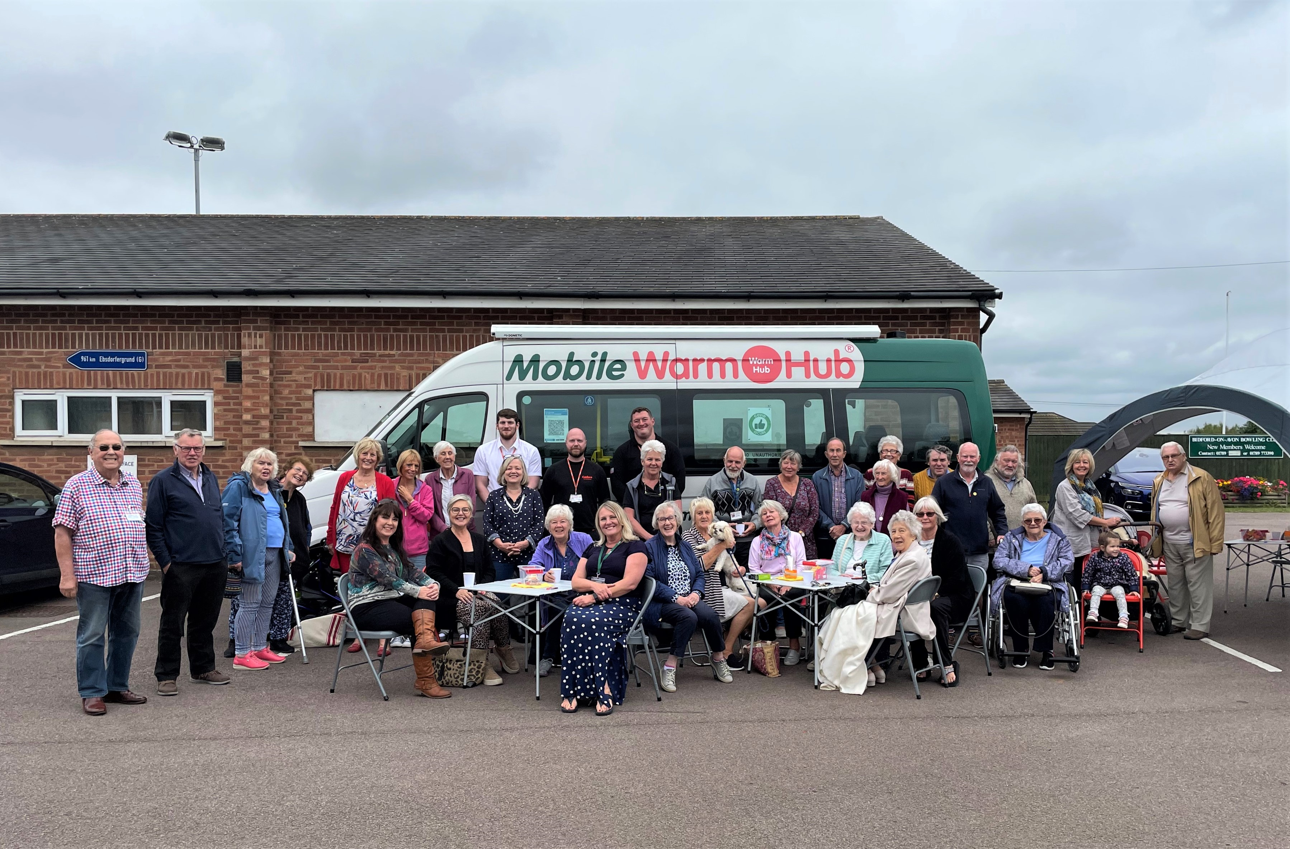

The Mobile Warm Hub community minibus has been visiting Bidford since May and last Wednesday was its busiest coffee morning yet, with nearly 50 people in total joining in the fun. Run by Warwickshire charities WRCC and VASA, and sponsored by Cadent Gas, the bus goes out on a daily basis and is doing its bit to beat social isolation in communities around the county. On Wednesdays it parks in the Crawford Memorial Hall car park and local residents come along to enjoy free refreshments and lots of friendly chat outdoors. And what a Bidford success story it’s been!
Just ask regular attendee Phyllis, who plans her week around the event. “It’s been a light at the end of the tunnel,” she declared, “which gives us a purpose and something to look forward to.” Andrew, who‘s been coming since the start, agrees. He welcomes the informal socialising and shared support from volunteers and other residents, particularly as many other events have been suspended for so long.
The best thing about it is the people I’ve met,” said Pamela, who like many people had lost confidence due to lockdown. She enjoys the coffee mornings so much that when the minibus couldn’t come one week, she got together with her friend Sue and other residents to hold their own mini event in Sue’s garden! “It’s so important to keep in contact with others”, she added.

The Mobile Warm Hub has helped create a new focus for community collaboration in Bidford, supported by the Parish Council. Bidford Midcounties Co-op sends a volunteer (and extra chocolate biscuits!) and community band Upbeat regularly entertains residents. Stratford Time Bank and WCAVA joined in with the community spirit last week, along with a team from Cadent Gas, who provided practical advice on home safety and warmth and free carbon monoxide monitors. The minibus also carries flyers and information from other support groups and organisations on board.
Bill Fleming, Parish Council Chair, is delighted with the community project: “It’s kept Bidford people in touch with each other, especially those who wouldn’t otherwise have had anywhere to go, and no one to chat to face to face. It’s made such a difference to the local community.”
Attendees have enjoyed the regular event so much that they’ve been asking what would happen when the Mobile Warm Hub has to move on to its next location. The good news is that, from mid September, Bidford Parish Council will be running its own permanent Warm Hub event, accredited by WRCC, inside the Crawford Memorial Hall. Watch out for the launch update coming soon!
Jackie Holcroft, WRCC Projects Co-ordinator, said:
“We’re delighted with the fantastic response our Mobile Warm Hub has received from the Bidford community, and we’ve really enjoyed meeting and chatting with local people every week. We’re also grateful to Cadent for supporting this important project. WRCC is looking forward to supporting Bidford Parish Council with its new Warm Hub, which will continue to help the community come together and tackle social isolation and loneliness.”
Susan Greenway, VASA Project Co-ordinator, commented:
“This shows what charities and community groups can achieve when we work together. And we’d like to thank our amazing VASA and WRCC volunteers for giving their time to support this project and for helping to bring a bit more happiness into people’s lives.”
If you’d like the Mobile Warm Hub to visit your community (the minibus goes out each week on Mondays – Fridays), or you’d like to discuss setting up a Warm Hub in your village, please email jackieh@wrccrural.org.uk. And we’re always looking for more volunteers – please email sue@vasa.org.uk if you’d like to join our friendly team.
You can find more information at www.wrccrural.org.uk/warm-hubs

ENDS
------------------------------------------------------------------------------------------------------------------------------------------------

NOTES TO EDITORS
WRCC
WRCC has been working to support vital villages in Warwickshire for over 80 years. The charity’s mission is to help rural communities become thriving, vibrant and sustainable places where people want to live and work. The charity’s core services include running its Back&4th community transport service, advising village hall committees, managing a Warwickshire energy consortium and supporting affordable housing projects. WRCC is a member of the ACRE Network (Action with Communities in Rural England).
WRCC is working with village halls and community groups to target social isolation and loneliness in Warwickshire by setting up Warm Hubs and the Mobile Warm Hub, both supported by Cadent Gas, the UK’s largest gas distribution network. WRCC accredited the first Warwickshire Warm Hub at Shotteswell Village Hall in December 2020 and launched the Mobile Warm Hub initiative with VASA in May 2021.
To find out more about WRCC, Warm Hubs and the Mobile Warm Hub service run in partnership with VASA, please contact Jackie Holcroft, WRCC Projects Coordinator. Call 01789 842182/07523 911394 or email jackieh@wrccrural.org.uk

VASA
VASA is a charity in South Warwickshire that connects people through community activities, including carer support, memory clubs, community allotments and volunteer transport in Rugby and South Warwickshire. Plus our Mobile Warm Hub minibus, run in partnership with WRCC, which covers all of Warwickshire.
To find out more about VASA’s community work, please contact Janis Robinson, Communities Manager, on 01789 777986 or email janis@vasa.org.uk.
To find out more about VASA’s work with the Mobile Warm Hub, please contact Susan Greenway, Project Co-ordinator, on 01789 777986 or email sue@vasa.org.uk

------------------------------------------------------------------------------------------------------------------------------------------------
WRCC, Warwick Enterprise Park, Wellesbourne, Warwick CV35 9EF
Tel: 01789 842182 enquiries@wrccrural.org.uk www.wrccrural.org.uk

WRCC (Warwickshire Rural Community Council) is a registered charity No.1081017
and a Company Limited by Guarantee in England and Wales No. 3930819

