Snitterfield Village Hall

COVID-19: ADDITIONAL TERMS AND CONDITIONS

These conditions may change to reflect government requirements and guidance. Just before your booked session check our website. The issue date is at the bottom of the page.

NOTES: All actions below are to be compliant at least to the government’s published guidance.

The Hall’s standard Terms and Conditions apply (attached to booking forms)

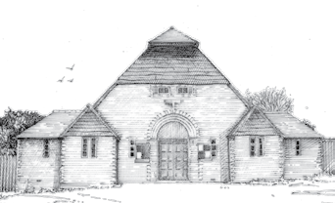
The hirer is to act as the C-19 Compliance Officer (CCO) to ensure these terms and conditions are obeyed.

The main door will be the entrance door for the Hall.

The exit door for the Main Hall will be the Right Hand side Fire Exit.

The CCO shall carry out the Get-In procedure (see file & website).

The CCO shall ensure Participant’s Behaviour (see file & website).

The CCO shall carry out the Get-Out procedure (see file & website).

The CCO shall prevent access to the restricted areas: stage, back room and store room.

