Snitterfield Village Hall

Covid-19 Participant Behaviour

Snitterfield Village Hall Committee has made the Hall as safe as is reasonably possible.

These instructions are as simple as possible relying on individual common sense to fill in any gaps.

You are responsible for your own and others’ safety. Do not enter unless you can carry out the requirements below.

Participants shall ...

- Wait outside/in vehicles until the scheduled start of the event.

2. Not attend if they have any transmittable illness or are feeling unwell. Any participant, who is detected as unwell, will be required to leave.

3. Wear their choice of PPE (visors, face covering, gloves, etc.) or none at all if maintaining a two- metre spacing.

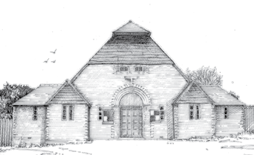
4. Sanitise their hands and select a seated position to sit/stand at, placing any personal items at that place (their place). On leaving all participants will remove all items including waste. Personal items such as equipment shall be sanitised before entry into the Hall.

5. Remain at their place during the course of the event. Do not mingle.

6. Circulate in a clockwise direction (even if it is not the shortest route) for the purposes of visiting the toilets or kitchen when leaving their place and maintain suitable social distancing.

7. The occupancy of the toilets and kitchen in restricted to two persons in the kitchen and one persons in each toilet, therefore reducing numbers in these pinch point area.

8. This access is supervised by the named hirer of the hall. Please queue if necessary.

9. Bring with them any cold drinks and food they wish to consume.

10. If hot drinks are provided by the hirer. Participants shall not exchange drinks or food unless they are from the same household or “bubble”.

11. Sanitise their hands before exiting and exit leaving a 2m gap between each person.

12. Comply with all signage.

