Snitterfield Village Hall

COVID-19 treatment plan

In the event of someone becoming unwell with suspected COVID-19 symptoms while at the hall you should:

- Send them home immediately

- Ask other members of your group to provide their contact details if you do not have them

- Ask the rest of your group to leave the premises, observing the usual hand sanitising and social distancing precautions

- Advise them to launder their clothes when they arrive home

- Inform our Bookings Secretary - Sharon Aust - Tel: 01789 730514 or 07501416221
email: saust1@btinternet.com

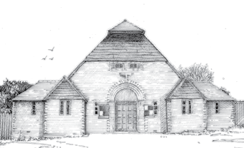
- If the unwell person needs to wait for a lift: -

      - Remove them to the safe waiting area, which is in the back room - a chair and washing bowl should already be there

      - Put on a mask, face shield, gloves & apron to protect yourself

      - Provide them with tissues, a plastic rubbish bag, a bowl of warm water & soap for hand washing & paper towels

      - Once they have been collected: -

- Remove gloves, apron and face mask to the rubbish bag*
- Leave face shield on top for disinfection
- Wash your hands for at least 20 seconds with warm soapy water
- Wait for a responsible committee member to arrive.
- Once home - launder all your clothes and wipe down disinfect your car

*Note that the waste should be double bagged and kept for 72 hours before being collected.

