Snitterfield Village Hall

Opening Announcements to be made by all Hirers

Maintain social distances as the current government advice/requirements.

Frequently sanitise your hands.

Stay in your place, except when visiting the toilets, or the kitchen, or collecting a hot drink.

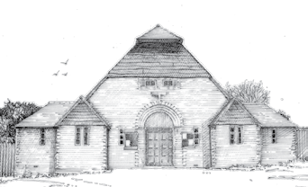
Use the clockwise circulation system around the hall.

No more than two persons in the kitchen and one in each of the toilets.

No exchange of food/drink unless members of the same household/bubble.

If you feel unwell go or be taken to the rear room, follow the instructions in the Covid-19 first aid box & leave the building as soon as possible.

Please follow these instructions to keep our hall and all users safe - thank you.

