Snitterfield Village Hall

GET-IN PROCEDURE

1. The hirer shall enter the Hall at the beginning of the booked session, at least 15 minutes before their scheduled event is to begin, locking the door behind them, and carry out the Get-In Procedure.

2. Check all hand washing and other signs are in place.

3. Check doors to the toilet lobby is latched/pegged open.

4. Move tables and chairs for their requirements using gloves placing them at a suitable distance for socially distancing

5. Wipe all surfaces down using their own cleaning equipment or that provided by the hall

6. Ensure hand sanitising is available throughout the hall

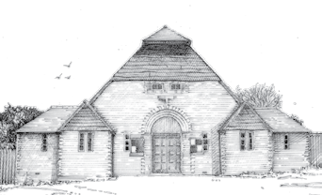
7. Open the right hand fire exit and all windows to ensure good ventilation.

8. Check arrivals are well and happy to attend.

9. Supervise arrivals separated to at least two metre distances.

10. Ensure the arrivals sanitise their hands.

11. Keep an attendance list of all participant’s contact details and retain for 21 days.

12. When the permitted number of attendees have arrived, shut the entrance door. Replacement participants can enter by substitution.

13. Ensure that no one, who is not a member of your party, enters, eg: to use the toilets.

14. Ensure that the seat positions, tables, etc. are not moved.

15. At the start of the meeting make the Opening Announcements.

Snitterfield Village Hall

GET-OUT PROCEDURE

1. Carry out basic cleaning of all surfaces that may have been touched, eg: toilets & cubicle doors, table/kitchen tops, chairs legs where they have been lifted, door handles, light switches (using a cloth on these switches and NOT spray)

2. Check all signs are in place.

3. Check all internal doors including those to the toilet lobby are latched/pegged open.

4. Check all tables and chairs are returned to their places using gloves

5. Turn off all lights, heaters, etc.

6. Shut/lock all outside doors and windows.

7. Leave and check exit door is locked

